Note: Because calculator computing programs may vary, minor differences are possible in solutions to problems that involve large sums or long-term financial instruments such as annuities.

Prerequisite Skills

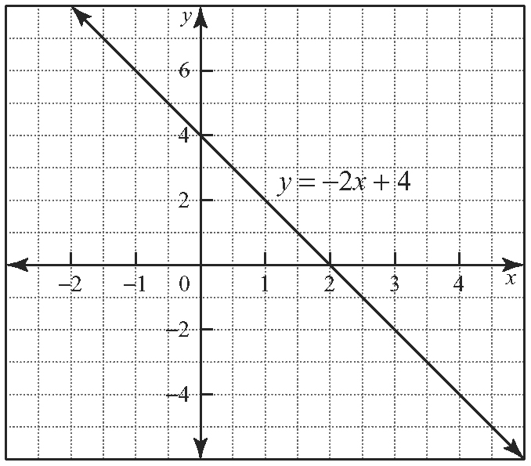
1. a)

The relation is linear.
b) −2; 4
c), d)
x | y | First  Differences
0 | 4 | First  Differences
0 | 4 | −2
1 | 2 | −2
1 | 2 | −2
2 | 0 | −2
2 | 0 | −2
3 | −2 | −2
3 | −2 | −2
4 | −4 | −2
4 | −4 | −2
5 | −6 | −2
The first differences are a constant value that is the same value as the slope of the relation.
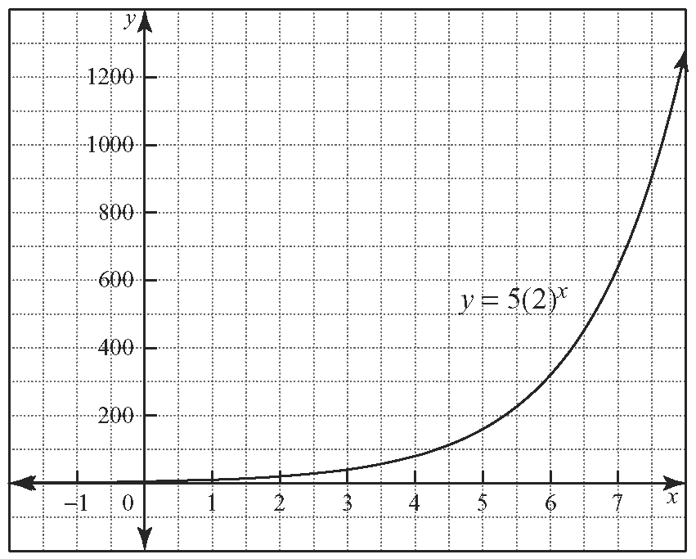
2. a)

The relation is exponential.
b) 1

c), d)
x | y | First  Differences | Second  Differences
0 | 5 | First  Differences | Second  Differences
0 | 5 | 5 | Second  Differences
1 | 10 | 5 | 5
1 | 10 | 10 | 5
2 | 20 | 10 | 10
2 | 20 | 20 | 10
3 | 40 | 20 | 20
3 | 40 | 40 | 20
4 | 80 | 40 | 40
4 | 80 | 80 | 40
5 | 160 | 80
Answers may vary. Sample answer: The values of the first differences are the same as those of the second differences.
e) Answers may vary. Sample answer: The ratio of all consecutive terms is 2, the same as the base of the exponential relation.
3. Answers may vary. Sample answers:
a) partial, because relation includes a fixed value
b) direct, because ratio of x and y values is constant
c) partial, because relation includes a fixed value
d) direct, because ratio of x and y values is constant
4. a) C = 25m + 100
b) fixed part 100; variable part 25m
c)
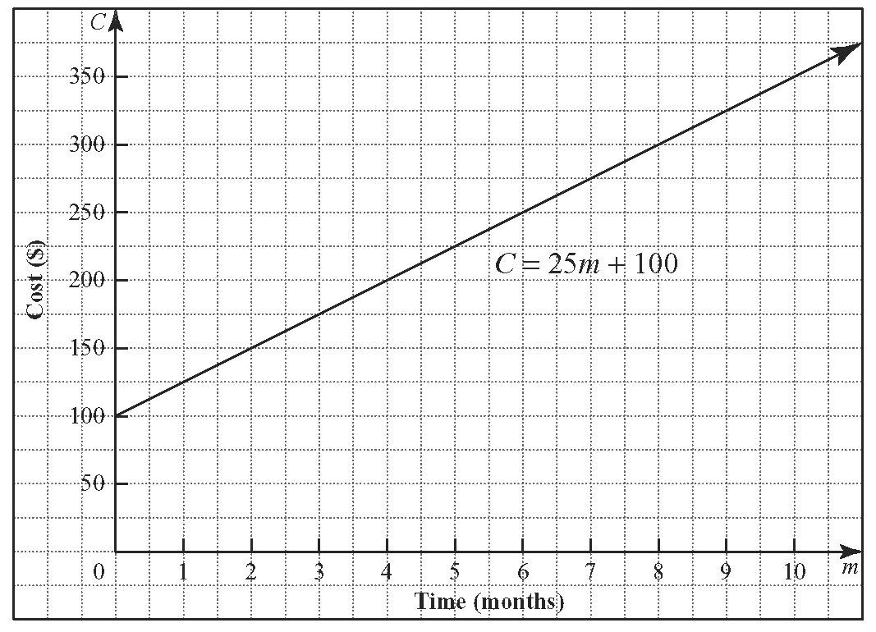
d) 25; 100
e) Answers may vary. Sample answer: The slope represents the monthly cost and the vertical intercept represents the initial cost.
5. a) Answers may vary. Sample answer: The sequence is arithmetic because consecutive terms differ by a constant value.
b) a = −3; d = 4 c) t_{n} = 4n − 7
6. a) 1, 4, 7, 10, 13 b) a = 1; d = 3
7. 1520
8. a) Answers may vary. Sample answer: The sequence is geometric because consecutive terms differ by a common ratio.
b) a = ; r = 2 c) t_{n} =
9. a) 5, 15, 45, 135, 405 b) a = 5; r = 3
10. 442 865
11. 100
12. a) 50 b) 236 c) 625
d) 0.04 e) −0.94 f) 1.057

7.1 Simple Interest

1. a) $5000 b) $255 000
2. a) A = 3000 + 150t
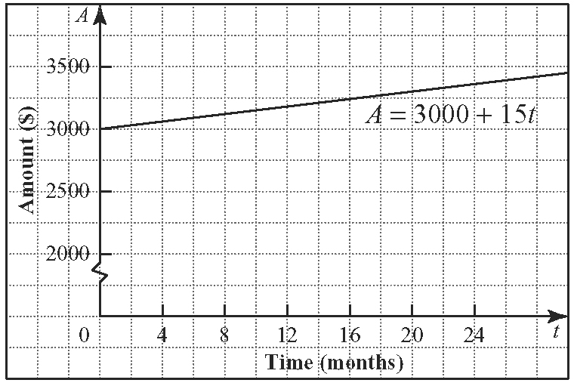
b)

c) 20 years d) 10%
3. a) $500 b) 10% c) A = 500 + 50t
4. a) 4 years 2 months b) approximately 1 year faster
5. a) $1198.63 b) $2333.33 c) $14 000
6. a) A = 1200 + 48t
b)
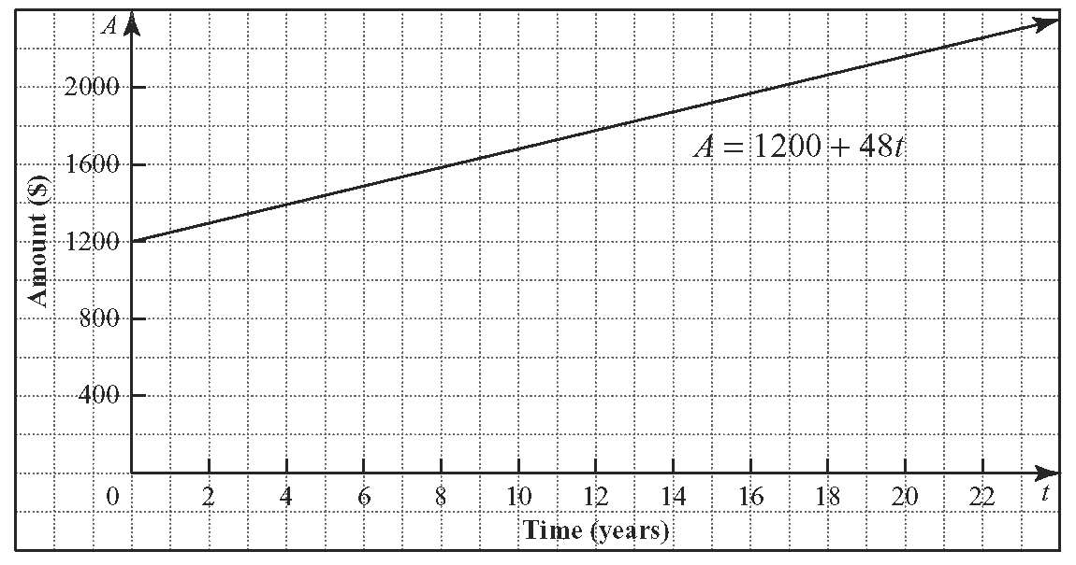
c) 6 years 3 months
7. 16.7%
8. 3 years
9. $1972.60

7.2 Compound Interest

1.
Annual Interest Rate | Frequency of Compounding | Interest Rate Per Compounding Period | Number of Compounding Periods
16% | quarterly | 4.0% | 40
8% | semi-annually | 4.0% | 20
9% | semi-annually | 4.5% | 20
12% | annually | 12.0% | 10
24% | monthly | 2.0% | 120
18% | monthly | 1.5% | 120
13% | bi-weekly | 0.5% | 260
7% | semi-annually | 3.5% | 20
2. $5441.96
3. a) $5386.24 b) $5529.69
c) $5656.81 d) $5670.94
e) $5682.25
4. 9%
5. $3580.91
6. $7595.12
7. $21 320.05
8. approximately 6 years 7 months
9. 4%

7.3 Present Value

1. $20 713.97
2. a) Plan A: $22 335.79; Plan B: $24 410.84;
Plan C: $25 526.60
b) Plan A
3. 6.2%
4. $120 838.46
5. a) $8153.56 b) $846.44
6. $15 381.59
7. a) Answers may vary. Sample answer: Doubling the amount wanted at the end of the investment doubles the present value.
b), c) Answers may vary.
d) Answers may vary. Sample answer: Because of the compounding nature of the investment, the effect of doubling the time is not the same as the effect of doubling the amount wanted.
8. a) $9427.99 b) $10 554.51 c) $1126.52
9. a) $15 000 b) $9015.48 c) 7.87%

7.4 Annuities

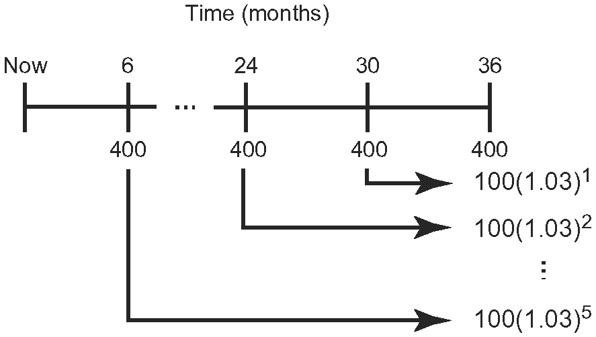
1. a)

b) $2587.36 c) $187.36
2. a) $17 442.51 b) $2442.51
3. $267.69
4. 7.0%
5. $82 719.43
6. a) $52.57 b) $1 141 349.43
7. approximately 8 years
8. $329.38

7.5 Present Value of an Annuity

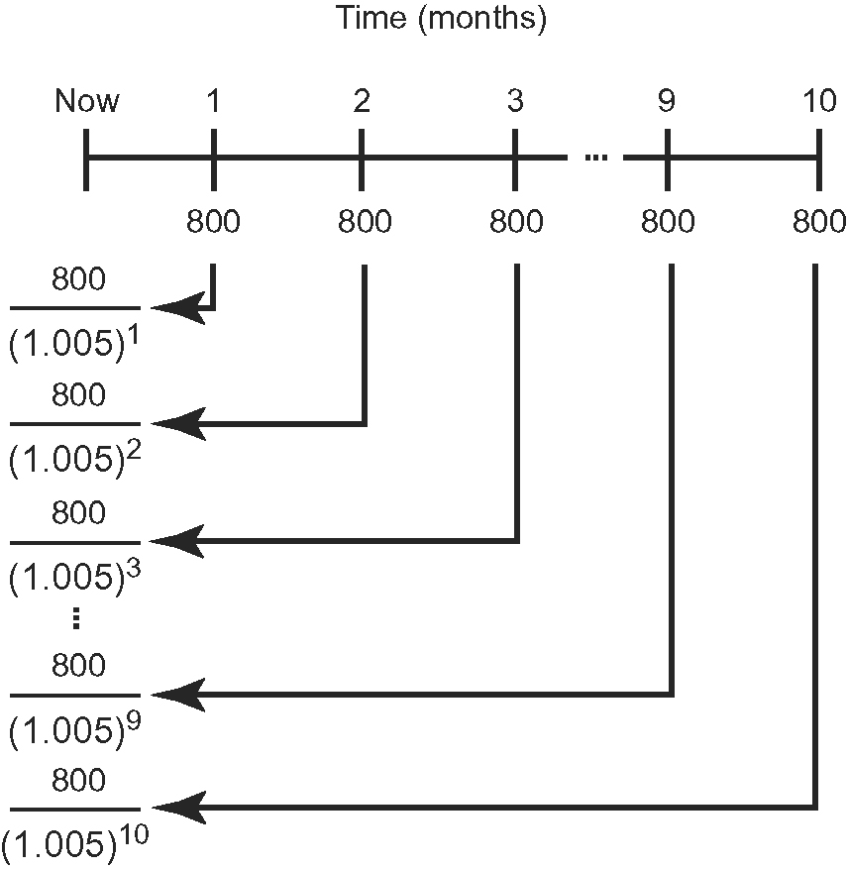
1. a)

The discrepancy between the total here and in part b) is error due to rounding.
b) $7784.33 c) $215.67
2. $54 310.84
3. a) $38 449.76 b) $4790.24
4. $1563.76
5. $8066.75
6. $1282.50
7. $94 937.10
8. $2331.11
9. $660 089.73

Chapter 7 Review

1. $11 000
2. 4.5%
3. 20 years
4. $4880.76
5. Answers may vary. Sample answer: An annual interest rate of 6%, compounded annually, for 7 years is a better investment.
6. a)
Time  (years) | Amount  ($)
0 | 5000.00
1 | 5308.39
2 | 5635.80
3 | 5983.40
4 | 6352.45
5 | 6744.25
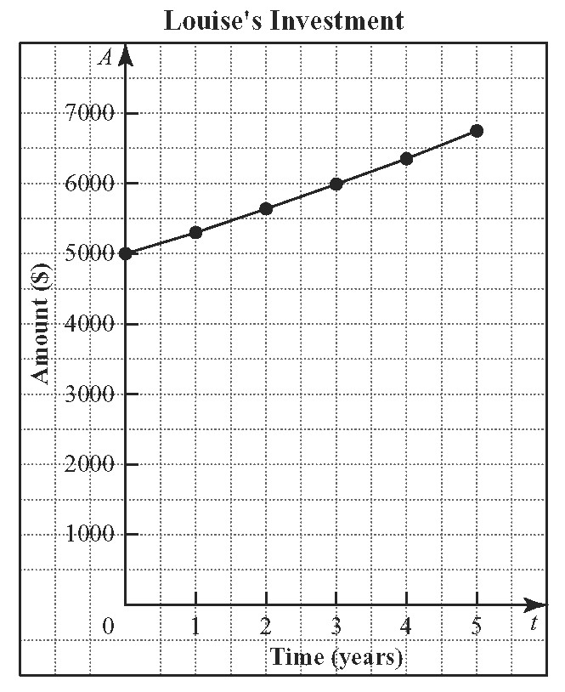
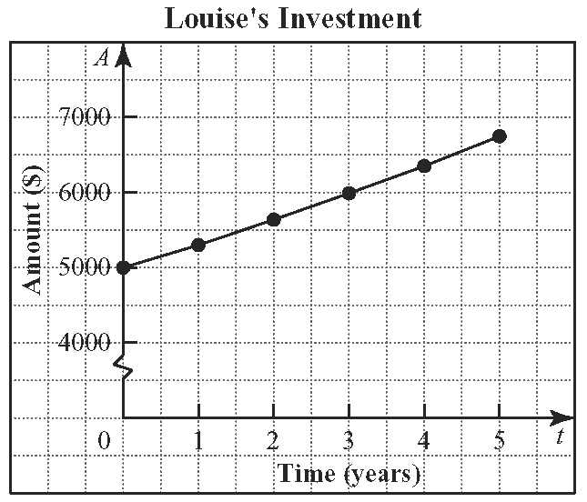
b)

c) Answers may vary. Sample answer: A graph of simple interest is linear with the slope representing the amount of interest paid. In this graph, the slope is not constant. The function is exponential, which increases faster than a linear function.
d) 5000; Louise’s initial investment of $5000
7. 8 years 10 months
8. 2.04%
9. 7 years 10 months
10. a) Option A: $32 702.03; Option B: $32 919.67
b) Option A
11. $446.07
12. Answers may vary. Sample answer: No, because the annuity will be worth only $743 115.74 at the end of the investment.
13. $192 274.77
14. $1200
15. $6633.39
16. $29 481.70
17. $469.70

Chapter 7 Practice Test

1. C
2. D
3. A
4. A
5. C
6.
Year | Pina’s  Investment ($) | Patricia’s Investment ($)
0 | 8 000.00 | 8000.00
1 | 8 320.00 | 8300.00
2 | 8 640.00 | 8611.25
3 | 8 920.00 | 8934.17
4 | 9 280.00 | 9269.20
5 | 9 600.00 | 9616.80

7. $8325
8. a) $493.07 b) $3166.32
9. $6000
10. $6400
11. Answers may vary. Sample answer: Plan A is better, because it pays more in interest.
12. $686.19

