Microsoft ® Excel
Open
Access Microsoft ® Excel from the Start menu or directly from a desktop icon.
The Basics
The Microsoft ® Excel spreadsheet screen is called a worksheet.
• Each cell has a cell address. For example, the address of the active cell shown is D3 (column D, row 3).
• The toolbar contains the most commonly used functions from the menus, such as Save, Print, Copy, and Paste.
• The formula bar displays the address and the contents of the cell in which you are currently working.
• The Chart Wizard takes you through the steps of creating a chart (graph) that displays
the data in the spreadsheet.

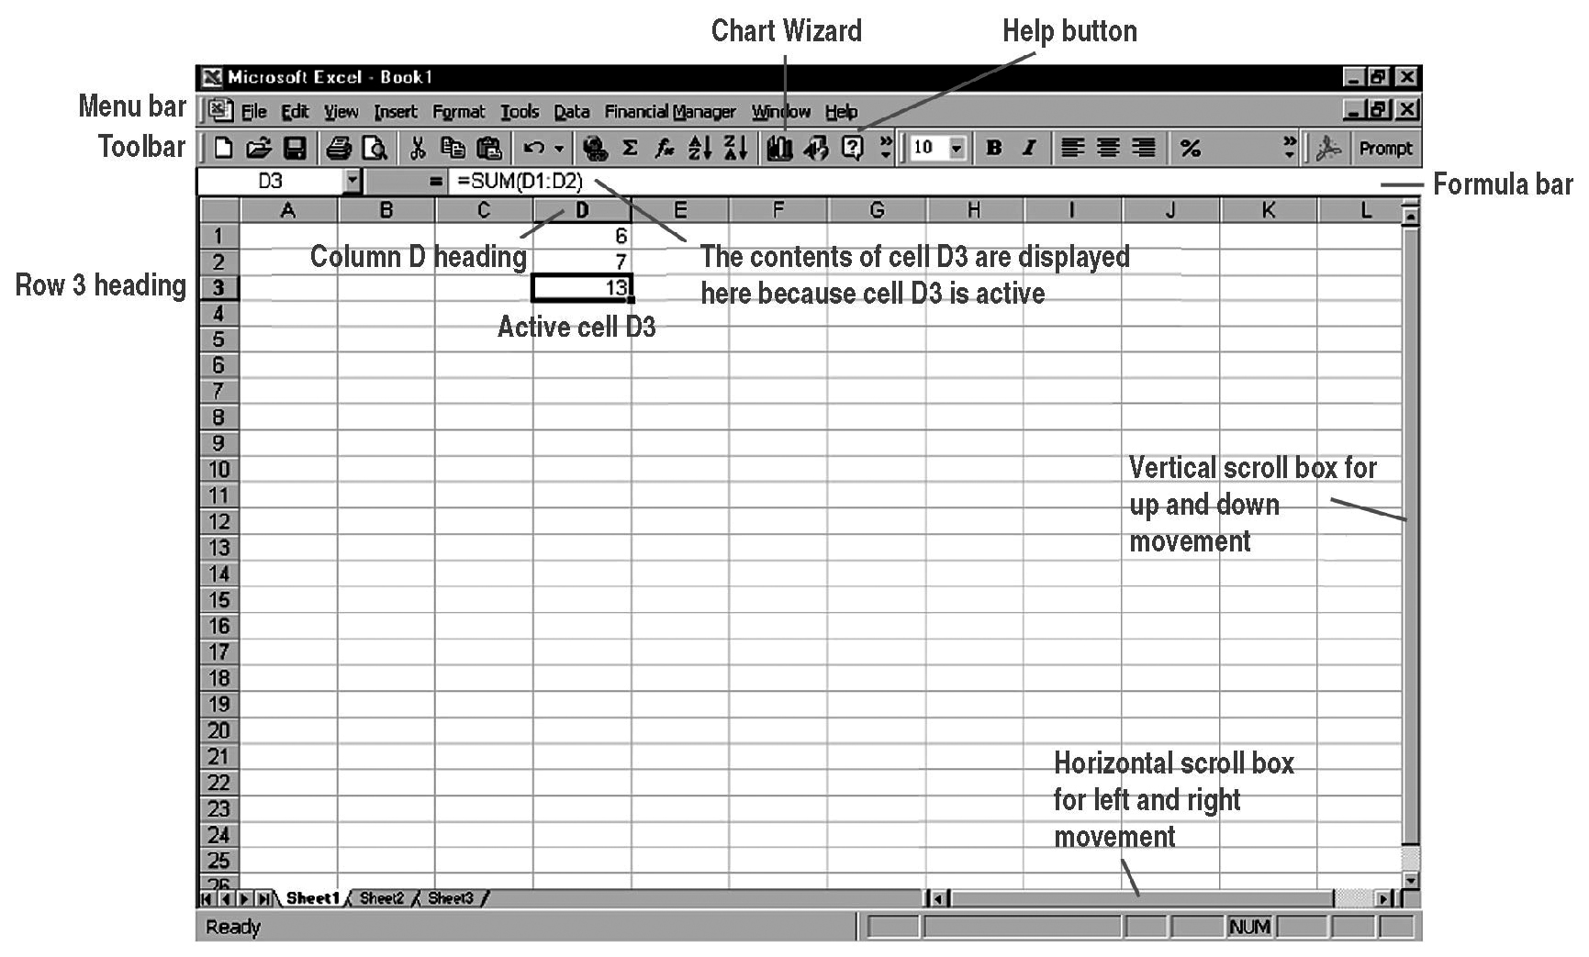

To highlight an entire column,  click the column letter. | To highlight an entire row, click  the row number. | To select the cell into which you wish to enter data, click the cell.
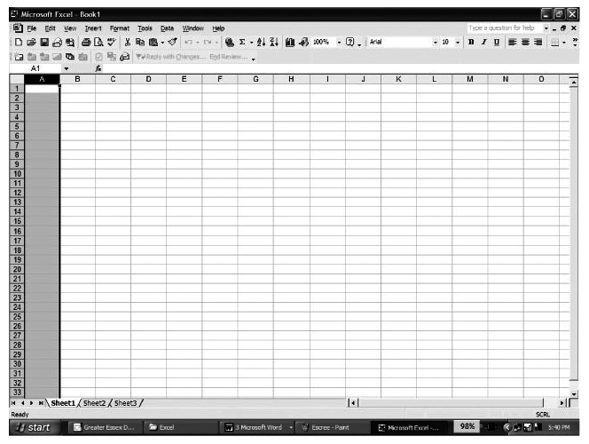 | 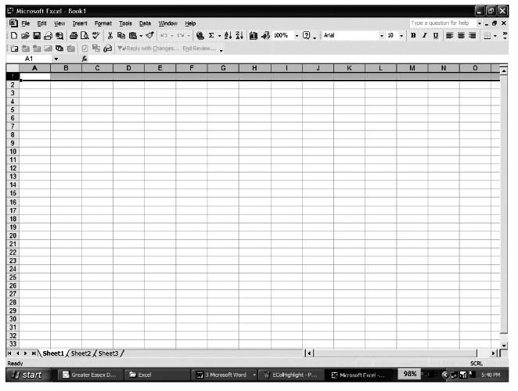 | 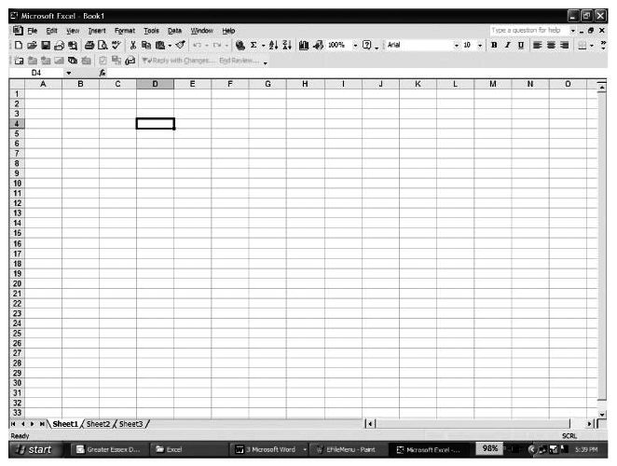

Microsoft ® Excel
Menus
To display a menu, click on the menu name in the menu bar.
File | Edit | Options
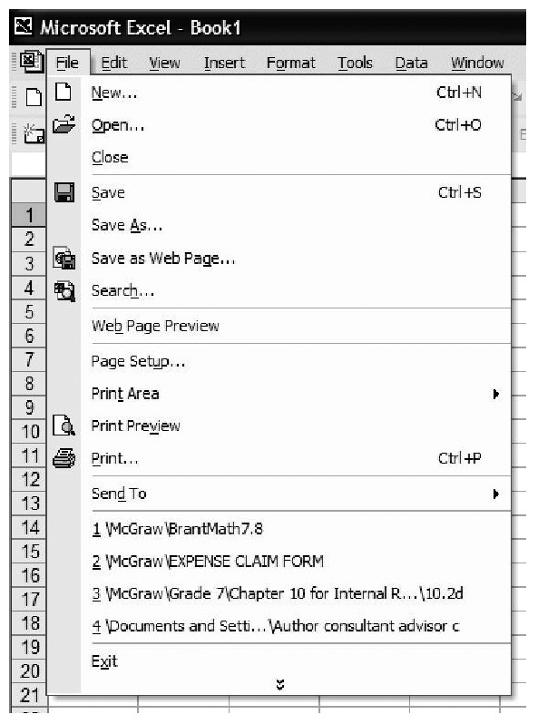 | 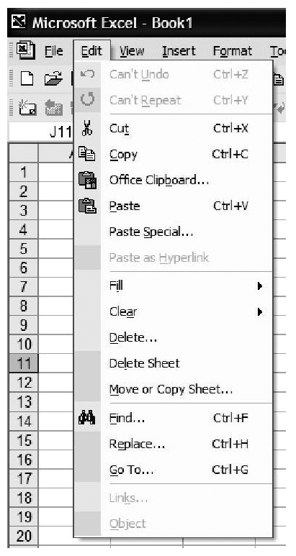 | 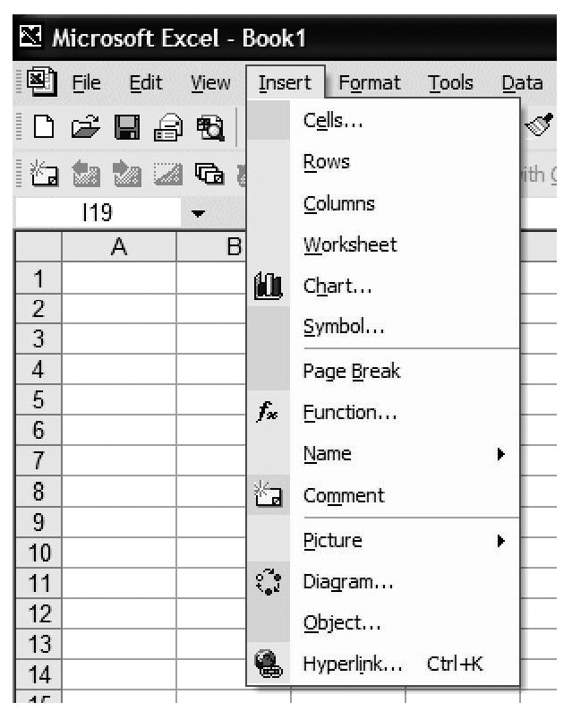
Use this menu to Save your file,  to Print your file, or to Open an existing file. | Use this menu to Copy or Cut highlighted data, to Paste data previously copied, or to Fill  a selected row or column. | Use this menu to create a graph  by clicking the Chart… menu command.

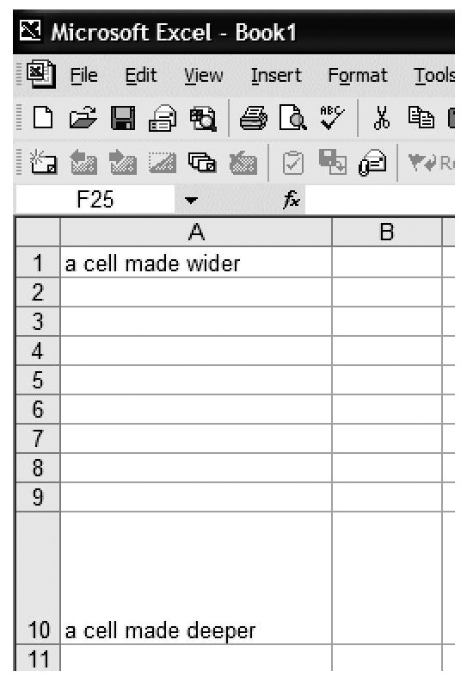
Cell Sizing
To adjust cell size, click on the edge of the cell column
heading (A, B, …), and drag to widen or click on the bottom
of the cell row heading (1, 2, …), and drag to deepen.
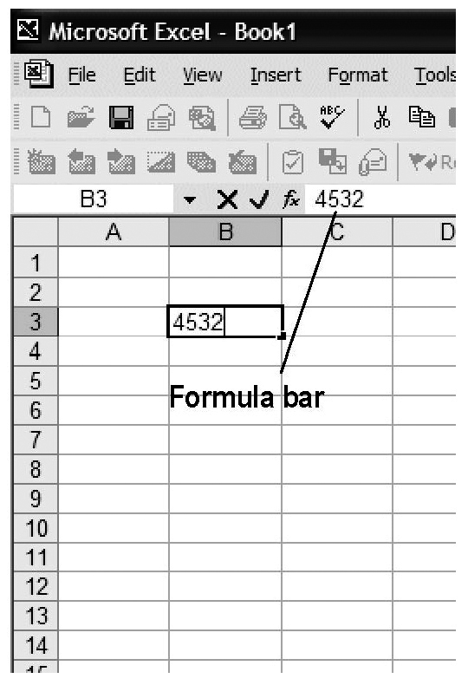
Entering Data
Click on the cell into which you wish to
enter data (here B3), and type in your
data. The data can be numeric, alphabetic,
or alphanumeric. You may widen or
deepen the row/column as necessary
to hold the data. To edit existing data,
click the cell, then click the formula bar.
Microsoft ® Excel
Creating a Graph
Select the cells containing the  data you wish to graph. On  the Insert menu, click  Chart…. | Select the type of graph you  wish to create. Here Pie (or  circle) graph has been chosen. Click the Next button. | Select proper Data range and Series in. Click the Next button.
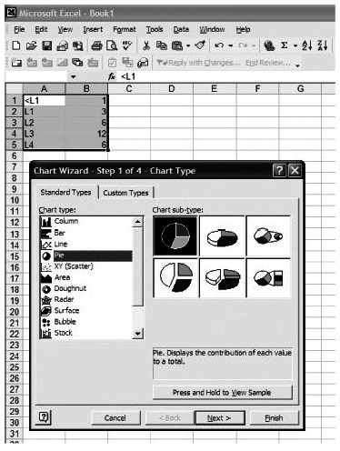 | 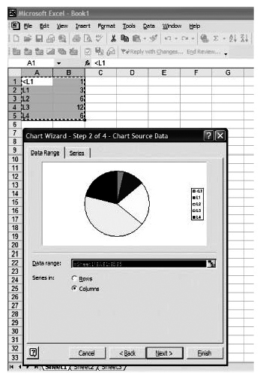 | 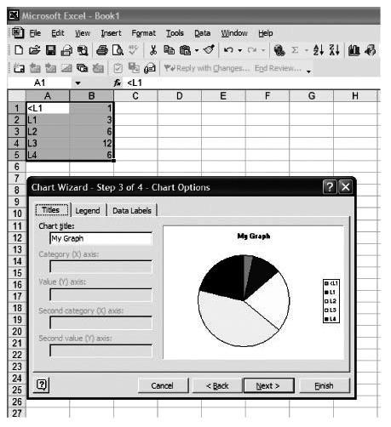

Label your graph as needed, and click the Next button. | Select As object in, and click Finish. | Position the graph where you would like it on the spreadsheet, and click. Your graph will appear.
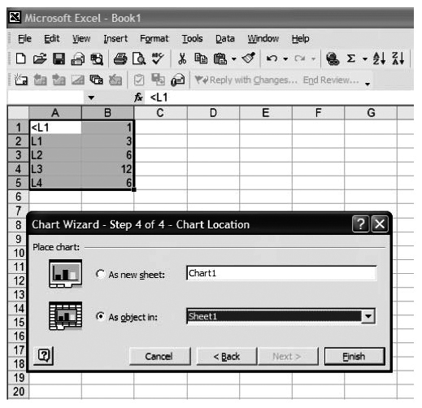 | 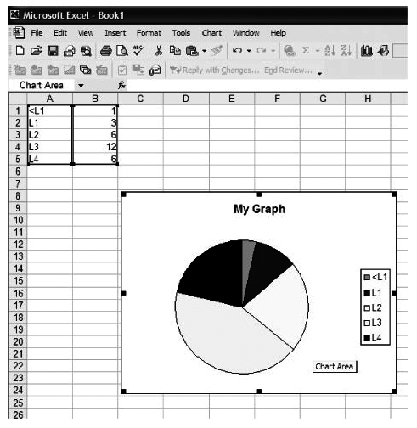 | 