Métis Life After 1885

Name _____________________ Date _____________________

Read pages 221–222 in Shaping Canada to identify the challenges Métis people faced after 1885 and how they protected Métis culture.

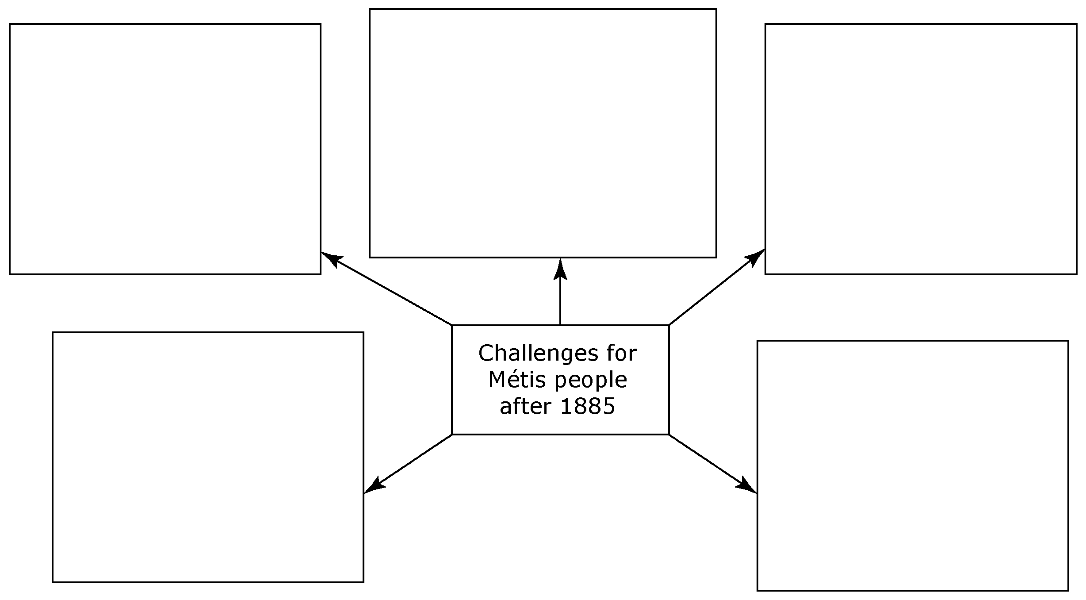

How did Métis culture survive despite these challenges?

