Date: Name: Class:
GENERAL | WHMIS Symbols | BLM G-2
SAFETY | WHMIS Symbols

Goal • Review the meaning of warning labels in your science classroom and at home.
Introduction
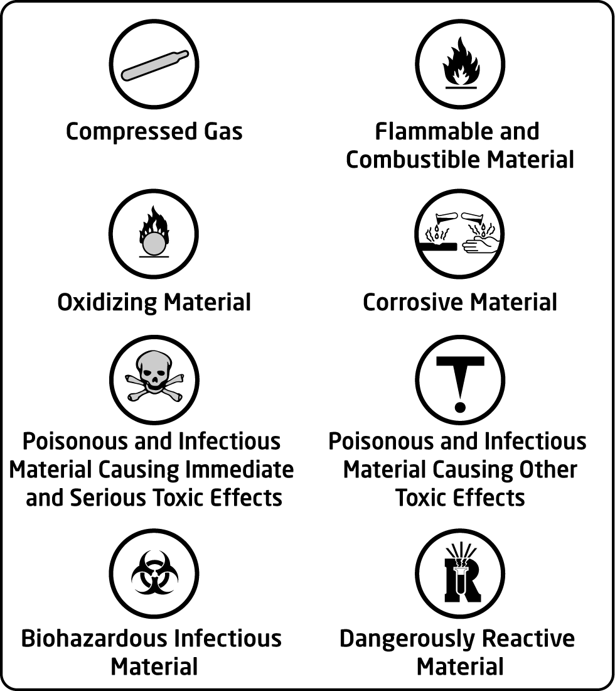
In Canada, standard symbols are used to identify dangerous materials. The Workplace Hazardous Materials Information System (or WHMIS) has produced symbols for work places such as science laboratories. These are known as WHMIS symbols. These symbols provide warnings about the possible hazards of using a product, and the necessary precautions to take when using it.
What to Do
• Read “Safety Symbols” on page xv of your textbook.
• Review each of the WHMIS symbols.
• Answer the questions below.
Questions

1. Briefly explain what kind of hazard each of the following words describes.
a. poisonous
b. infectious
c. flammable
d. explosive
e. reactive
f. corrosive

2. In the space provided, draw the standard WHMIS symbol for each of the following.
a. Compressed Gas | b. Flammable Material | c. Dangerously Reactive Material

Date: Name: Class:
GENERAL | WHMIS Symbols | BLM G-2
SAFETY | WHMIS Symbols | (continued)

3. Choose two WHMIS symbols not used in question #2. Draw the symbol for each one. Describe some precautions you would take when handling products labelled with each symbol.
WHMIS symbol for | Drawing | Precautions
a.
b.

