Date: Name: Class:
GENERAL | Using a Balance | BLM G-12
SCIENCE TOOLKIT | Using a Balance

Goal • To identify and describe the parts of a balance.

What to Do
Label the parts of the balance in the picture, then complete the table.
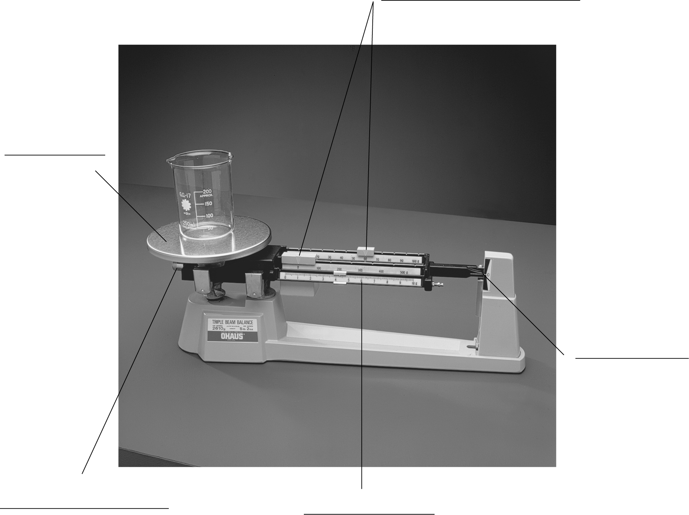
Labels
pan, pointer, beam,
adjustment screw, rider
Parts of a Balance | Function of Part

