Date: Name: Class:
GENERAL | Making Simple Scientific Drawings | BLM G-14

Goal • Practise making simple drawings to represent complex scenes.

Introduction
When drawing representations in science, it is not always necessary to include all the information in your image. Simplifying is an important tool to make the images easier to draw and easier to understand.
What to Do
• Examine simple scientific drawings to figure out what gets included and what is left out.
• Practise making simple scientific drawings.
1. This diagram shows how the position and tilt of the Earth determine the seasons.
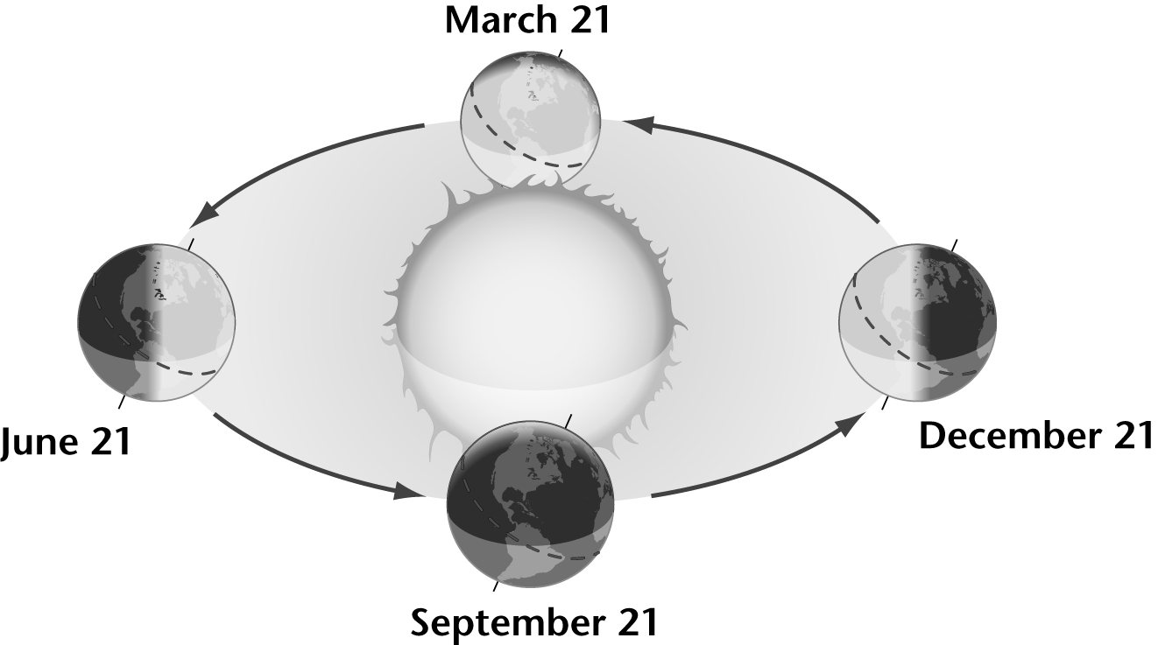
a. What information can you get from this diagram about the seasons?

b. List 3 things that are not included in this drawing.
•
•
•
c. The Earth is shown much larger and closer to the Sun than it really is. How would this drawing be different if the scale were correct?

Date: Name: Class:
GENERAL | Making Simple Scientific Drawings | BLM G-14
 | Making Simple Scientific Drawings | (continued)

2. This diagram shows the carbon and oxygen cycles.
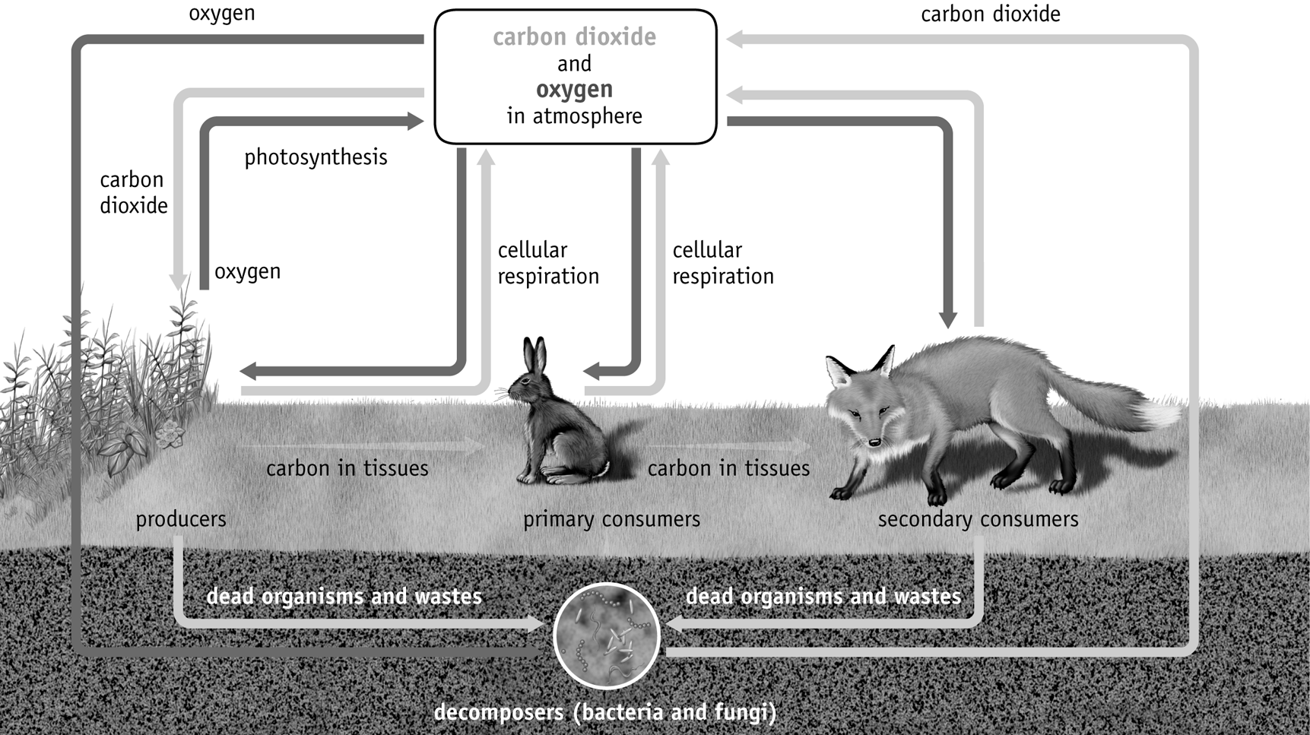
This diagram only shows a few plants and animals to represent the rest. What place would each of the following occupy in the diagram?
a. Ant __________________________
b. Oak tree __________________________
c. Falcon __________________________
d. Earthworm __________________________
e. Algae __________________________
f. Human __________________________
3. This diagram shows light reflecting off a tomato.
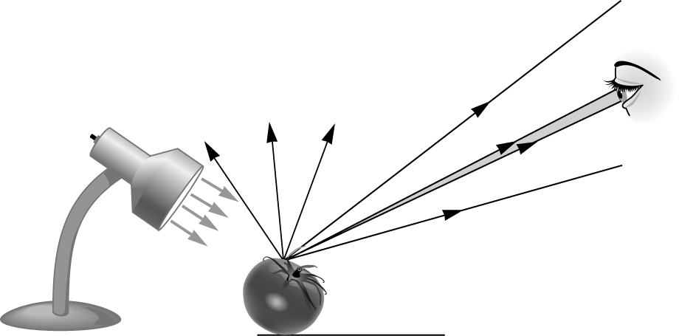
a. There are 7 arrows coming off the tomato. Are these the only directions light travels after reflecting off the tomato? Explain how you know.

Date: Name: Class:
GENERAL | Making Simple Scientific Drawings | BLM G-14
 | Making Simple Scientific Drawings | (continued)

b. How does the drawing simplify the scene without losing information?

c. Draw a similar drawing to represent this scenario:
Iris is looking at a poster on the wall. There only light is coming from a high window behind Iris.

4. While studying cells and cell division, you are asked to draw a simplified plant cell highlighting the nucleus. Use this cross-section to draw your plant cell.
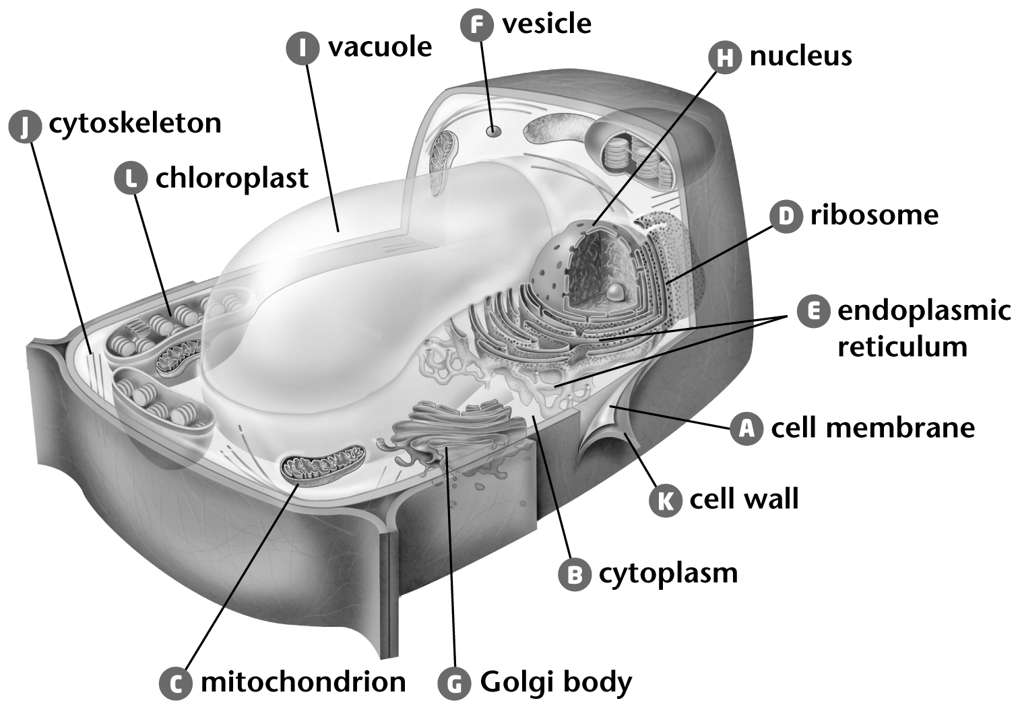
5. A potassium ion has 18 electrons, 19 protons, and 21 neutrons. Draw this ion without drawing each individual particle.

