Date: Name: Class:
GENERAL | Making Decisions Flowchart | BLM G-24
Societal decision making | Making Decisions Flowchart

Goal • Become familiar with steps for making science decisions that affect people.

What to Do
• Follow the flowchart as you complete the outline. (You can adapt the flow chart and outline for making decisions on any issue.)
• Answer the questions that follow.
Outline
Issue:
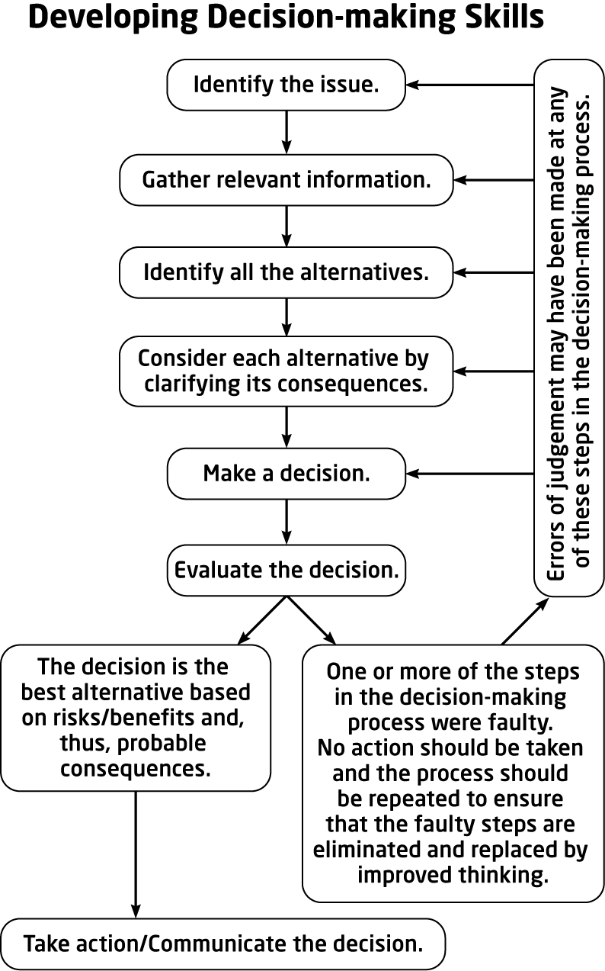 |  | Specify sources for gathering relevant information:  List possible alternatives to the issue:  Are people directly affected by the decision?  Is there any effect on the environment?  List other known or potential risks and benefits:  List implementation strategies:  List ways to communicate the decision:
Date: Name: Class:
GENERAL | Making Decisions Flowchart |  | BLM G-24
Societal decision making |  |  | (continued)

Questions
1. Explain each alternative in more detail.

2. If people are affected by the decision, explain who is affected, and how.

3. If there is a possible effect on the environment, describe the effect.

4. How likely is it for each of the possible risks to cause harm?

5. How likely is it for each of the benefits to occur?

6. Explain how one alternative can be monitored to prevent harm.

