Date: Name: Class:
GENERAL | Organizing and Communicating Scientific Results with Graphs | BLM G-33
Math TOOLKIT | Organizing and Communicating Scientific Results with Graphs

Goal • Become more familiar with different types of graphs.

Scientists often display their observations in the form of graphs. Graphs give a visual representation of relationships that exist among data. There are several types of graphs. Three commonly used graphs are bar graphs, histograms, and line graphs.
Bar Graphs
A bar graph is used when one variable is numerical and the other variable consists of categories of places or things. Follow these steps to construct a bar graph.
1. On graph paper, label the x-axis to identify the categories of places or things. Label the y-axis to identify the numerical variable, remembering to include units.
2. Select an appropriate scale for the y-axis. Use a scale that will allow you to express clearly the smallest and largest numbers to be graphed.
3. Decide on a width for the bars that will make the graph easy to read. Leave the same amount of space between each bar.
4. Use a pencil and a ruler to draw in the bars for each category to a height required by the numeric scale. You might decide to colour code or otherwise uniquely mark each bar.
5. Give your graph a title. You may want to use the same title that was used for the data table from which the graphed data were taken.
What to Do
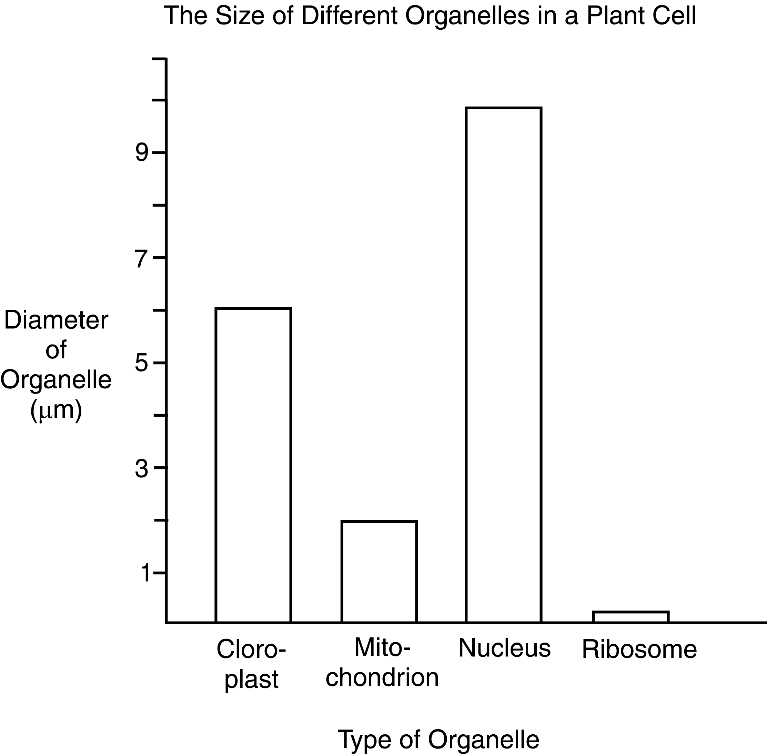
1. Study the following bar graph. It was constructed following the steps above.

Date: Name: Class:
GENERAL | Organizing and Communicating Scientific Results with Graphs | BLM G-33
Math TOOLKIT | Organizing and Communicating Scientific Results with Graphs | (continued)

2. Construct a bar graph for the following data.
The Mass of One Mole of Different Substances
Substance | Mass (g)
carbon monoxide  iron  methane gas  ozone  water | 28.01  55.85  16.05  48.00  18.02
Note: A mole is a unit that is used by chemists to talk about the amount of matter.
Histograms
Histograms are similar to bar graphs, but there are no spaces between the bars. Except for leaving no space between the bars, the steps for constructing a histogram are the same as the steps for constructing
a bar graph.
The reason for placing the bars in contact with each other is that the x-axis represents a continuous quantity such as time. Time can be grouped into months, as shown in the following histogram.
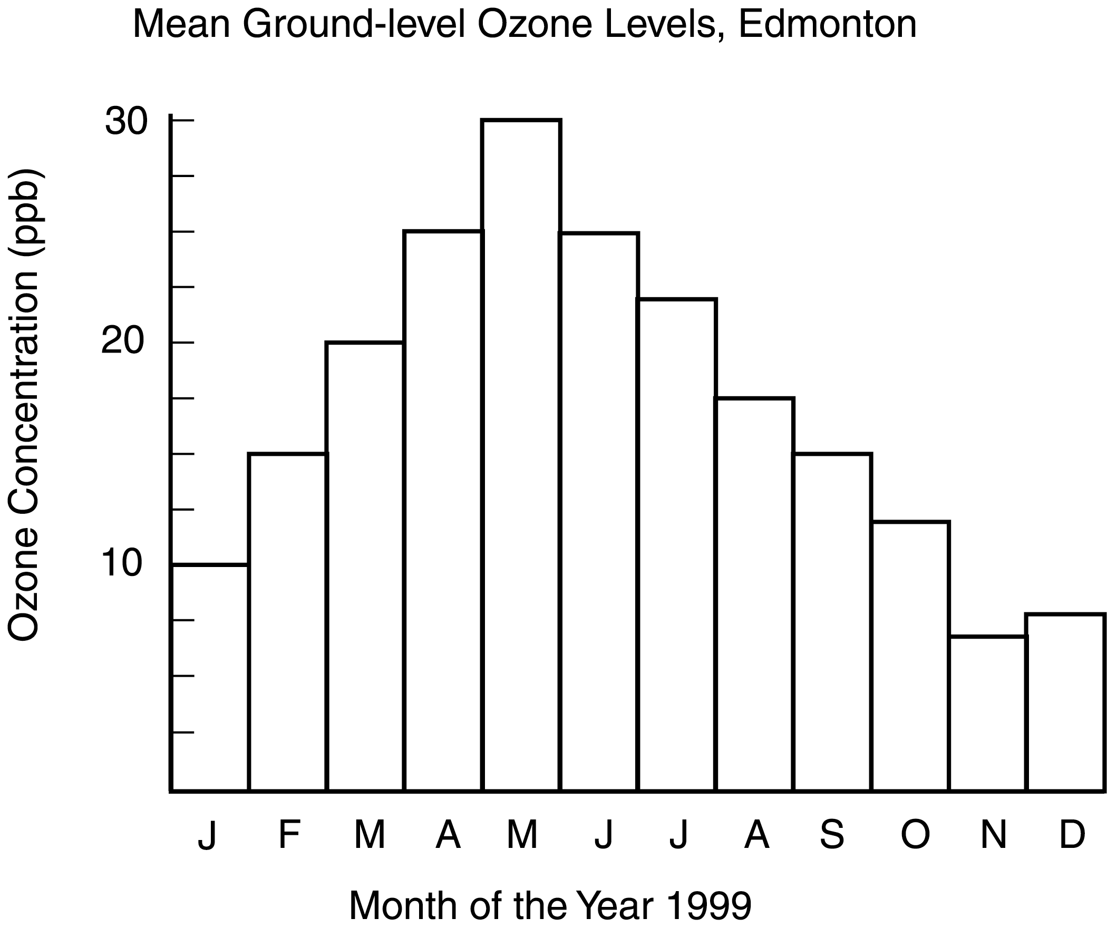
Source: http://www.hc-sc.gc.ca/hecs-sesc/air_quality/publications/ground_level_ozone/part2/chapter5.htm

Date: Name: Class:
GENERAL | Organizing and Communicating Scientific Results with Graphs | BLM G-33
Math TOOLKIT | Organizing and Communicating Scientific Results with Graphs | (continued)

What to Do
Canadians consume huge quantities of energy. One Ontario family’s natural gas consumption in the year 2008 is shown in the following data table. The home, a small bungalow, burned natural gas in the furnace, hot water tank, and clothes dryer. Burning natural gas releases carbon dioxide, a greenhouse gas associated with global warming. Use these data to construct a histogram.
Natural Gas Consumption by One Home During 2008
Month | Energy used (GJ)
January  February  March  April  May  June  July  August  September  October  November  December | 14.2  18.5  9.8  10.1  4.0  1.7  2.4  2.4  6.9  8.1  8.1  20.0
Line Graphs
A line graph is used when both the manipulated variable on the x-axis and the responding variable on the y-axis are numerical. Follow these steps to construct a line graph.
1. Include a descriptive title. Use the variables in your title: for example, Effect of Amount of Light on Plant Growth.
2. Always label the manipulated variable on the x-axis and the responding variable on the y-axis. Be sure to include units.
3. Decide on a suitable scale for each axis. Use tick marks at major intervals to show which lines the scale numbers relate to.
4. Plot a point on the graph for each pair of data, and draw a line of best fit through the plotted points. Some data will generate a straight line, but a curved line might better reflect other data. A line of best fit often passes through many of the points, but sometimes it goes between plotted points. Think of the plotted points as clues about where the perfect smooth line should go. A line of best fit shows the trend of the data. It can be used to predict values between plotted points in a procedure called interpolation. Extending a line of best fit beyond plotted points allows you to make predictions of what might happen, which is called extrapolation.
More than one line may be plotted on one graph. In such a case, a legend is needed to explain the colours or other codes that are used to distinguish the lines.
Date: Name: Class:
GENERAL | Organizing and Communicating Scientific Results with Graphs | BLM G-33
Math TOOLKIT | Organizing and Communicating Scientific Results with Graphs | (continued)

What to Do
1. Study the following line graph. It was constructed following the steps above.
When you observe living green plant cells with a compound light microscope, you can see bright green objects called chloroplasts. Two important pigments in chloroplasts are chlorophyll a and chlorophyll b. These two pigments absorb light to be used in the plant’s production of food. White light consists of different wavelengths (colours) that are absorbed unequally, as shown in the graph.
Note: A great number of observations (that is, plotted points) are needed to create lines of best fit that are this complex. You will rarely generate such data in high school experiments.
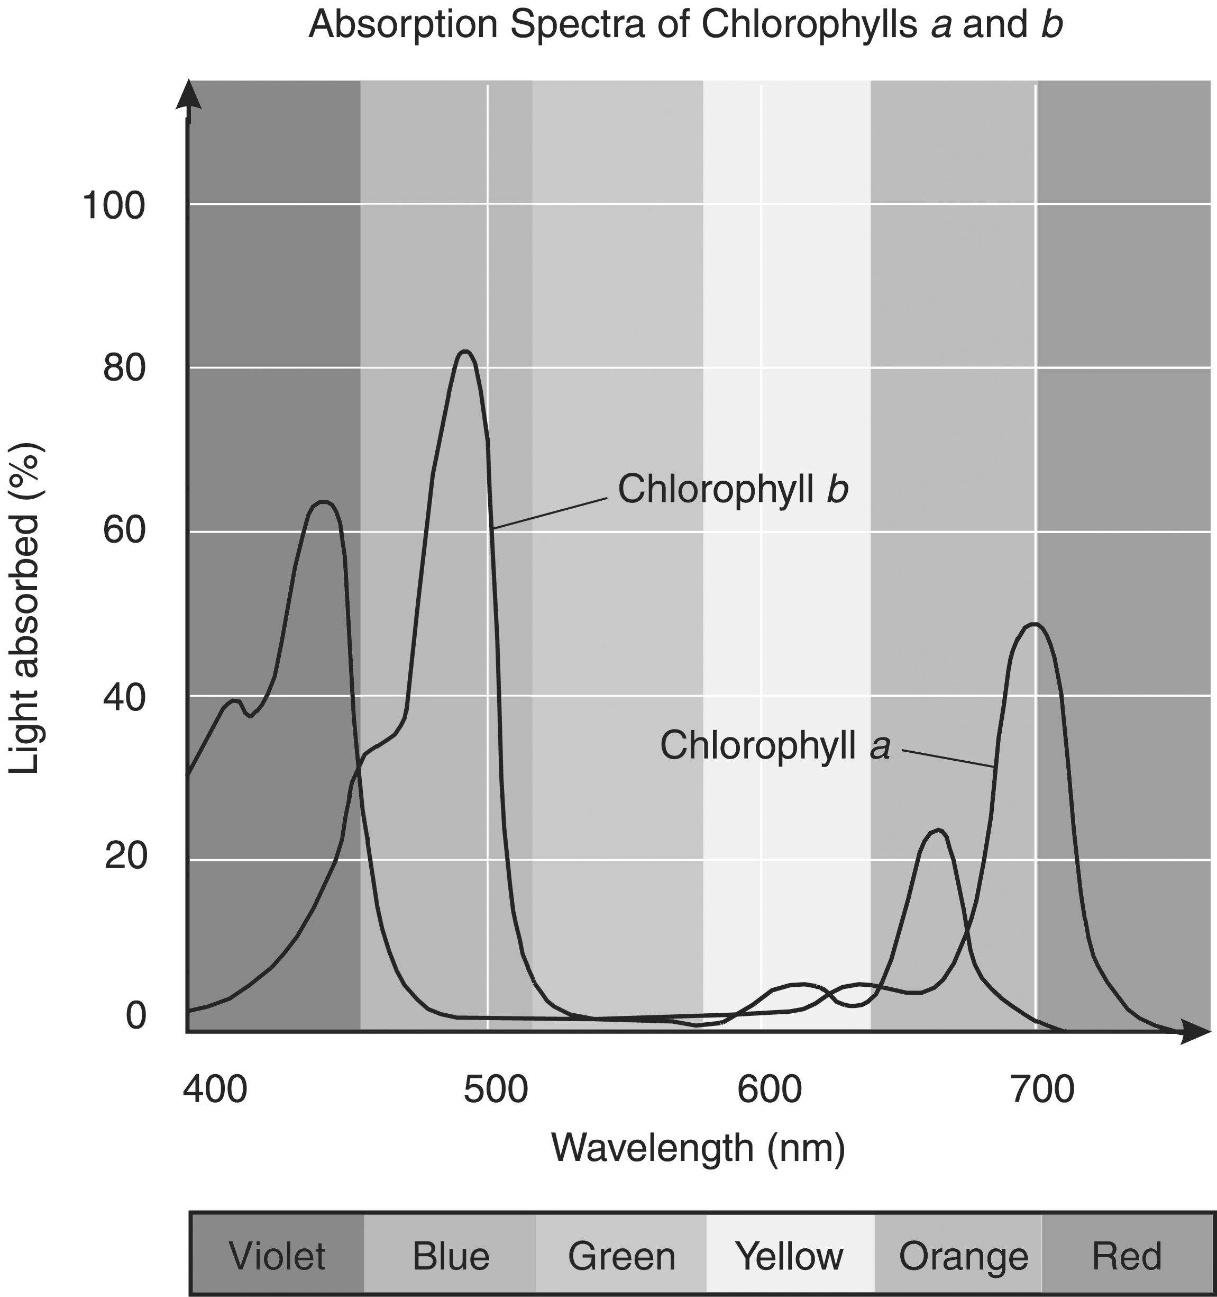
Source: Principles of Botany, by Uno, Storey, and Moore, McGraw-Hill, 2001 (p. 235).
2. Traffic investigators measured the kinetic energy of vehicles of different mass at the same speed. Graph the observations they recorded in the following data table.
The Effect of Mass on Kinetic Energy of Vehicles Moving at 80.0 km/h
Mass of vehicle (kg) | Kinetic energy (×10 J)
1200  1500  2000  2500  2800 | 3.0  3.7  5.0  6.2  7.0

Date: Name: Class:
GENERAL | Organizing and Communicating Scientific Results with Graphs | BLM G-33
Math TOOLKIT | Organizing and Communicating Scientific Results with Graphs | (continued)

3. The following data show how the rate of oxygen production in aquatic plants (an indicator of food production by photosynthesis) is affected by water temperature. Graph these data.
The Effect of Temperature on Oxygen Production in Aquatic Plants
Temperature (°C) | Number of oxygen bubbles released each minute
5  10  14  18  22  27  33 | 24  85  160  181  195  163  62

4. A painter combined white paint and black paint at specific temperatures and measured how long
the paints took to mix completely. At 10°C, they took 12 min to mix completely; at 20°C, they took 9.0 min; at 30°C, they took 7.0 min; at 40°C, they took 6.0 min; and at 50°C, they took 5.5 min. Create a data table and a graph based on these data.
Using Technologies to Generate Graphs
Today, there are technologies that can greatly enhance your ability to create graphs. Even some digital cameras use histograms to help you with light settings! Your teacher may have you use graphing calculators and computer software to display data and create graphs.

