Date: Name: Class:
GENERAL | Activity 2.8 Shapes | BLM G-51

Goal • To use these shapes to create models of ionic compounds.

What to Do
Cut out these “holes” representing negative ions.
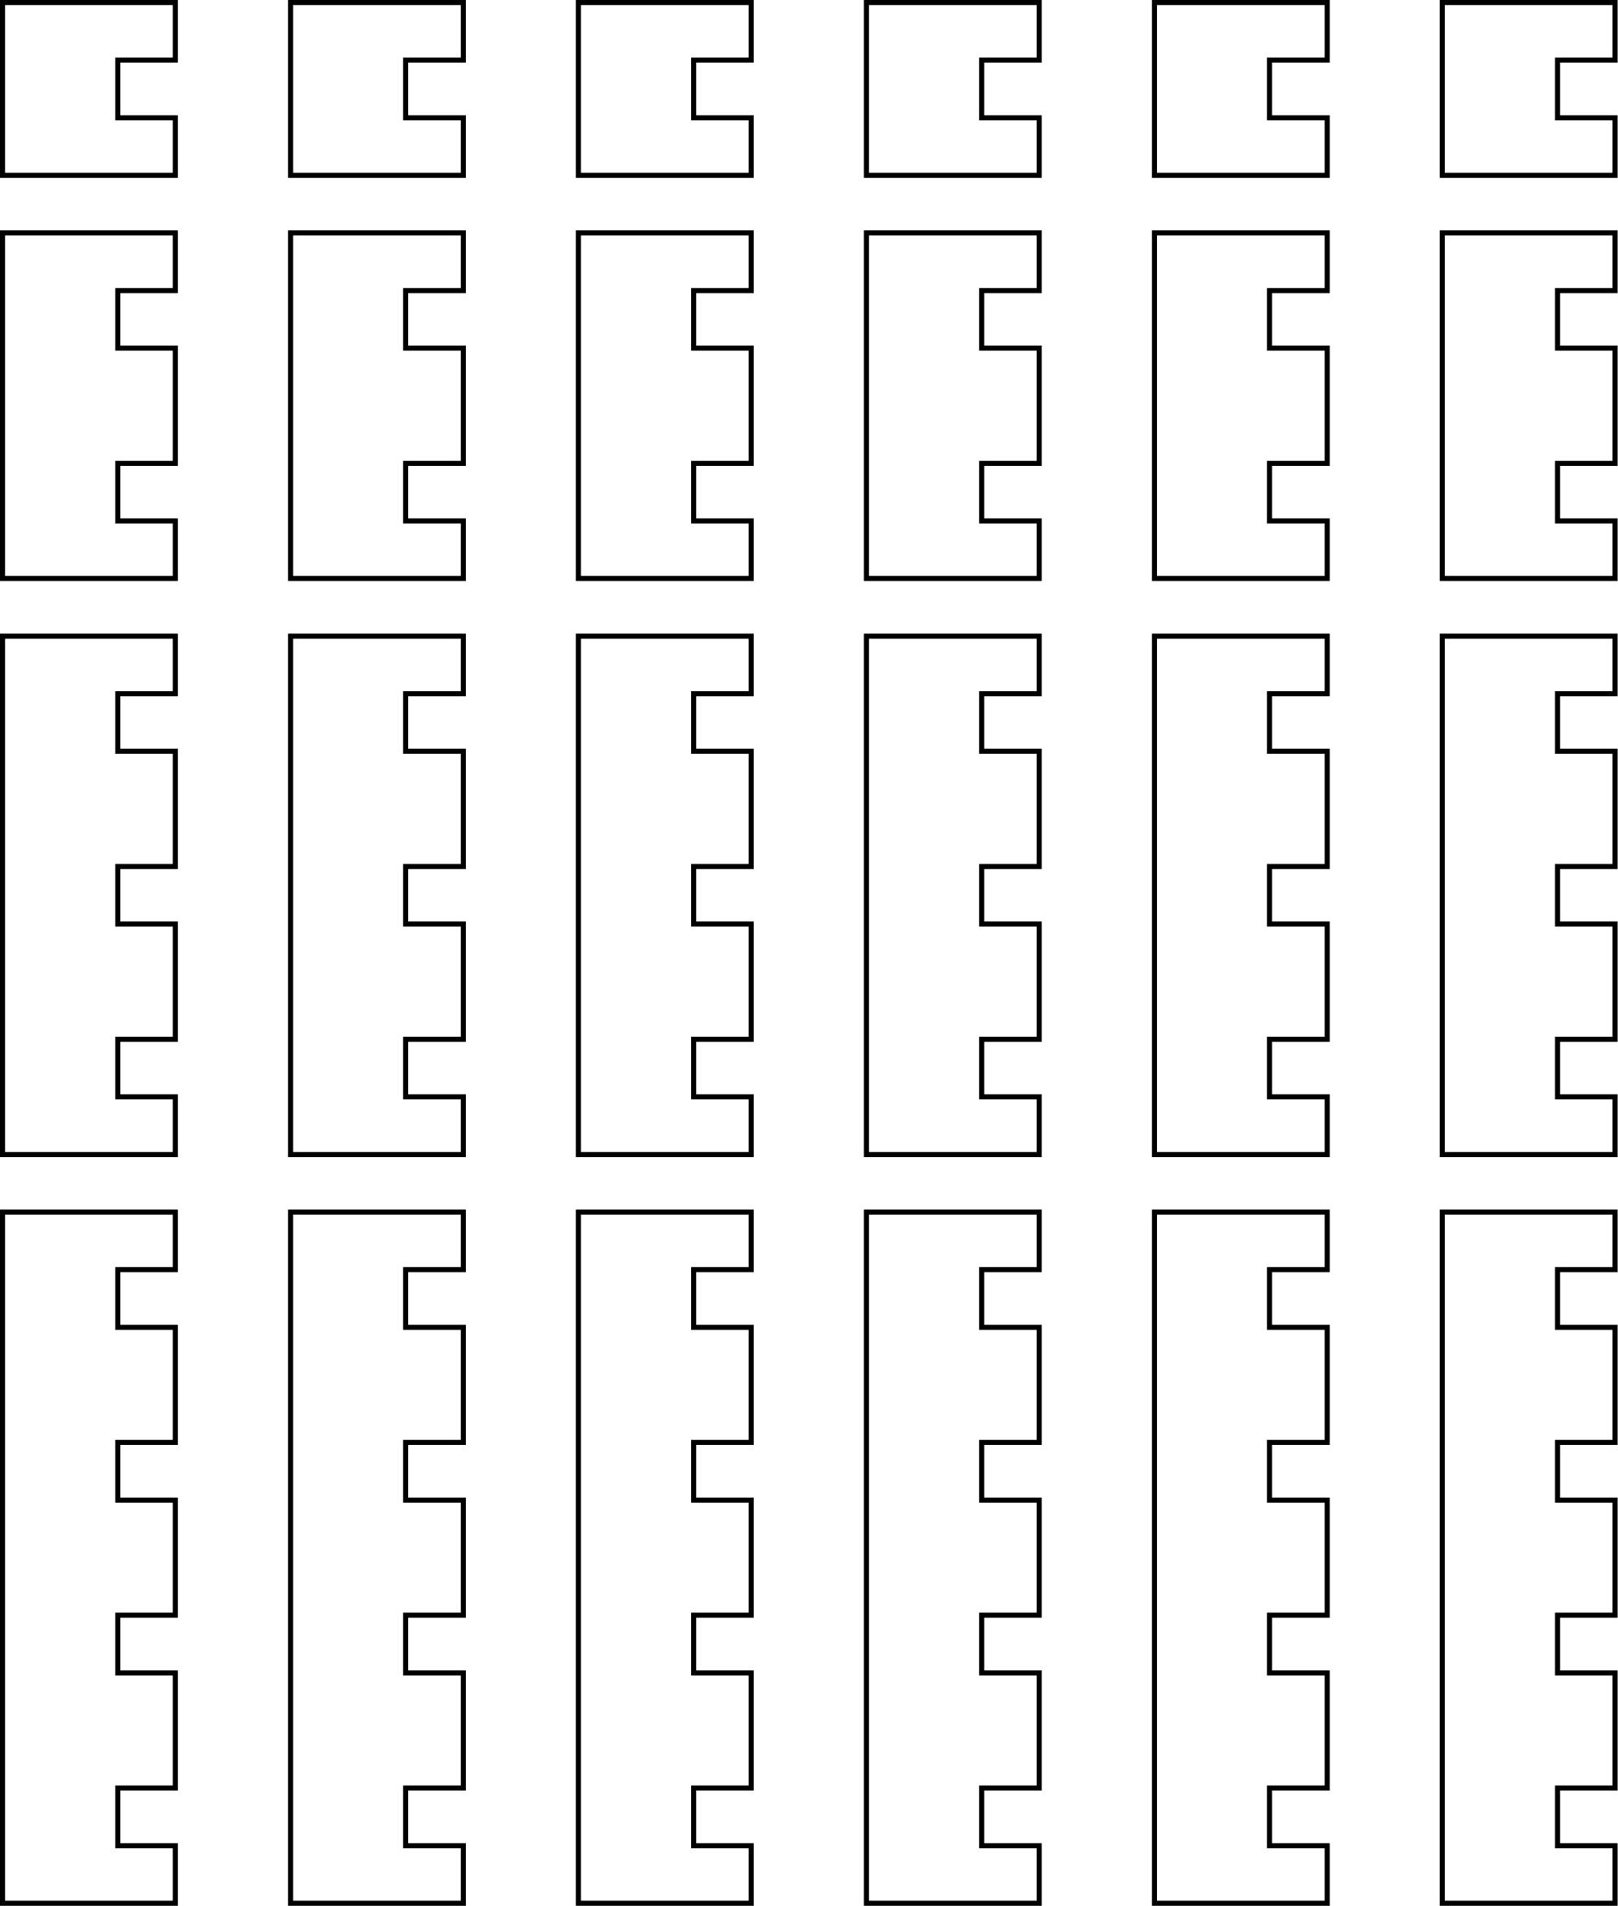
Date: Name: Class:
GENERAL | Activity 2.8 Shapes | BLM G-51
 | Activity 2.8 Shapes | (continued)

What to Do
Cut out these “pegs” representing positive ions.
