Date: Name: Class:
GENERAL | Reflection Obstacle Courses | BLM G-55

Goal • To use mirrors to reroute a beam of light.
What to Do
• Use mirrors to make the light ray travel along Line A and then back along Line B.
• Sketch to show where you placed the mirrors.
Obstacle Course A
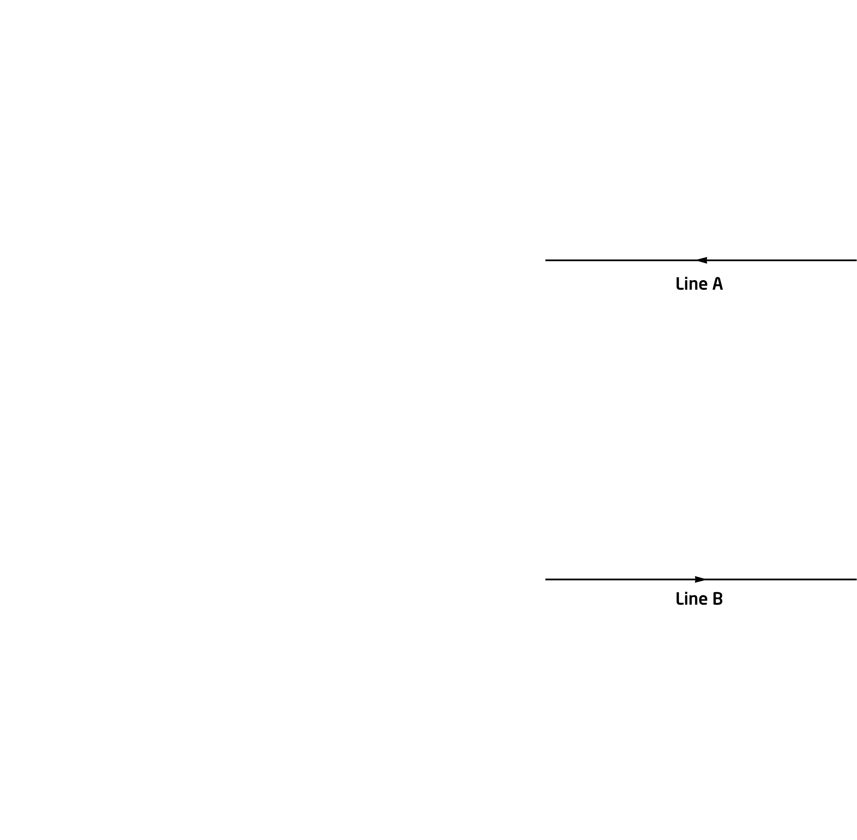

Date: Name: Class:
GENERAL | Reflection Obstacle Courses | BLM G-55
 | Reflection Obstacle Courses | (continued)

Obstacle Course B
