Date: Name: Class:
GENERAL | Using a Balance | BLM G-16
SCIENCE TOOLKIT | Using a Balance

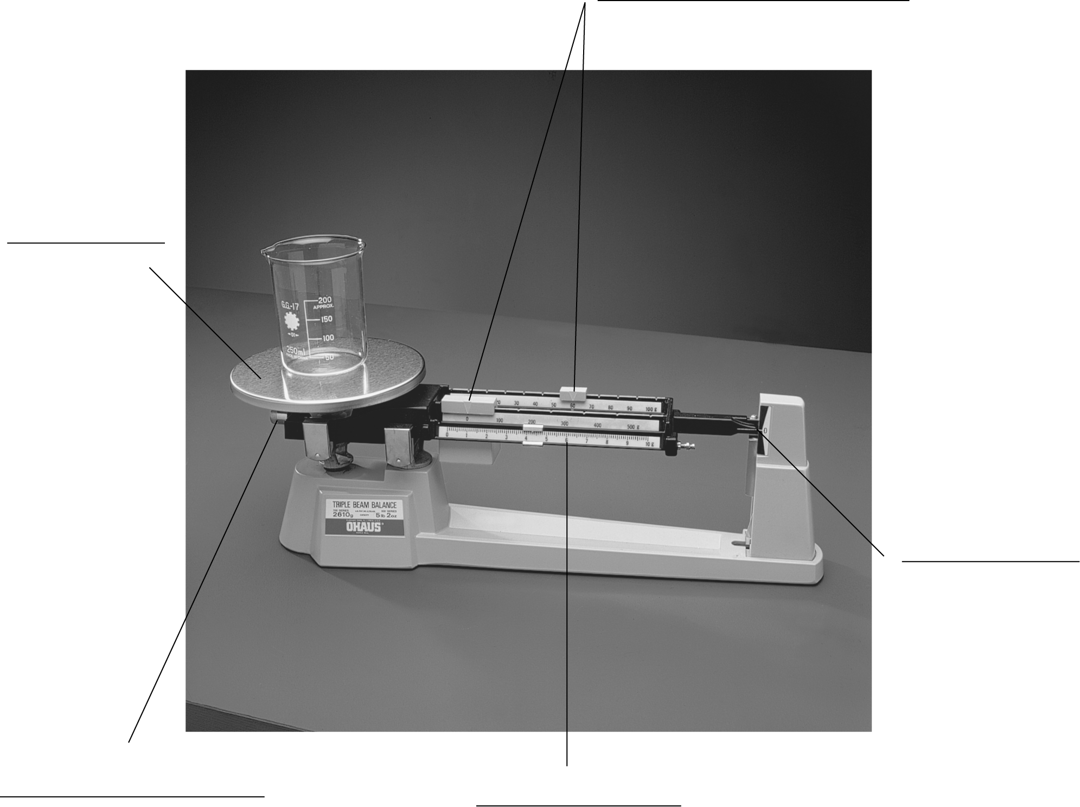
Labels
pan, pointer, beam,
adjustment screw, rider
Parts of a Balance | Function of Part

