Date: Name: Class:
GENERAL | Testing Scientific Ideas | BLM G-29
SCIENCE TOOLKIT | Testing Scientific Ideas

Goal • Following the steps to test a scientific idea in an investigation.
Introduction
When investigating a science idea, scientists follow specific steps. In this way, you can test your scientific ideas with precision.
What to Do
• Use this outline to help you organize your notes on a science inquiry you conduct by yourself.
Outline

Topic:
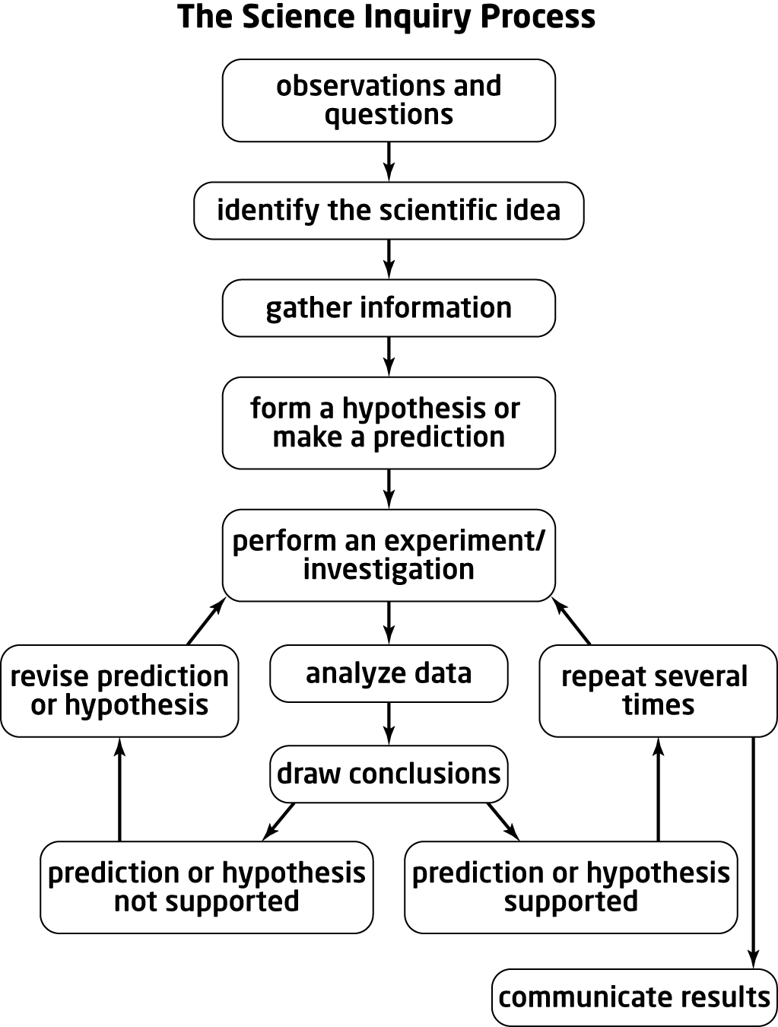 | • My scientific idea is .  • What I already know about this topic is  .  • Where I can look for more information is  .  • How I can explore this idea further is by  . (Experiment? Interviews? Research?)  • The hypothesis for this inquiry is .  • The equipment and materials I will need to include .  • I will record my findings by .  (Notes? Graphs? Tables? Charts?)  • When I will review my inquiry design:  .  • When I might revise my hypothesis: .  • Why I might change my design: .  • How I might adjust my design: .  • How I will communicate my findings:  .  (Write-up? Oral presentation? Model? Display?)

