Date: Name: Class:
GENERAL | Constructing Line Graphs | BLM G-35
science toolkit | Constructing Line Graphs

Goal • Practise developing line graphs with a step-by-step process.
Introduction
Every graph has two sides or axes. The horizontal side, which shows the units for the independent variable (or cause), is called the x-axis. The vertical side, which shows the units for the dependent variable (or effect), is called the y-axis.
Each axis of a line graph indicates the units of measurement according to a consistent scale.
The two axes do not have to have the same scale.
The units along one axis should start with 0 and increase uniformly in small whole numbers—
for example, in multiples of 1, 2, 5, or 10. Choose a scale that will allow you to plot all your data on the graph and that produces a graph that is large enough to read easily.
What to Do
• Follow the steps provided to construct a line graph with Data Set #1.
• Draw another line on your graph using Data Set #2.
Data Set #1
A racing cyclist travels 70 m in 20 s. In the first 4 s, the cyclist covers 10 m. Then the cyclist’s distance is measured after every 2 s.
At | Cyclist travels: | For total distance covered:
6 s | 9 m | 19 m
8 s | 8 m | 27 m
10 s | 8 m | 35 m
12 s | 7 m | 42 m
14 s | 6 m | 48 m
16 s | 5 m | 53 m
18 s | 8 m | 61 m
20 s | 9 m | 70 m
Steps
1. Your graph should show the relationship between time and the total distance the cyclist has travelled. Identify which factor from Data Set #1 is the independent variable (x-axis) and which is the dependent variable (y-axis).
a. time in seconds | axis
b. total distance in metres | axis

Date: Name: Class:
GENERAL | Constructing Line Graphs | BLM G-35
science toolkit | Constructing Line Graphs | (continued)
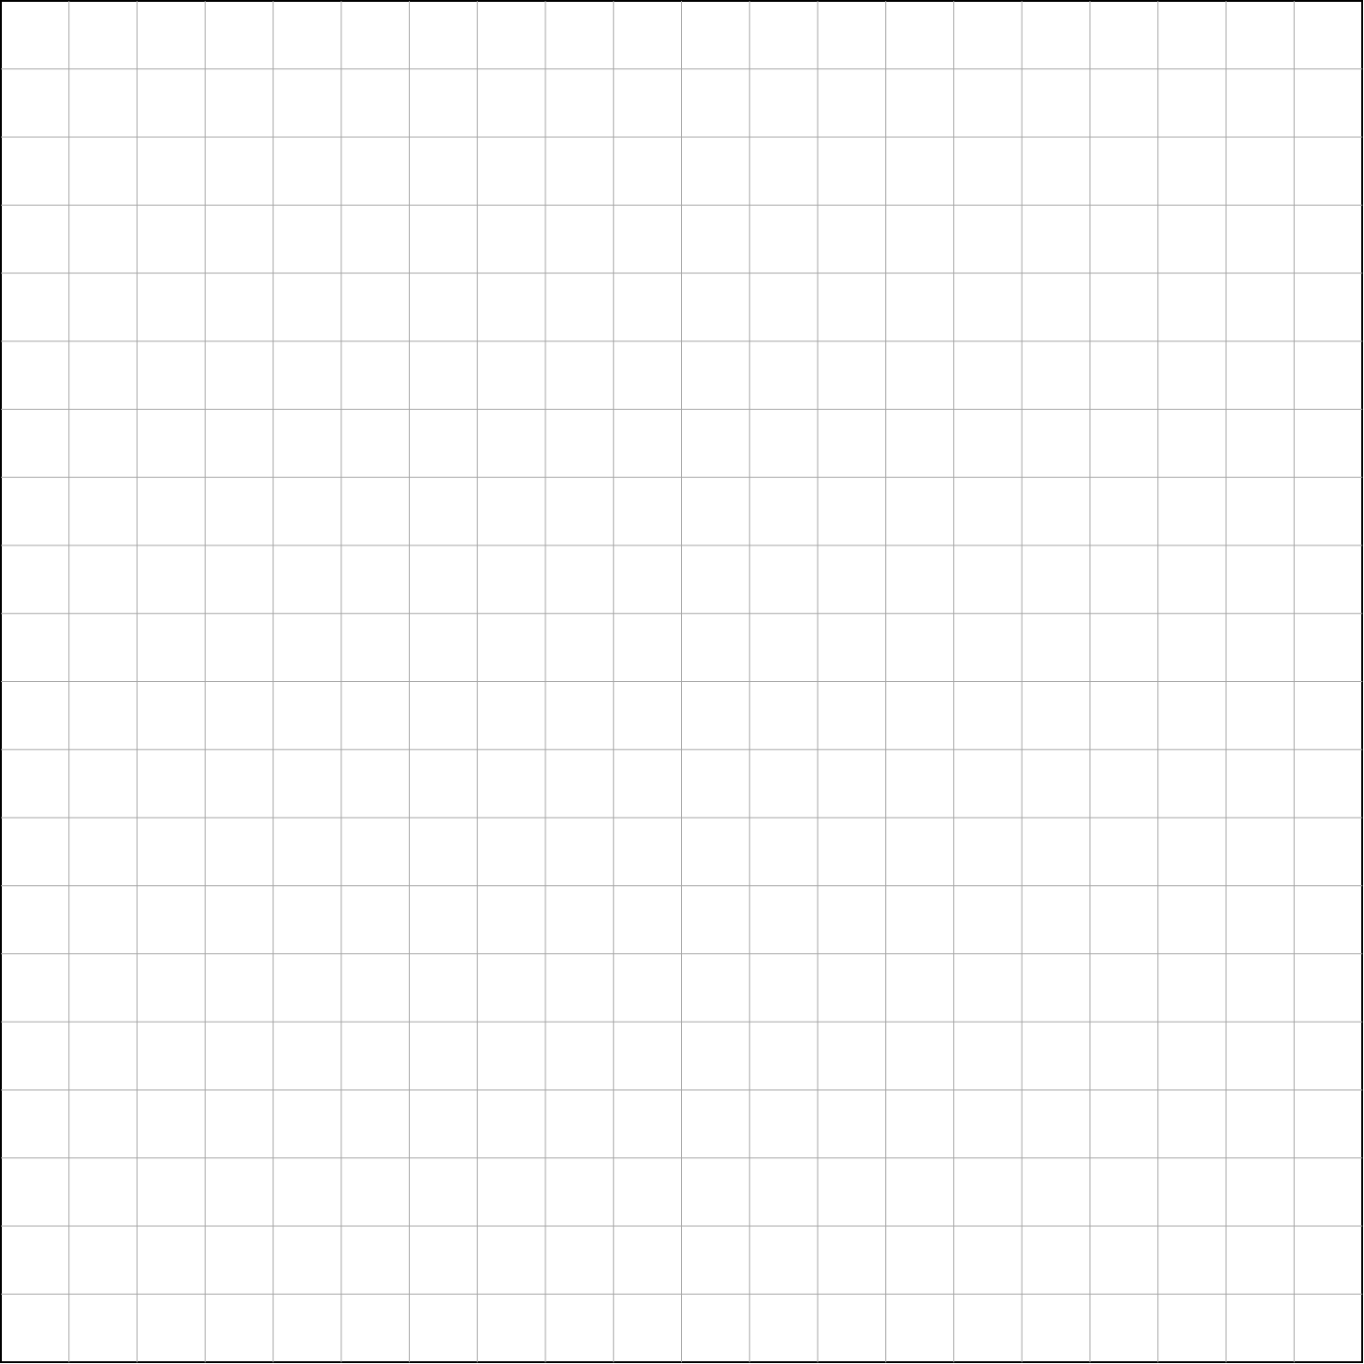
2. Draw and label the x- and y-axes. Label each axis with an accurate title, including the type of variable and the unit of measurement.

3. Select a suitable scale and label the axes.
4. Plot the data on your line graph using a dot surrounded by a small circle for each point.
5. When all the data points have been plotted, draw a line through most of the points to show the pattern formed by the data. The line does not have to pass through every data point, but there should be the same number of data points above and below the line. This is called the “line of best fit”.
6. Repeat steps 4 and 5 for the information from Data Set #2 (below). Use a coloured pencil and coloured line for this set of data.
Data Set #2
At | Cyclist travels: | For total distance covered:
4 s | 12 m | 12 m
6 s | 10 m | 22 m
8 s | 8 m | 30 m
10 s | 8 m | 38 m
12 s | 7 m | 45 m
14 s | 7 m | 45 m
16 s | 7 m | 59 m
18 s | 5 m | 64 m
20 s | 6 m | 70 m
7. Add a legend for the two lines. Give your graph a title.

