Date: Name: Class:
GENERAL | The Metric System and  Scientific Notation | BLM G-38
math toolkit | The Metric System and  Scientific Notation

Goal • Develop your understanding of the metric system and scientific notation.
What to Do
• Read about the metric system and how to do metric conversions.
• Answer the questions that follow.
The Metric System
• The system of measurement that is used throughout most of the world, including Canada, is La Système international d’unités (SI), commonly called the metric system. This system was developed in France in 1791 and was updated in 1960.
• The metric system is based on multiples of 10. Each type of measurement (length, mass, volume, energy, and so on) has a base unit. Larger and smaller units are named by adding a prefix to the base unit.
• For example, the basic unit of length is the metre. The prefix is kilo- means multiplied by 1000, so one kilometre is 1000 metres. The prefix milli- means divided by 1000, so one millimetre is one thousandth of a metre.
• The table shows the most commonly used metric prefixes.
Prefix | Symbol | Relationship to the Base Unit
giga- | G | 10⁹ = 1 000 000 000
mega- | M | 10⁶ = 1 000 000
kilo- | k | 10³ = 1000
hecto- | h | 10² = 100
deca- | da | 10¹ = 10
 |  | 10⁰ = 1
deci- | d | 10⁻¹ = 0.1
centi- | c | 10⁻² = 0.01
milli- | m | 10⁻³ = 0.001
micro- | μ | 10⁻⁶ = 0.000 001
nano- | n | 19⁻⁹ = 0.000 000 001

Date: Name: Class:
GENERAL | The Metric System and  Scientific Notation | BLM G-38
math toolkit | The Metric System and  Scientific Notation | (continued)
Converting Metric Units Using Metric Stairs
• You can use metric stairs to covert metric units. To use the stairs, simply start at the level of the original unit (litre, metre, gram) and move up or down the stairs to the unit to which you are converting. Each "jump" up the stairs is the same as dividing by 10. This means you move the decimal place one place to the left.
• Look at the example. To convert 3.4 cm to metres, make two jumps up the stairs (you are dividing by 100 (10 × 10)). This is the same as moving the decimal two places to the left, which would make
3.4 cm = 0.034 m.
• To convert 5.2 km to metres, make three jumps down the stairs, the same as multiplying by 1000
(10 × 10 × 10). This is also the same as moving the decimal three places to the right, which would
make 5.2 km = 5200 m.
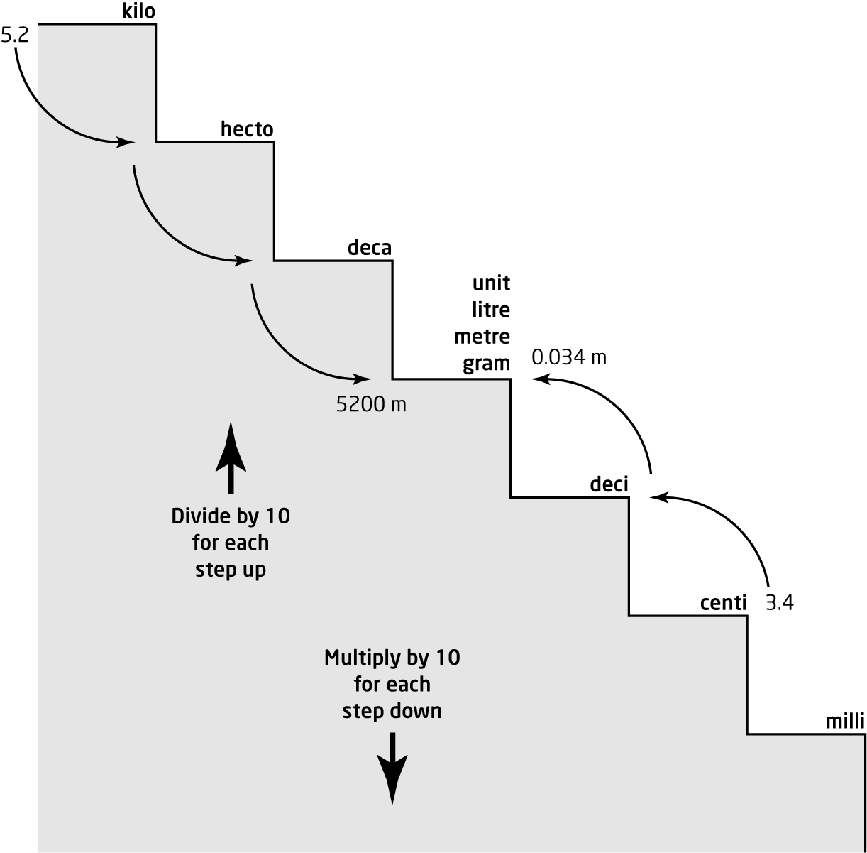
Hint: To remember in which direction to move the decimal, look at the stairs. When you come down the stairs (multiply), you are going to the right, so move the decimal to the right. When you go up the stairs (divide), you are going to the left, so move the decimal to the left.
Date: Name: Class:
GENERAL | The Metric System and  Scientific Notation | BLM G-38
math toolkit | The Metric System and  Scientific Notation | (continued)
Questions
Length
Use the phrase below to remember the order of the metric measures for length.
1000 | 100 | 10 | 1
km | hm | dam | m | dm | cm | mm
King | Henry | Drank | My | Dark | Chocolate | Milk
Example 1
Convert 37 m to centimetres.
Solution
Look at the stairs on the previous page. To convert metres to centimetres, jump down two stairs
or multiply by 10 × 10.
37 m = 37 × 10 × 10
= 3700 cm
Example 2
Convert 18 km to metres.
Solution
Look at the stairs on the previous page. To convert kilometres to metres, jump down three stairs or multiply by 10 × 10 × 10.
18 km = 18 × 10 × 10 × 10
= 18 000 m
Convert each length to the given measurement.
1. 85 cm = _______ m  2. 0.85 km = _______ m  3. 8.5 cm = _______ mm  4. 85 000 dm = _______ m | 5. 0.85 dam = _______ m  6. 2.77 m = _______ dam  7. 0.277 cm = _______ dm  8. 27.7 dam = _______ hm

Date: Name: Class:
GENERAL | The Metric System and  Scientific Notation | BLM G-38
math toolkit | The Metric System and  Scientific Notation | (continued)
Mass
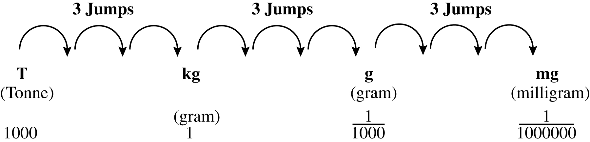
Use the table above to convert each mass to the given measurement.
9. 8.3 kg = _______ g  10. 830 mg = _______ g | 11. 2.77 hg = _______ g  12. 2700 mg = _______ dg
Capacity
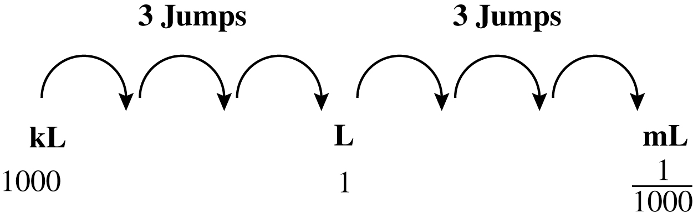
Use the table above to convert each volume to the given measurement.
13. 830 ml = _______ L
14. 083 L = ________ mL
15. 8.3 L = ________ mL
16. 83 000 mL = _______ L

Date: Name: Class:
GENERAL | The Metric System and  Scientific Notation | BLM G-38
Math toolkit | The Metric System and  Scientific Notation | (continued)

Goal • Develop your understanding of using scientific notation.
What to Do
• Read about scientific notation and answer the questions that follow.
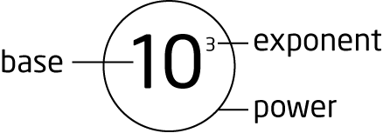
Powers
You can write repeated multiplication in a simpler way as a power.
Powers are named after their bases, so 103 is called a power of 10.
10³ = 10 × 10 × 10.
Writing Scientific Notation
Scientific notation is a way of writing very large or very small numbers so they are easier to work with.
A number written in scientific notation is the product of a number between 1 and 9, and a power of 10. Large numbers have a power of 10 with a positive exponent. Small numbers have a power of 10 with a negative exponent.
Example 1
Mercury is about 58 000 000 km from the sun. Write 58 000 000 in scientific notation.
Solution
The number will have two parts: a number between 1 and 9, and a power of 10. The first number will be 5.8. What do you need to multiply 5.8 by to get 58 000 000?
58 000 000 = 5.8 × 10 000 000 Write 10 000 000 as a power of 10.
= 5.8 × 10⁷
Check: Move the decimal in 5.8 seven places to the right and you get 58 000 000.
Example 2
The diameter of a helium atom is about 0.000 000 000 256 m. Write 0.000 000 000 256 in scientific notation.
Solution
The number will have two parts: a number between 1 and 10, including 1, and a power of 10. The first number will be 2.56. What do you need to multiply 2.56 by to get 0.000 000 000 256?
0.000 000 000 256 = 2.56 × 0.000 000 000 1 Write 0.000 000 000 1 as a power of 10.
= 2.56 × 10^{–10}
Check: Move the decimal in 2.56 ten places to the left and you get 0.000 000 000 256.

Date: Name: Class:
GENERAL | The Metric System and  Scientific Notation | BLM G-38
Math toolkit | The Metric System and  Scientific Notation | (continued)

Express each of the following in scientific notation.
1. The approximate diameter of an electron is 0.000 000 000 000 005 6 cm.
3. The approximate diameter of Saturn is 120 500 km.
2. Neptune is about 4 500 000 000 km from the sun.
3. The mass of a dust particle is 0.000 000 001 023 kg.
Calculating with Scientific Notation
You can multiply and divide with numbers in scientific notation without needing to write them in standard form. Use the exponent laws to calculate the new power of 10.
Product of Powers: a^{m} × a^{n} = a^{m + n} Quotient of Powers: a^{m} ÷ a^{n} = a^{m – n}
Example 1
Convert 9.7 × 10⁷ AU to light years. (1 AU = 1.58 × 10^{–5} light years)
Solution
If you are multiplying powers with the same base, you can add the exponents.
Check: The first number is not between 1 and 10. Change the number to proper scientific notation.
15.326 × 10² = 1.5326 × 10³ light years
Example 2
Convert 2.1 × 10⁸ light years to astronomical units.
Solution
If you are dividing powers with the same base, subtract the exponents.
Check: The first number is between 1 and 10 and the second number is a power of 10, so the number is written in proper scientific notation.
Solve the following. Express your answers in proper scientific notation.
1. (5.75 × 10⁹) × (1.4 × 10²)  3. | 2. (2.6 × 10⁴) × (3.5 × 10³)  4.

