Word Build
Possible words include: ago, auk, cache, café, can, cane, canine, casino, cask, check, clock, clone, cook, con, conch, cosine, cuckoo, hen, knife, knock, on, nacho, nan, neon, nine, no, none, sin, sine, sink. No words were found that included magnesium (Mg), zinc (Zn), mercury (Hg), and lead (Pb).

Who Am I on the Periodic Table?

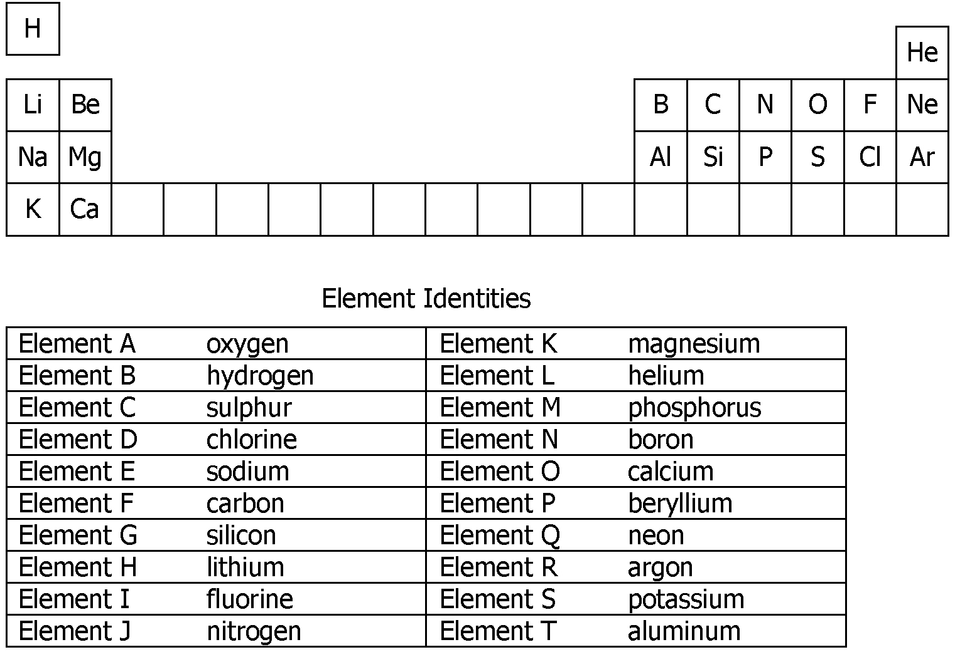

Find Someone Who…

• Chromosomes are the structures in the nucleus that you can see; genes are much smaller.  • Chromosomes are made up of genes; genes are made up of DNA.  • Chromosomes carry all the genetic information about the organism; a gene is a specific section of DNA that carries specific information to produce a specific trait. | • A mutagen is a substance or factor that can cause a mutation; a mutation is a change in the genetic material (either the amount or the order) in a chromosome or gene. | • Prophase, metaphase, anaphase, telophase
• Binary fission  • Budding  • Fragmentation  • Spores | • Diploid cells contain the total amount of genetic information for the organism; haploid cells contain only half the amount of genetic information.  • Only egg and sperm cells are haploid; all the rest of the organism’s cells are diploid. | • Adult  • Egg  • Larva  • Pupa

• Adult  • Egg  • Nymph | • In sexual reproduction there are two parent cells (egg and sperm); in asexual reproduction there is only one parent involved.  • Sexual reproduction produces greater variation in the offspring than does asexual reproduction. | • Meiosis only occurs in sex cells whereas mitosis occurs in any body cell.  • Meiosis results in cells that have half the genetic material of the parent cell; mitosis produces cells that have the same amount of genetic materials as the parent.  • Meiosis result in the formation of 4 haploid cells; mitosis results in the formation of 2 diploid cells.

A Science Write Around
Answers will vary depending on each student’s background knowledge. Encourage students to write as much as is comfortable without worrying about spelling and grammar. This activity is intended to activate prior knowledge and should not be formally assessed.

Meiosis — Important Points of Note
Answers will vary but should reflect the information contained on pages 176 and 177 of the student text. Students should include information on the following 9 events of meiosis: Prophase I, Metaphase I, Anaphase I, Telophase I, Interkinesis, Prophase II, Metaphase II, Anaphase II, Telophase II).

Scientific Symbols Game
The connection of the alternative symbols must follow the same principles as would the accepted symbols. Principles to be followed include:
• A voltmeter must be connected in parallel across a circuit element, where as an ammeter must be connected in series.
• A battery is a combination of cells.
• Conducting wires must allow for a path of electrical current to flow from the negative terminal and back to the positive terminal of the source.
• Every circuit must contain a source of electrical energy; that is, a cell or battery.
• Every circuit must contain an electrical load; that is, a bulb and/or resistor.

What Does that Word Mean?
1. potential
Electrical meaning: Potential difference is the amount of electric potential energy per one coulomb of charge at one point in a circuit compared to the potential energy per one coulomb of charge at another point in the circuit.
Alternative meaning: Possible answer: Potential means capable of being or becoming.
Sentence: An icy sidewalk is a potential danger.
Similarity: There is little similarity as these definitions are given. However, in electricity, potential energy/potential difference can possibly be used to do work or be converted into other forms of energy.

2. current
Electrical meaning: Current electricity is the continuous flow of charge in a complete circuit.
Alternative meaning: Possible answer: Current means something that flows.
Sentence: The river’s current can help move objects downstream.
Similarity: Both definitions refer to flow or motion.

3. resistance
Electrical meaning: The property of any material that slows down the flow of electrons and converts electrical energy into other forms of energy
Alternative meaning: Possible answer: Resistance is the opposition offered by one thing to another.
Sentence: When he went for a walk, the wind offered a lot of resistance to his motion.
Similarity: Both definitions focus on opposition.

4. parallel
Electrical meaning: A parallel circuit is an electrical circuit that has more than one path.
Alternative meaning: Possible answer: Parallel means extending in the same direction and never converging or diverging.
Sentence: Dragsters run along parallel drag strips.
Similarity: Both reference more than one path.

5. cell
Electrical meaning: An electrochemical cell is a device that converts chemical energy into electrical energy.
Alternative meaning: Possible answer: A cell is a small group forming part of a whole.
Sentence: In science class we looked at a skin cell using the microscope.
Similarity: There is little similarity as these definitions are given. However, a similarity exists when an electrochemical cell is considered a small part of a battery.

6. load
Electrical meaning: An electric load is any device that transforms electrical energy into other forms of energy.
Alternative meaning: Possible answer: A load is freight or cargo.
Sentence: The truck carried a load of vegetables.
Similarity: There is little similarity between these definitions as given unless an electrical load is viewed as the part of the circuit using energy similar to energy being needed to transport cargo.

7. ground
Electrical meaning: Ground refers to connecting a conductor so that electric charge flows into Earth’s surface.
Alternative meaning: Possible answer: Ground is the solid surface of Earth.
Sentence: Leaves fall to the ground in autumn.
Similarity: Both definitions refer to Earth.

Dominoes: Electricity

Question | Answer
Which term describes electric charge that can be held in one place? | Static electricity
What type of charge does an object with more protons than electrons possess? | Positive
Object A is attracted to a neutral object. What do we know about the type of charge on object A? | Positive or negative
What is the unit of electric charge called? | Coulomb

Object A is attracted to a positively charged object. What do we know about the type of charge on object A? | Neutral or negative
What device is used to protect against the dangers of static electricity? | Lightning rod
Which term describes the amount of electric potential energy per one coulomb of charge? | Potential difference
What is the SI unit for potential difference? | Volt
What is the SI unit for electrical current? | Ampere
What term is used to describe the property of any material that slows down the flow of electrons? | Resistance
Which term describes a device that can turn a circuit on or off by closing or opening the circuit? | Switch
As the temperature of a piece of wire increases, how does its resistance change? | Increases
An aluminum wire identical in size to a copper wire has a greater resistance. Which factor affecting the resistance of a wire accounts for this? | Nature of material
Electrical resistance is the ratio of the voltage to the current. What term is used to describe this statement? | Ohm’s law
When one bulb in a string of lights burns out, none of the other bulbs lights. How must these bulbs be connected? | Series
As the resistance of a circuit increases, how does the current in the circuit change? | Decreases
A battery consists of three cells, each 1.5 V. If the effective voltage of the battery is 1.5 V, how are the cells connected? | Parallel
What term is used to describe a device that transforms electrical energy into other forms of energy? | Load
What unit is used to measure energy? | Joule

What unit is used to measure power? | Watt
What term is used to describe the rate of change in energy? | Power
What device is used to measure the flow of current in a circuit? | Ammeter
What is an example of a protective device used in an electric circuit? | Fuse
What tells you how much energy an appliance uses in a typical year of use? | EnerGuide label
Which device can be used to measure the potential drop across a resistor? | Voltmeter
Along with a coil of wire, what else can be found in an electrical generator? | Magnets
What is an example of an alternative source of electrical energy? | Fuel cell
Which electrical device is used to change voltage? | Transformer
Which type of generating station burns fossil fuels? | Thermal
What term is used to describe the percentage of energy converted into a useful form? | Efficiency

The ABCs of Space
Answers will vary depending on background knowledge. You might ask students to clarify why they feel certain words or phrases are related to space.

Memory Board
Answers will vary depending on the content and terms presented. Accept point-form responses, examples, and sketches as long as they align with the definition. Students should be encouraged to write in their own words.

Why It’s Important
Answers will vary and be related to students’ familiarity with the topic. You might ask students to clarify why they think a point is important.

Active Reading — Active Learning
Answers will vary.

