Goal • Use this activity to build your understanding of the factors affecting a liquid’s resistance to flow.
What to Do
1. Meet in the home group your teacher has assigned. Take note of the number from
1 to 6 which your teacher gives you.

2. Form an expert group with all other students in the room who have been assigned the same number as you. Each group will be given, to research, a factor affecting a liquid’s resistance to flow.

3. In your expert groups, study the assigned factor and complete the instructions provided on the handout.

4. Once the members of your expert group have a thorough understanding of the assigned topic, return to your home group and report what you have learned.

Expert Group # _______________________
Topic: Temperature

Read pages 286 and 287 of Discovering Science 8. Complete the following to report to your home group.

1. What is kinetic energy?
________________________________________________________________________
________________________________________________________________________
________________________________________________________________________

2. How are temperature and average kinetic energy related?
________________________________________________________________________
________________________________________________________________________
________________________________________________________________________

3. When heat is added to a liquid, how is the ability of the particles to slide past one another affected?
________________________________________________________________________
________________________________________________________________________
________________________________________________________________________

4. Draw a model to help illustrate the response to #3. You can use the back of this sheet.

5. How is a liquid’s viscosity affected by temperature?
________________________________________________________________________
________________________________________________________________________
________________________________________________________________________

6. List as many examples of this relationship as you can.
________________________________________________________________________
________________________________________________________________________
________________________________________________________________________

Expert Group # _______________________
Topic: Concentration

Read the section Concentration and Viscosity on page 288 of Discovering Science 8. Complete the following to report to your home group.

1. What is concentration?
________________________________________________________________________
________________________________________________________________________

2. The diagram below models cornstarch particles dissolved in a given volume of water. Draw models showing an increase in concentration and a decrease in concentration.

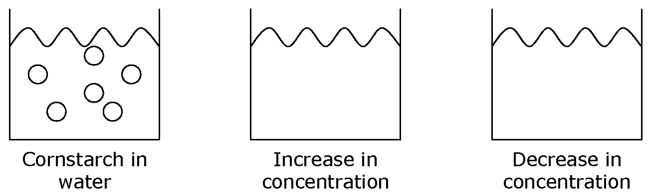

3. How is a substance’s viscosity affected by concentration?
________________________________________________________________________
________________________________________________________________________

4. List as many examples of this relationship as you can.
________________________________________________________________________
________________________________________________________________________
________________________________________________________________________
________________________________________________________________________
________________________________________________________________________
________________________________________________________________________
________________________________________________________________________
________________________________________________________________________
________________________________________________________________________

Expert Group # _______________________
Topic: Strength of Attraction between Particles

Read the sections Attractive Forces and Viscosity on page 288 of Discovering Science 8. Complete the following to report to your home group.

1. Does the strength of attraction between particles within one substance have to be the same as for another substance? Explain.
________________________________________________________________________
________________________________________________________________________
________________________________________________________________________

2. If the attractive forces between the particles of a liquid are strong, how easily can the particles slide past one another?
________________________________________________________________________
________________________________________________________________________

3. Draw a model to help illustrate the response to #2. You can use the back of this sheet.

4. How is a substance’s viscosity affected by attractive forces?
________________________________________________________________________
________________________________________________________________________
________________________________________________________________________

5. After a rainfall, water droplets can normally be seen on a window pane.
a) What forces cause the water particles to form a droplet? Are these forces strong or weak?
_____________________________________________________________________
_____________________________________________________________________
_____________________________________________________________________

b) What forces cause the water droplets to “stick” to the middle of the window pane? Are these forces strong or weak?
_____________________________________________________________________
_____________________________________________________________________
_____________________________________________________________________

