Science Jeopardy
Answers will vary but should be aligned with the topic being studied. Ensure student responses are correct before students quiz each other.

Core Lab Think-Write-Pair-Share
This is a sample answer for Core Lab 1-2B. Answers for other labs should follow this format and include a similar level of detail and clarity.

1. To find out how the amount of salt in water change its density

2. Will vary but should include the main steps as outlined in the textbook. This should not be a complete repetition of what is in the text, merely a quick summary of the main things students did.

3. Manipulated: the amount of salt in the water
Responding: whether the water sinks or not
Controlled: using the same tap water in each test; using the same number of drops from the medicine dropper; making sure the water samples were the same in each test (e.g., rinsing the beaker and dropper to avoid contamination with previous water sample)

4. The more salt in the water sample, the more it would sink in tap water or in less salty water.

5. Water that has salt dissolved in it (salty water) is denser than tap water (salt water is denser than
fresh water).

6. Answers will vary but should relate to the different densities of salt and fresh water. The response might include reference to the different buoyant properties of salt and fresh water.

Give One, Get One
Questions and answers will vary. Circulate as students work to check that their responses to the questions they posed are accurate.

Boxing Science Ideas
Answers will vary depending on the topic and level of student knowledge. Using the Water Cycle as an example, potential answers from an average student might include the following:

What I know might include statements such as the following, in point form in the outer section of the graphic:
- Water moves from Earth to atmosphere back to Earth.
- Water evaporates from land and water.
- Water vapour condenses in atmosphere and falls back to Earth as rain, snow, and so on.
- Water runs from land into rivers, lakes, and oceans.
- Water is in constant movement from liquid/ice on land to gas in atmosphere and back to land.
- Water is stored in snow and ice.
- All the water on Earth is called the hydrosphere.
- Energy from the Sun drives the water cycle.
- It is a cycle because water starts at one place and moves to other places and back again to where it started.

What it means might be summed up as:
This means that all the water we have on Earth is all we will ever have.
New water is not created.
Water is recycled.
If we pollute our water supplies we will run out of usable water.

The sketch should show the main parts of the water cycle (the Sun, water sources on and in Earth, clouds, precipitation); and include arrows to show the cyclical nature.

Dominoes: Optics

Question | Answer
Who believed light consisted of beams? | Pythagoras
What is the name for the form of energy that  can be detected by the human eye? | Light
What is the speed of light? | 3 x 10⁸ m/s
During a thunder and lightning storm, which property of light and of sound causes us to see lightning before hearing the thunder? | Speed
Which property of light explains why shadows form? | Rectilinear propagation
Which term describes the separation of light into  its constituent colours? | Dispersion
When a stick is placed in water, it appears bent. Which property of light explains this observation? | Refraction
A frosted window is an example of which type  of material? | Translucent
What is the name for a material which prevents  any light from passing through it? | Opaque
Which colour of light refracts the least? | Red
Which colour of light refracts the most? | Violet
What term is used to describe the number of repetitive motions of a wave in a given time? | Frequency
What term describes the distance from one trough on a wave to another trough? | Wavelength
What term completes the statement “Shorter wavelength colours refract the ___________.”? | Most
As the frequency of waves increases, how does  their wavelength change? | Decreases
Which type of electromagnetic wave has the  longest wavelength? | Radio waves

Sun tanning salons make use of which type of electromagnetic radiation? | Ultraviolet radiation
Which type of electromagnetic radiation is commonly used to detect a broken bone? | X ray
What term completes the statement “_____________ energy electromagnetic radiation is most harmful to humans.”? | Higher
What is the name for a line drawn perpendicular  to a reflective surface? | Normal
In order for a clear image of a person looking into a pond to form, what type of reflection must occur? | Specular
What term completes the statement “In a plane mirror, the image distance is ____________ the object distance.”? | Equal to
What term completes the statement “If the angle  of incidence increases for a light ray, the angle of reflection will __________________.”? | Increase
What type of mirror is the inside of a metal spoon most like? | Concave
What type of mirror is used as a safety mirror on the front of a school bus? | Convex
What type of image is always formed in  plane mirrors? | Virtual
What is the point called where converging reflected light rays meet? | Focal point
What type of image forms in front of a mirror? | Real
An image formed in a convex lens is upside down compared to the object. Which image characteristic does this demonstrate? | Orientation
What term completes the statement “When light rays travel from air into a lens, they bend _________________ the normal.”? | Toward

Squaring Off

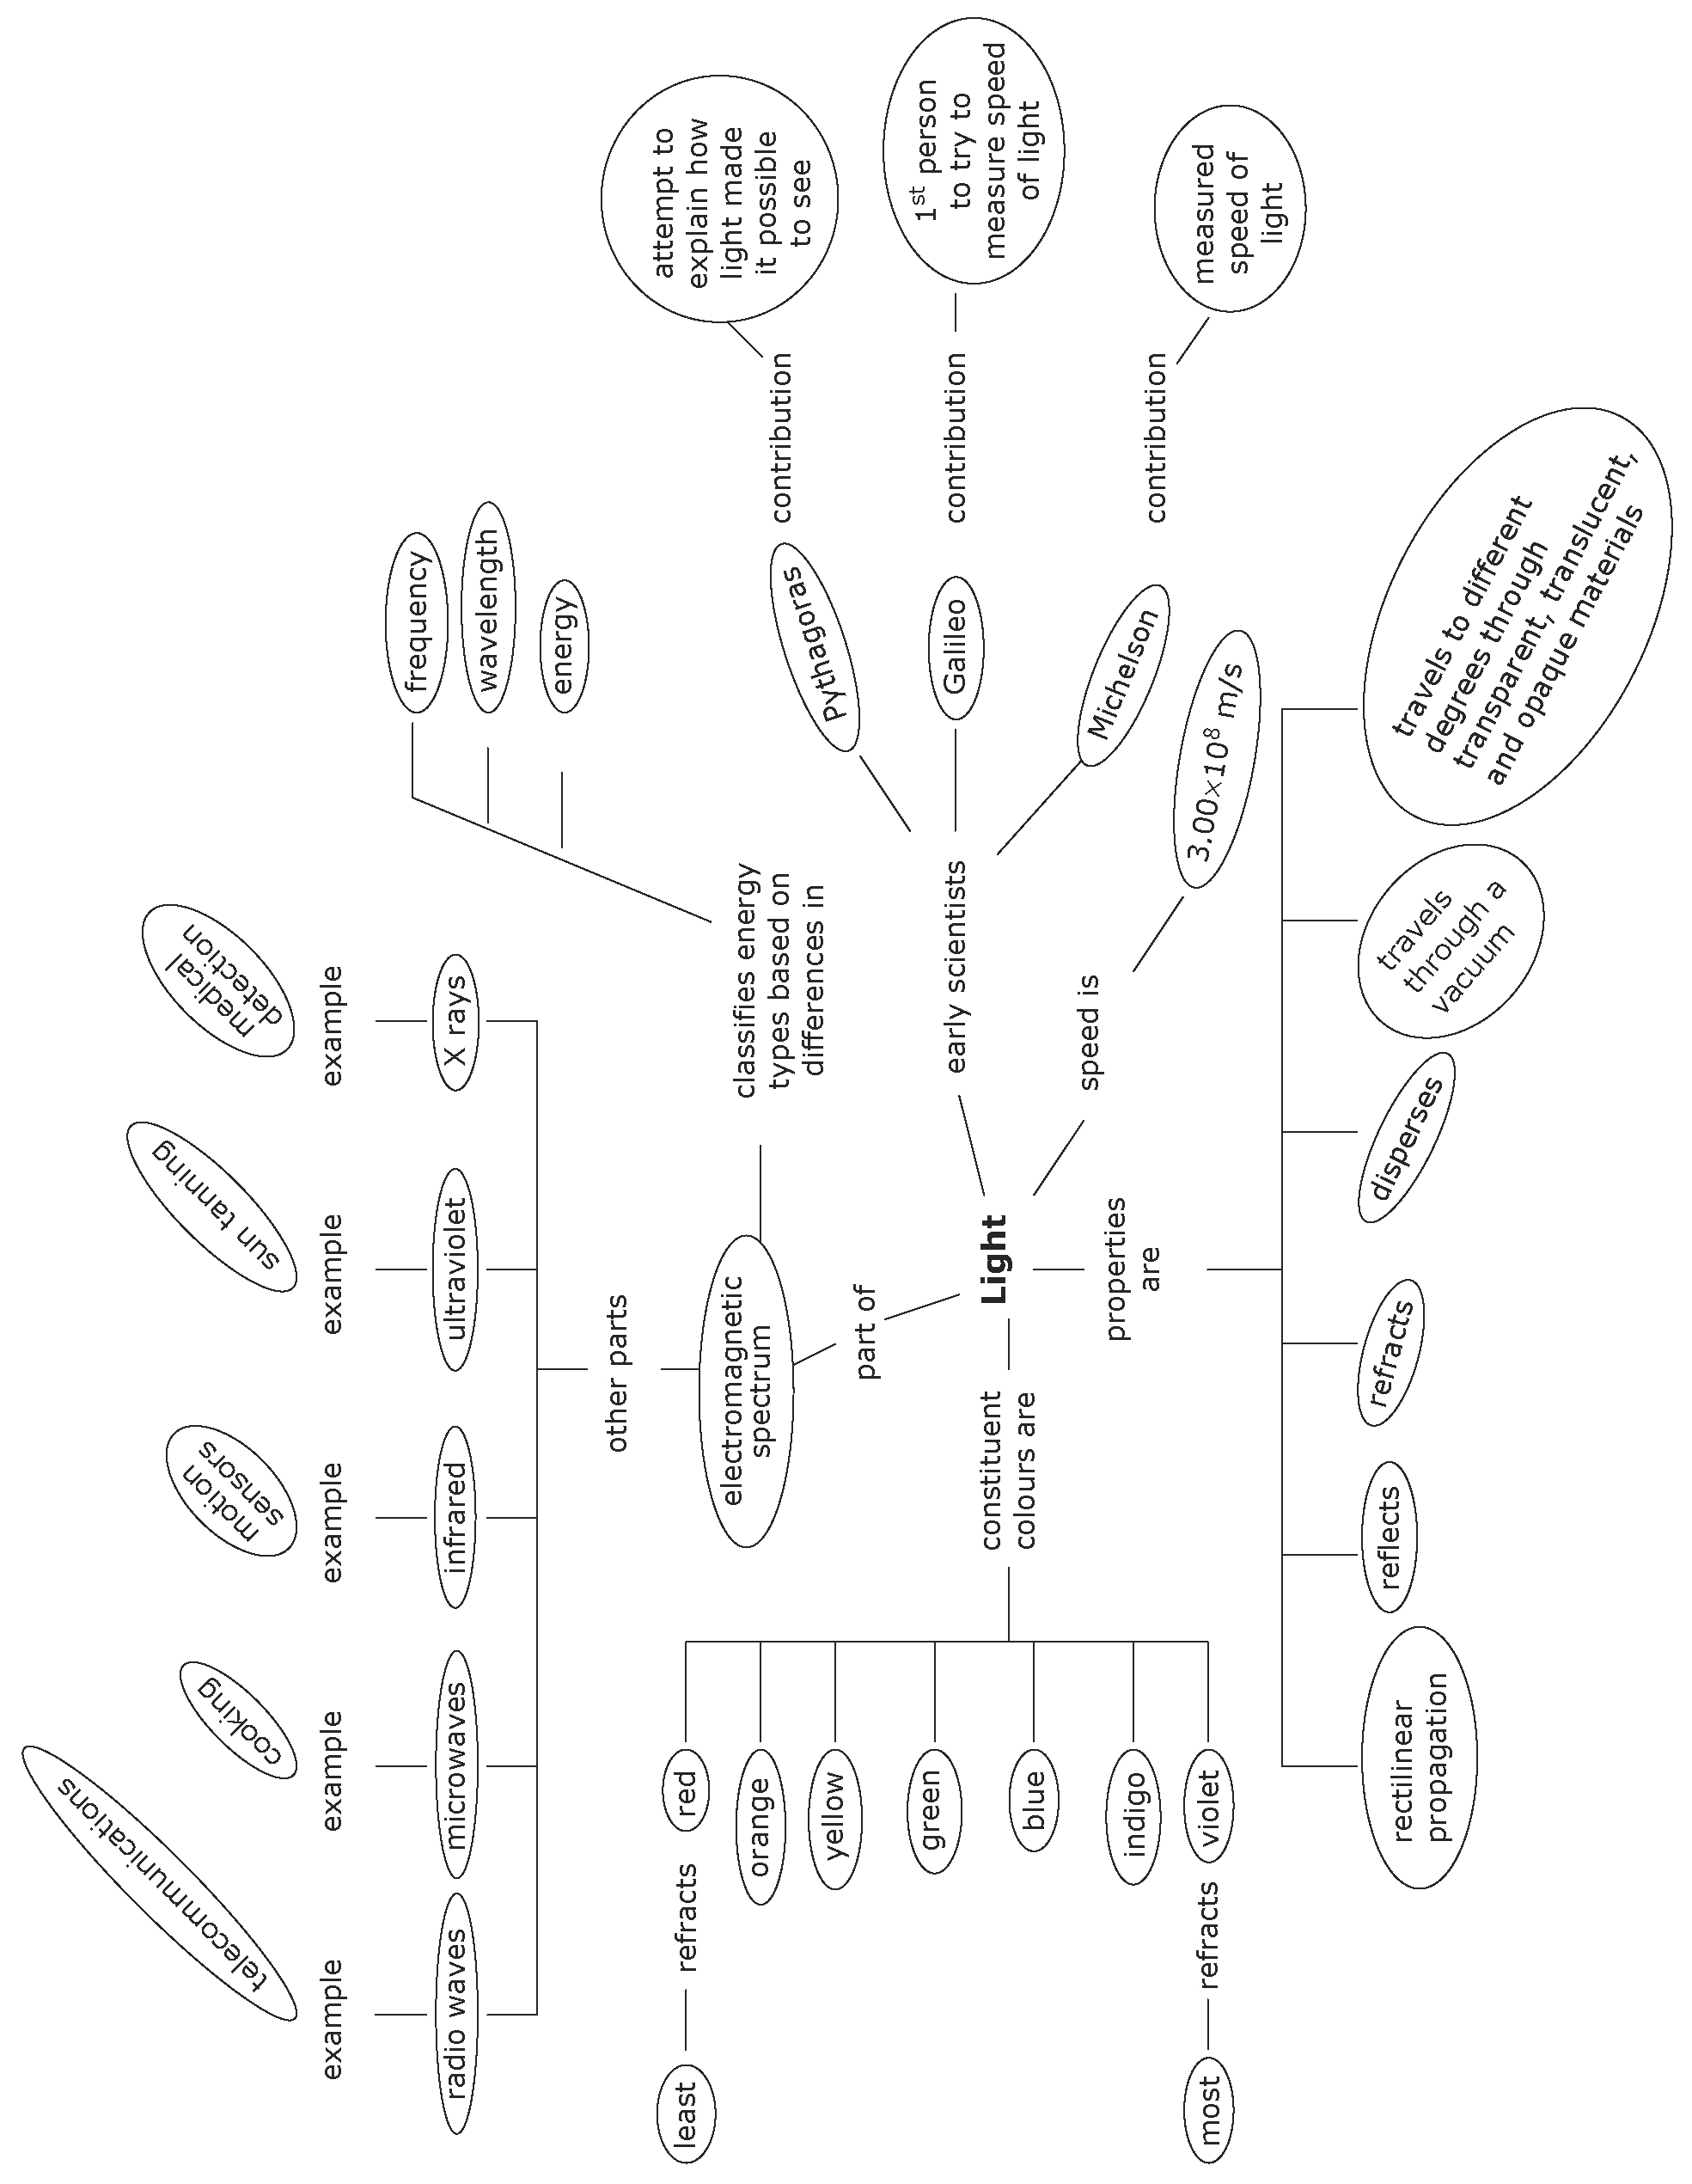

Factors Affecting a Liquid’s Resistance to Flow

Temperature
1. Kinetic energy is the energy of motion.
2. As the average kinetic energy of particles increases, so does the temperature.
3. When heat is added to a liquid, the particles have more energy, and can pull away from neighbouring particles. As they pull away, the particles can slide past one another more easily.
4. Diagrams may include representations of particles moving about more rapidly as heat is added. This increased motion allows the particles to move past one another more easily.
5. A liquid’s viscosity decreases as the liquid is heated, and increases as the fluid cools.
6. Answers may include motor oil, molasses, and honey. All have an easily observable change in viscosity
with a change in temperature.

Concentration
1. Concentration is the amount of a substance dissolved in a specific volume.
2. Diagram for increase in concentration should show more than 6 cornstarch particles in the same volume
of water. Diagram for decrease in concentration should show fewer than 6 cornstarch particles in the
same volume of water.
3. As the concentration of a substance increases, its viscosity increases.
4. Answers may include pancake batter, ketchup, and canned soups. All show an easily observable change
in viscosity with a change in concentration.

Strength of Attraction between Particles
1. No. The strength of the attraction can be very strong for some substances but weak for others.
2. If the attractive forces between the particles of a liquid are strong, the particles do not slide easily
past one another.
3. Answers will vary. Diagrams may include representations of particles not easily sliding past one another since attractions are strong; compared to particles easily sliding past one another since attractions
are weak.
4. If the attractive forces are strong, the substance will have a high viscosity.
5. a) The attractive forces between water particles cause them to form a droplet. These forces are strong.
b) The attractive forces between water particles and the window pane cause the droplets to “stick” to
the pane. These forces are weaker than those holding the water droplets together.

Dominoes: Cells, Tissues, Organs, and Systems

Question | Response
What are the four characteristics of living things? | Growth, response to stimuli, reproduction, and movement (locomotion)
What is a cell? | The smallest, most basic functional system of any living thing
What is the cell theory? | All living things are made up of cells and all cells come from other living cells.
What is the function of the stage in a compound light microscope? | To support the slide

What is the function of the coarse adjustment knob on the compound light microscope? | To bring an object into focus at low or medium power
What is the function of the objective lenses in a compound light microscope? | To magnify the image of the specimen
What is the role of the nucleus? | It contains the genetic material that controls a cell’s growth, reproduction, and other activities.
What are mitochondria? | Oval structures that produce energy
What is the function of a vacuole? | It provides space to store food, wastes, and other substances.
What is the function of the cell membrane? | It controls the movement of food, wastes, and other substances into and out of a cell.
What is mitosis? | The process of cell division during which the genetic material is duplicated and separated into two identical sets of chromosomes.
To what does the term “system” refer? | A group of individual parts that work together  as a whole
What are tissues? | A group of similar cells
What are organs? | Structures made up of two or more types of tissues that perform a specific function
What is an organ system? | A group of organs that work together to perform  a specific task
What do the cells of an organism and the entire organism have in common? | Both require oxygen, nutrients, and waste removal.
This system enables organs such as the heart to contract and relax. | Muscular system
This system controls breathing and exchanges gases in the lungs and tissues. | Respiratory system
This system removes liquid and gaseous wastes from the body. | Excretory system
What is the function of the nervous system? | Controls and coordinates body activities; senses and responds to changes
Which system transports blood, nutrients, and oxygen, as well as liquid and gaseous wastes? | Circulatory system
This system absorbs nutrients and eliminates  solid wastes. | Digestive system
How is the circulatory system connected to the respiratory system? | Blood picks up carbon dioxide from the cells and delivers it to the lungs. It picks up oxygen in the lungs and brings it to the cells.

How is the circulatory system connected to the digestive system? | Blood picks up nutrients in the small intestine and brings them to the cells of the body.
How does diet affect the circulatory system? | Eating foods that are high in salt can raise blood pressure and put additional strain on the heart.
How is the nervous system connected to the muscular system? | Information is sent from the cells to the brain.  The brain sends information to cells causing them  to take certain actions.
This device helps control the amount of sugar  in your blood when the body’s natural systems malfunction. | Insulin pump
This system can cause your muscles to contract quickly (shiver) when it is cold outside. | Nervous system
This structure is found in plant cells but not  animal cells. | Cell walls
This part of the compound light microscope controls the amount of light reaching the specimen. | Iris diaphragm

Exit Cards
Use these cards for informal assessment for learning, and to promote individual responsibility for learning. Writing the card also offers students the opportunity to synthesize the information presented during the lesson. Cards can be submitted anonymously or with student names included. Responses will vary. While
you may want to provide written feedback to questions/comments, do not use these cards as summative assessment.

Points to Note
Student responses will vary. Quality of the sketches is not important, but the explanation of the sketch should clearly describe the “event.” Point form descriptions are acceptable. If possible, students should use colour in their sketches. Your might ask students to volunteer to describe their important points to the class.

Windows on Science
Provide a list of between 9 and 14 terms from the unit such that students must answer all 9 or can choose 9. Answers will vary depending on the terms you provide. The quality of the sketch is not important as long as students can explain how the sketch helps them remember the term. Where possible, students should use colour in their sketches. Word diagrams or flow charts are also acceptable graphic representations.

