Prerequisite Skills

Algebra
1. Solve for x. If necessary, round answers to one decimal place.
a) 9 = x
b) 3x – 5 = 13
c) 2x² = 16
d) 5x² + 4 = 136
e) 6x³ = 92
f) 7 = πx

2. Rearrange each equation to isolate the indicated variable.
a) y = 3(2x – z), for z
b) b = 3a²c + 2c², for a
c), for f

Converting Measures

Metric |  | Imperial
1 mm |  | 0.03937 in.
1 cm | 10 mm | 0.3937 in.
1 m | 100 cm | 1.0936 yd
1 km | 1000 m | 0.6214 mile

Imperial |  | Metric
1 in. |  | 2.54 cm
1 ft | 12 in. | 0.3048 m
1 yd | 3 ft | 0.9144 m
1 mile | 1760 yd | 1.6093 km

3. Match each measure with its equivalent.
a) 6 mm A 4.494 991 in.²
b) 140 yd B 85 km
c) 52.819 miles C 0.236 22 in.
d) 29 cm² D 128.016 m
4. Convert each measure as indicated.
a) 25 in. in centimetres
b) 19 m in yards
c ) 7 ft² in square metres
d) 4 m in inches
e) 360 yd in metres
f ) 2.3 m² in square feet

5. A piece of wood is 16 ft long. Write the length of the wood in
a) metres
b) inches
c) yards

6. A rectangular field measures 0.6 km
by 0.2 km.
a) What are the dimensions in metres?
b) What is the area of the field in
i) square kilometres?
ii) square metres?
c) How do the areas from part b) compare?
Explain.

Metric |  | Imperial
1 L | 1000 cm³ | 1.76 pt

7. Convert each measure to litres.
a) 5500 cm³
b) 43 cm³
c) 0.06 m³
d) 12 ft³

8. A water tank can hold 450 L of water. What is the tank's capacity in
a) cubic centimetres?
b) cubic metres?

9. A jug has a volume of 3200 cm³. What is the jug's capacity in
a) litres?
b) pints?

10. A cube-shaped container has volume 6.7 L. What is the side length of the container, to the nearest tenth of a centimetre?
Pythagorean Theorem
11. A right-angled triangle has legs that measure 7.9 cm and 3.2 cm. Calculate the length of the hypotenuse.

12. A right-angled triangle has a leg that measures 10.6 mm and a hypotenuse that measures 14.8 mm. Calculate the length of the other leg.

13. Mrs. Quan presented her mathematics class with several triangles.
The side lengths were the following:
Triangle A: 15.3, 20.4, 25.5
Triangle B: 3.1, 4.1, 5.1
Triangle C: 8, 15, 17
Triangle D: 7, 24, 24
Which are right triangles?
Perimeter, Circumference, and Area
14. Determine the perimeter or circumference
of each shape.
a) A rectangle with sides that measure 16 m and 9 m.
b) A right-angled triangle with a base of
8 cm and a height of 5 cm.
c) A square with side lengths that measure 6.2 yd.
d) A circle with a radius of 7.4 in.

15. Determine the area of each figure in
question 14.
Three-Dimensional Figures
16. A box is in the shape of a triangle-based prism.
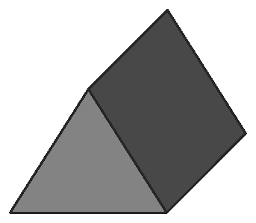

a) Draw the top, front, and side view of
the prism.
b) How many faces does the prism have? Name the faces by shape.
c) Which faces are congruent?

17. A can is in the shape of a cylinder.
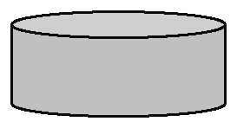

a) Draw the top, front, and side view of
the can.
b) How many faces does the cylinder have? Name the faces by shape.
c) Which faces are congruent?

18. Draw the net of a square-based prism.
a) How many faces does the prism have?
b) Name the faces by shape.
c) If the sides of the prism were congruent to the bases, what object would you have?

19. a) Name this figure.
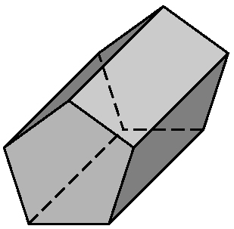
b) Name the faces by shape.
c) Which faces are congruent?

