Section 1.1 Composite Figures

1. Draw lines to divide the composite figures into two or more component shapes.

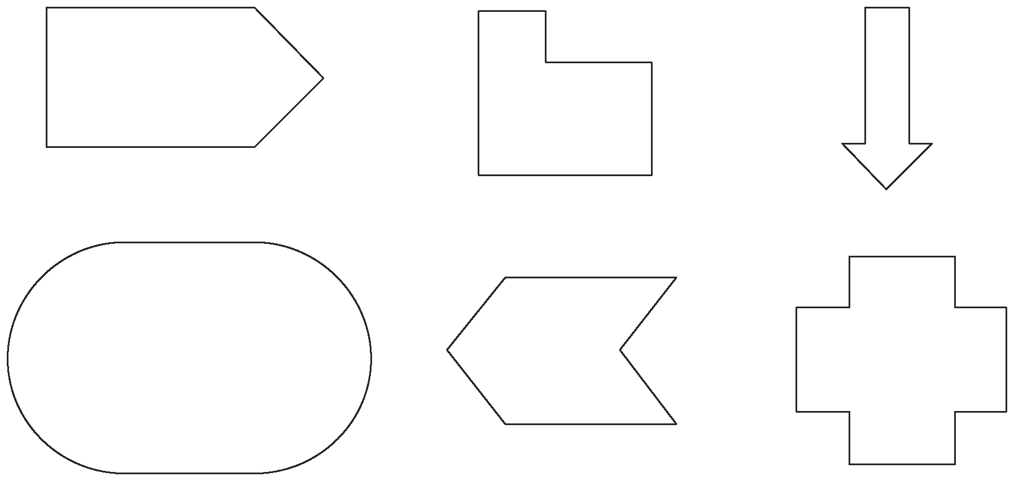

2. Can any composite figures in question 1 be divided into component shapes in more than one way? If yes, show how this can be done.

3. Draw a composite figure consisting of:
a) two simple component shapes
b) three simple component shapes

