Section 1.2 Work With Volume

1. a) Identify the shape of the base for each figure.
b) What measures would you need to know to calculate each base area?

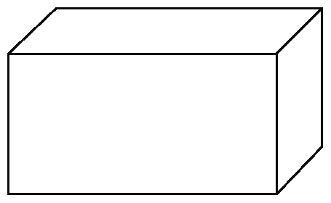
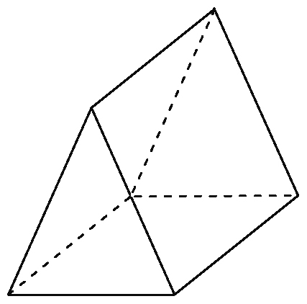
i) ii)

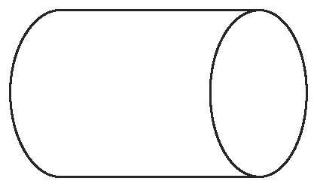
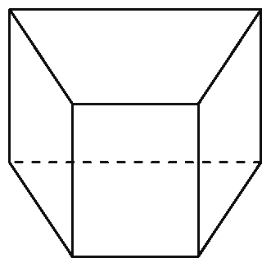
iii) iv)

2. a) Write a formula that would allow you to calculate the volume of each figure in question 1. Identify what each variable represents.

3. a) Draw lines to show how this composite figure could be divided into two or more simple
three-dimensional figures.

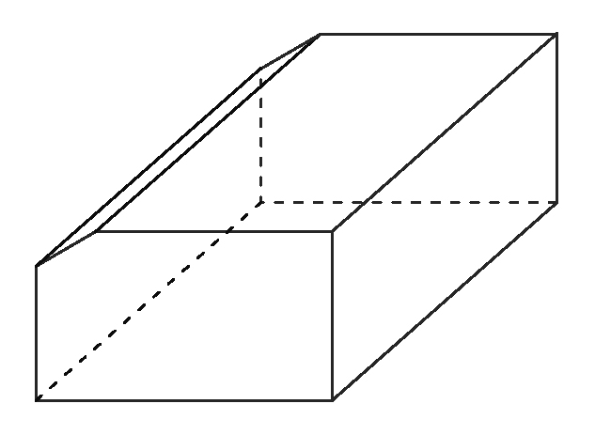

b) Solve part a) using different simple three-dimensional figures.

