Section 1.2 Volume

1. a) Identify the shape of the base of this prism.
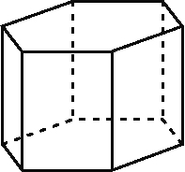

b) The base area of the prism is 30 cm² and its height is 14 cm. Determine the volume of the prism.

2. a) Which units would you use for the volume of this rectangle-based prism? Explain.
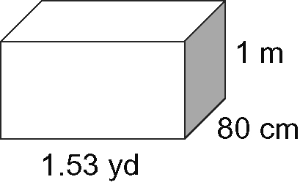
b) Calculate the volume of the prism.

3. A cylinder has a diameter of 9.3 cm and a height of 5.8 cm.
a) Sketch and label a diagram of the cylinder.
b) Determine the volume of the cylinder to
the nearest cubic centimetre.
c) What volume of liquid will this cylinder hold, to two decimal places? Recall
1 L = 1000 cm³.

4. Determine the volume of the mailbox, to the nearest square inch.
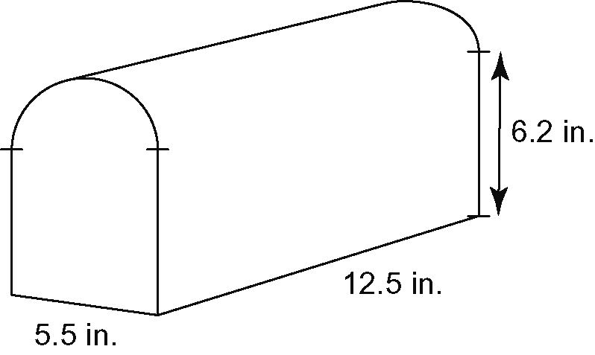
5. The volume of this package is 1490 cm³.
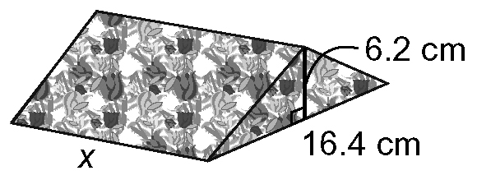
Determine the length of the package.

6. A cylinder has a circumference of 65 cm and
a volume of 1500 cm³. Determine the height of the cylinder to the nearest tenth of
a centimetre.

7. Determine the volume of concrete needed to build this platform, in cubic metres.
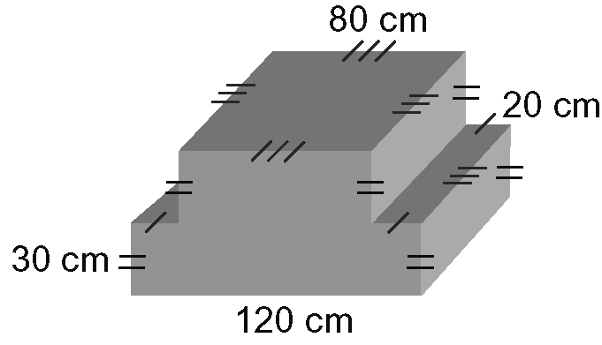

8. A soup can has a diameter of 3 in.
and a height of 4.5 in. A box in the
shape of a square-based prism holds
16 cans, as shown.
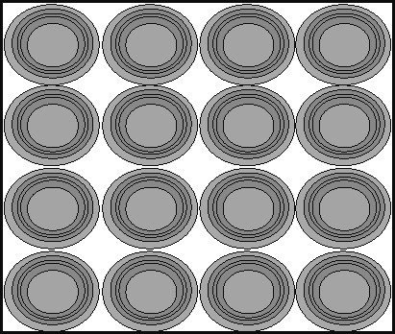

a) What is the minimum volume of this box, to the nearest cubic centimetre?
b) What is the volume of the 16 soup cans, to the nearest cubic centimetre?
c) How much space is left in the box after the soup cans are packed?

