Section 1.3 Surface Area

1. a) Draw a net for this gift box. Label it with the dimensions.
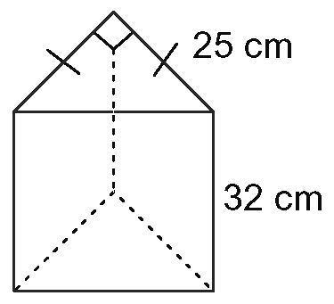
b) Determine the surface area of the box.

2. Refer to question 1. Suppose the lid was removed from the box.
a) Show how this would change the net.
b) Determine the surface area of the new box.

3. Determine the surface area of this box.
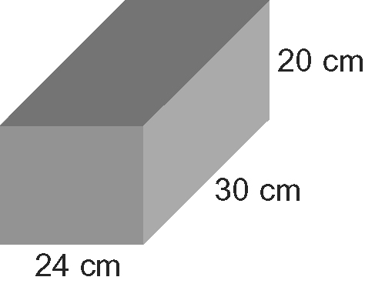

4. A soup can has a height of 4.5 in. and a diameter of 3 in. Determine the surface area of the soup can, to the nearest square inch.

5. A can of hot cider mix has dimensions as shown. Determine the surface area of the can to the nearest square centimetre.
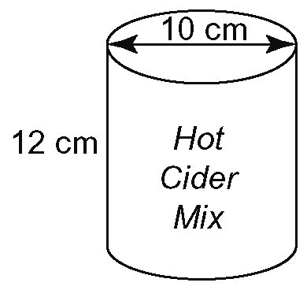
6. Refer to question 5. Calculate the minimum surface area of a box with a lid that could hold six cans, arranged in two rows of three cans.

7. Determine the outer surface area of a cylindrical planter with a radius of 40 cm and a height of 1.5 m, to the nearest hundredth of a square metre.

8. A standard pool ball has a diameter of 2.25 in.
a) Determine the minimum surface area of a square-based prism box that could just hold 16 pool balls, arranged in four rows of four balls as shown.
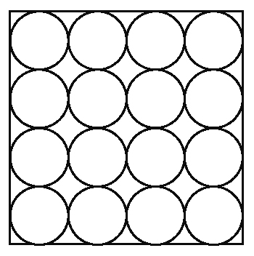
b) Determine the surface area of the new square-based prism box that could just
hold 16 pool balls arranged as shown.
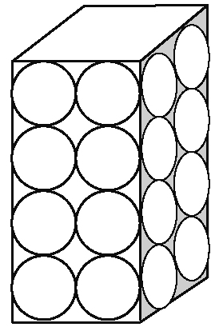
c) Which box requires less packaging?

9. Nadine wants to make a new slipcover for
her sofa.
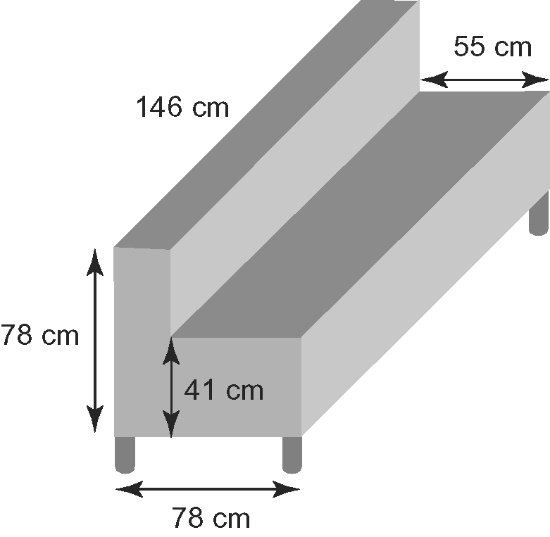
a) Determine the missing dimensions of the sofa. Draw a net of the sofa, excluding the bottom of the sofa and the legs. Label the net with all the dimensions.
b) Use your net to calculate the surface area of the sofa that will be covered by the slipcover. Explain the steps in your solution.
c) Fabric costs $7.99 per square metre. Nadine will need 25% more fabric than the surface area found in part b). Determine the cost of the fabric for the slipcover.

10. Nadine has purchased a matching armchair to go with her sofa. The chair has the same dimensions and style as her sofa but the length of the chair is half the length of the sofa and it is wider by 2 cm. The thickness
of the back of the armchair remains the same. She will make a slipcover for the armchair using the same fabric.
a) How much fabric will she need?
b) How much will the fabric cost?

11. a) Determine the surface area of the mailbox, including the bottom, to the nearest
square inch.
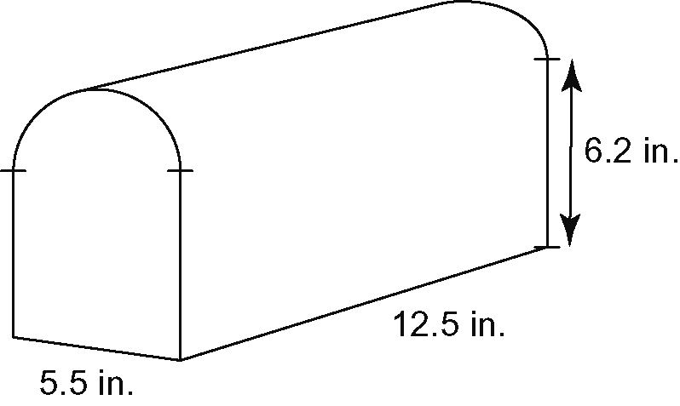
b) A 340 g can of enamel spray paint covers approximately 25 ft². How many mailboxes could be painted with one can of spray paint?

12. How would your answer to question 11,
part b), change if the bottom of the mailbox was not painted?

13. The surface area of the cube is 150 cm².
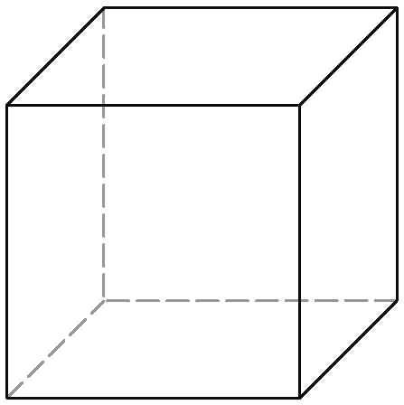
a) The cube is sliced horizontally through
the centre to make two congruent rectangular prisms. What is the surface area of one of the prisms?
b) The cube is sliced diagonally from one corner of the cube to the opposite
corner. The result is two congruent
right-triangular prisms. What is the
surface area of one of the prisms to the nearest square centimetre?

