Section 1.4 Optimize Perimeter and Area

Use this information to answer questions
1 and 2.
These rectangles all have the same perimeter.
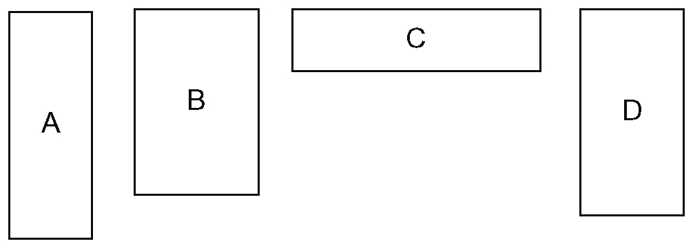

1. Order the rectangles from greatest to
least area.

2. Is it possible to draw a rectangle with the same perimeter but lesser area than these rectangles? Explain using words and
a diagram.

Use this information to answer questions
3 and 4.
These rectangles all have the same area.
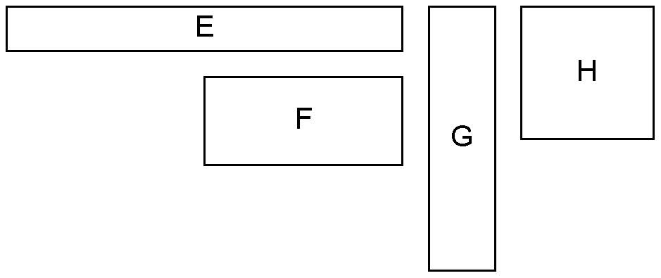

3. Order the rectangles from least to
greatest perimeter.

4. Is it possible to draw a rectangle with the same area that has a greater perimeter than any of the given rectangles? Explain using words and a diagram.
5. Organizers of an outdoor music festival want to enclose a rectangular dining area against a large barn. They have 40 m of rope to use as a fence.
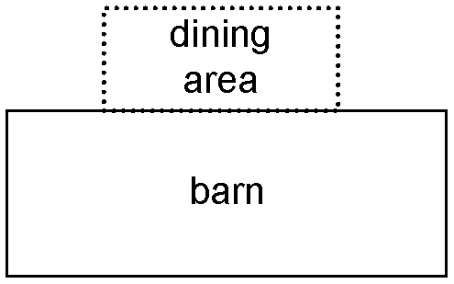
Determine the length and width of a fence that will provide the maximum dining area. Use words and diagrams in your answer.

6. a) Samuel has 30 segments of 1-m fence rails to build a pen for his goats. What
are the dimensions of the pen with the maximum possible grazing area for the goats, assuming the fence rails cannot
be cut?
b) How does your answer change if the fence rails can be cut? How much additional area does this provide?

7. A scout camp is being built on the shore
of a lake. The scouts are digging a narrow, 100-m long drainage ditch to surround the rectangular camp area on three sides.
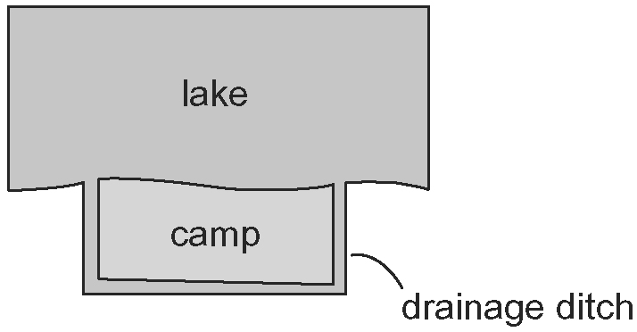
Determine the length and width of a ditch that will provide the maximum area for
the camp.

Use this information to answer questions
8 to 11.
Halima is building a garden in her large backyard. She has 160 ft of fencing with which
to enclose her garden. She also has the option
of using the river or the wall (or both) instead
of fencing.
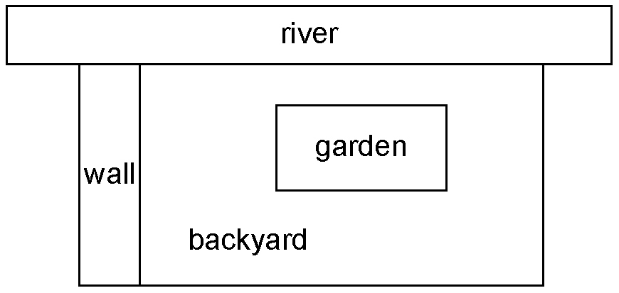

8. Halima decides to build the garden somewhere in the middle of the backyard, as shown above. What are the dimensions of the rectangular garden with maximum area? What is the maximum area in this case?

9. Halima decides to build the garden against either the river or the wall. What are the dimensions of the rectangular garden with maximum area? What is the maximum area in this case?

10. Halima decides to build the garden against both the river and the wall. What are the dimensions of the rectangular garden with maximum area? What is the maximum area in this case?
11. a) Order the three gardens from questions
8 to 10 from greatest to least area.
b) Which garden design do you think Halima should choose? Why?
12. Tyrone is a furniture designer. He is designing a rectangular desk that must have an area of 7200 cm² and a minimum perimeter. What are the dimensions of
the desk?
13. A marine biologist wants to use netting to build a rectangular holding pen by the beach to study marine life. The pen must have an area of 90 m².
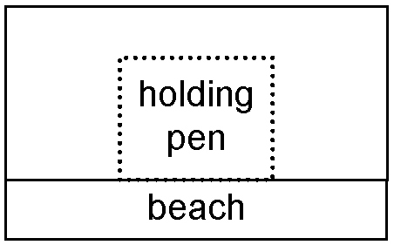
a) Determine the dimensions of the pen that requires the least amount of netting.
b) Determine the total length of netting required to build the pen from part a).

14. Conrad wants to build a 160-ft² deck against his cottage. He is considering these options.
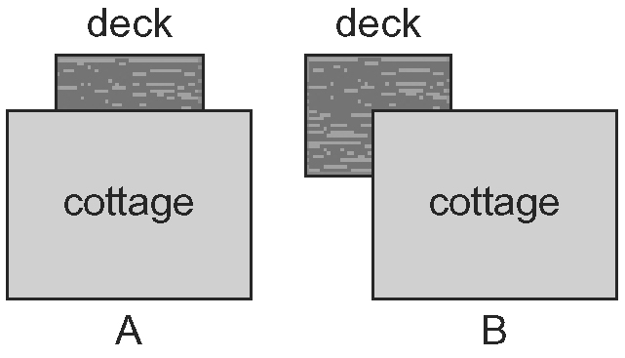
a) Assume Conrad does not have to install railing along the sides of the cottage. Which option minimizes the amount of railing that Conrad needs to enclose his deck?
b) What is the minimum length of railing needed to the nearest foot?
c) What other considerations might Conrad think about when choosing his design?

