Section 1.6 Analyse Optimum Volume and
Surface Area

1. Each box has the same volume.
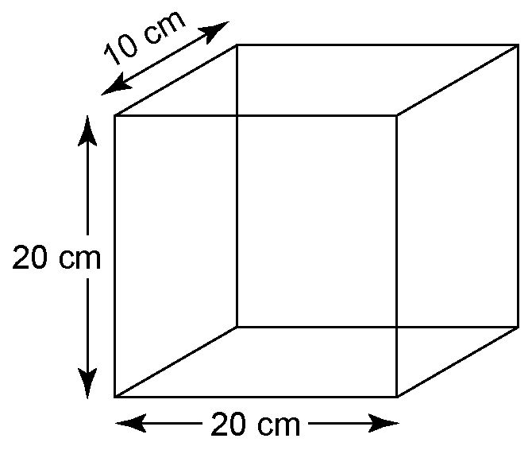
A

B
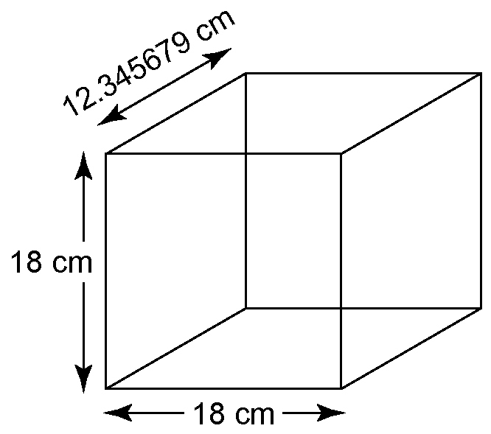

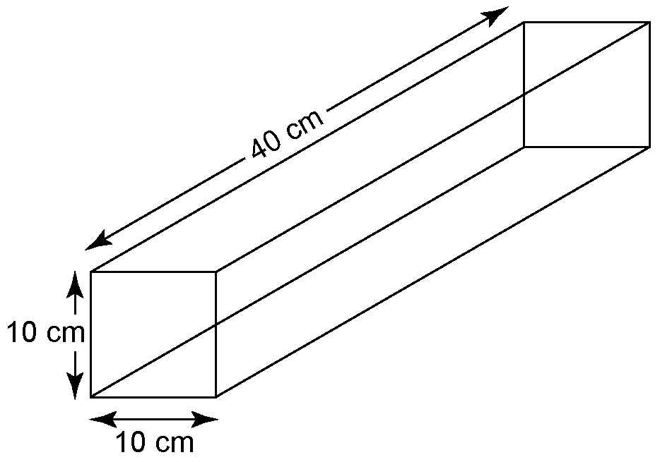
C

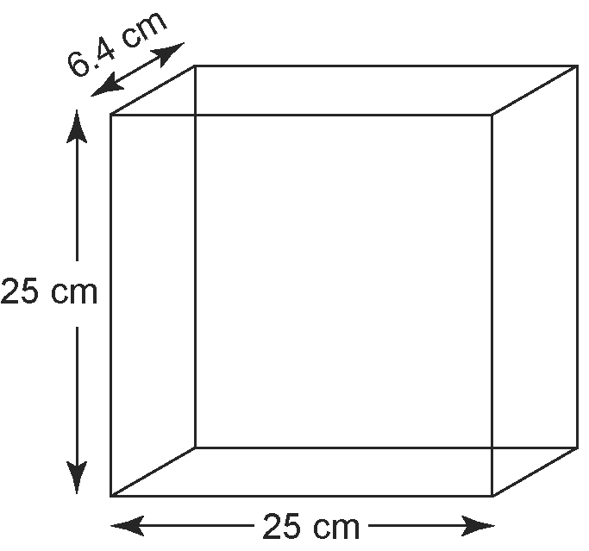
D

Without measuring, order these boxes from maximum to minimum surface area. Include the bottom of the boxes. Explain your reasoning.

2. Each cylindrical container has the same surface area.
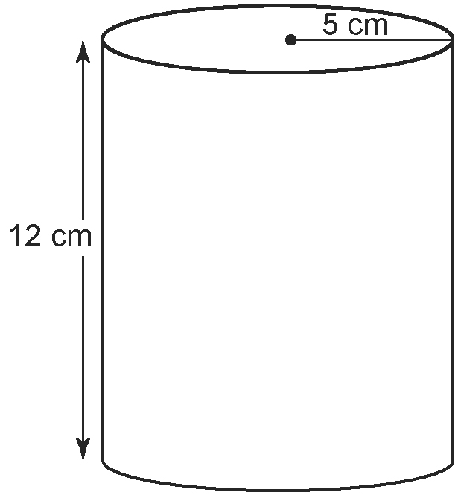
E

F
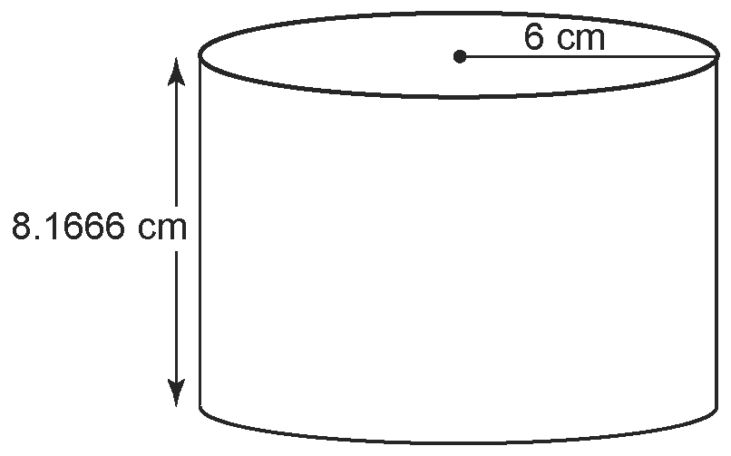

'

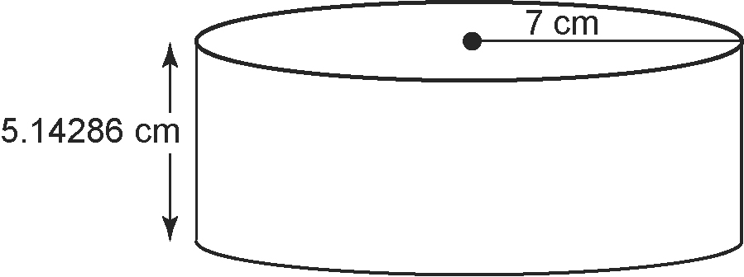
G

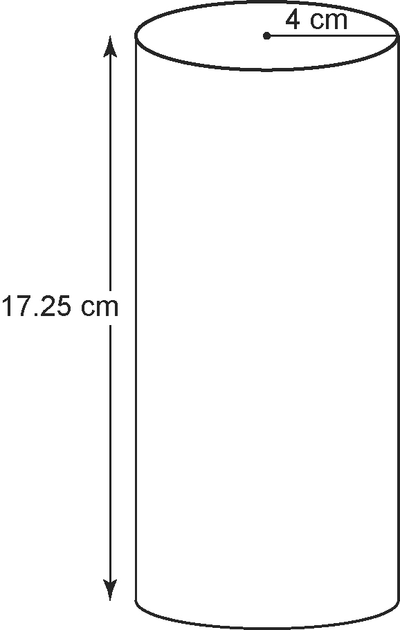
H

Without measuring, order these containers from minimum to maximum volume.
Explain your reasoning.

3. A shed, in the shape of a square-based prism, is to have volume 800 m³. Determine the dimensions of the shed
with the minimum surface area.

4. Refer to question 3. How would your answer change if the minimum surface area did not include the bottom of the shed? Explain.

5. Pyjamas are to be shipped in boxes in the shape of square-based prisms, 40 pairs to a box. The pyjamas can be arranged in different ways, but each pair of pyjamas requires 12 000 cm³ of space.
a) Determine the volume of each
shipping box.
b) What are the dimensions of the box with a minimum surface area?
c) Sketch the box and label its dimensions.

6. Coca's Hot Cocoa mix comes in cans
as shown.
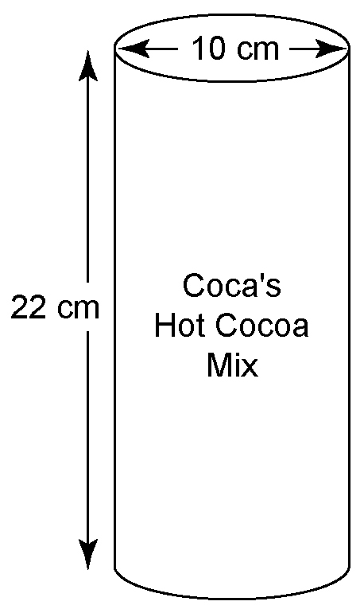

a) Determine the volume of one can.
b) Could Coca save money on packaging materials by altering the design of her can? Explain.
c) Determine the maximum amount Coca can save on materials without reducing the volume of the container. Express your answer as a percent.

7. A soup can is to hold 425 mL of soup. Determine the dimensions of the can with minimum surface area.

8. A cheese maker plans to sell a new type
of cheese in a package in the shape of
an equilateral triangular-based prism.
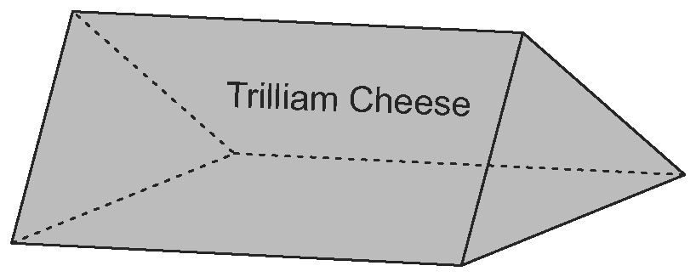
a) Determine the dimensions of a
500-mL package that requires a minimum amount of packaging material.
b) Describe the tools and strategies you used to solve this problem, and any assumptions you made.
Use this information for questions 9 to 11.
Ivan is designing gift boxes but cannot decide which shape to use: a square-based prism, an equilateral triangle-based prism, or a cylinder. He wants the boxes to be 15 cm in height. Each box should use 600 cm³ of material and should have a maximum volume.

9. a) Determine the dimensions for a
square-based prism box that meets Ivan's conditions. What is the volume?
b) Determine the dimensions for an equilateral triangle-based prism
box that meets Ivan's conditions.
What is the volume?
c) Determine the dimensions for a cylindrical box that meets Ivan's conditions. What is the volume?

10. Ivan wonders if he can make a box with a greater volume if he does not use a
fixed height.
a) Determine the dimensions that give a maximum volume for each shape of box given a surface area of 600 cm². What is the volume?
b) How has each shape changed compared to the dimensions you found in question 9?

11. Which shape gives the greatest volume? Give two reasons why Ivan might not choose this shape for his gift boxes.

