Chapter 1 Review

1.1 Area, pages 4–15
1. Determine the area of this patio, to the nearest square foot.
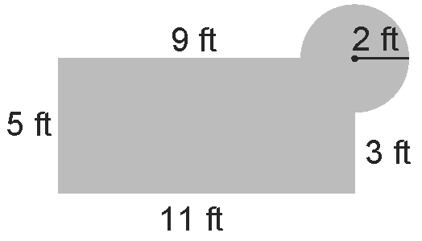

2. Vikram is constructing a sign for his store, Vikram's Jewellery.
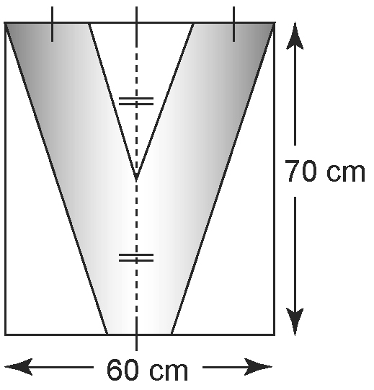

What is the area of the sign, once the white parts are removed?

3. This design is to be painted on a dance club floor. Each colour requires two coats of paint. Each can of paint will cover 40 m².
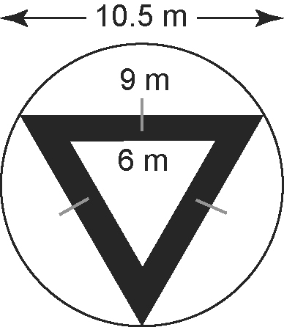
a) How many cans of white paint
are required?
b) How many cans of black paint
are required?
1.2 Volume, pages 18–25
4. A cylindrical container has a volume of
600 cm³ and a height of 9 cm. Determine the radius of the circular base, to the nearest tenth of a centimetre.

5. Determine the volume of concrete needed to build this ramp, to the nearest tenth of a cubic metre.
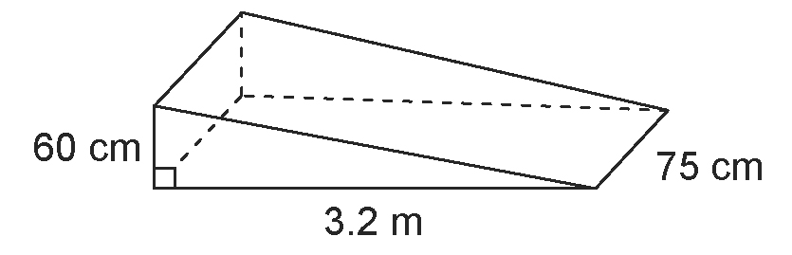

6. A storage container in the shape of a
square-based prism has a volume of 120 ft³. lf the sides of the square base are 4 ft in length, determine the height of the container.

1.3 Surface Area, pages 26–35
7. Refer to question 5. Determine the surface area of the ramp, not including the bottom, to the nearest tenth of a square metre.

8. Jyeed is painting a riser used to display clothes in his store. Each display surface
is a square with sides 2 ft in length. Determine the surface area to be painted, not including the bottom.
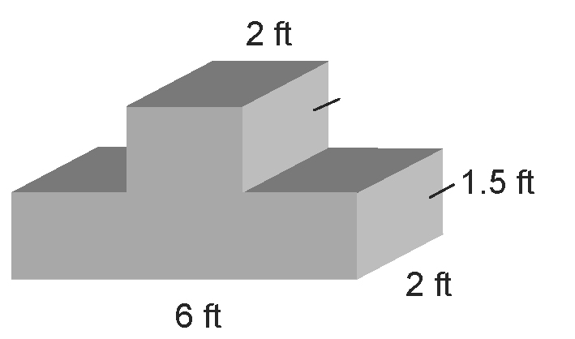

9. A cylindrical box has a height of 14 cm and a diameter of 19 cm. Determine the surface area, to the nearest square centimetre.
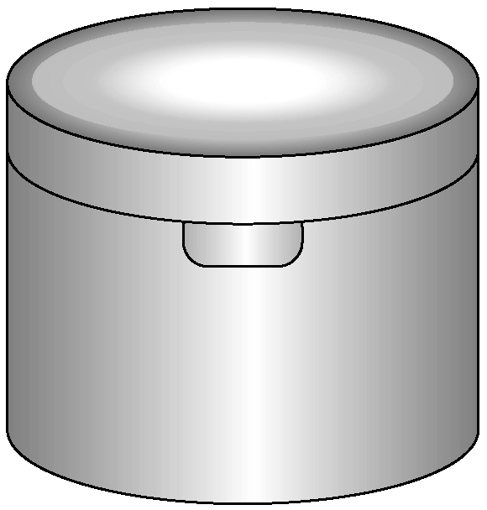

1.4 Optimize Perimeter and Area,
pages 36–45
10. A soccer coach is fencing in a rectangular area of the playing field for ball practice.
a) If she has 24 m of fencing, how should she arrange the fencing to provide the greatest possible practice area?
b) How should she alter her design if she can use part of an existing fence as one
of her boundaries?

Use this information to answer
questions 11 and 12.
Students at a high school want to start a school garden. The principal will allow them to enclose a rectangular area of a field behind the school. The garden cannot be larger than 60 yd².

11. What is the minimum perimeter of fence that can be used to enclose the garden?

12. How would the solution change if the school can be used as one side of the garden? Use words and diagrams to explain your answer.

1.5 Investigate Optimum Volume and
Surface Area, pages 46–53
13. These boxes are in the shape of a
square-based prism. Each box has
the same volume.
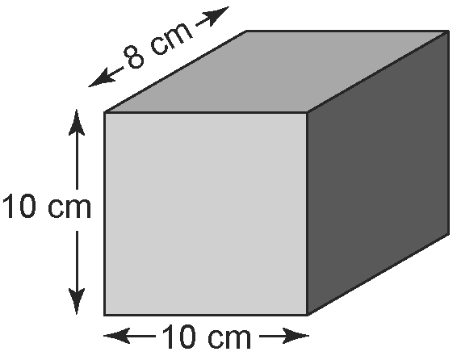
A

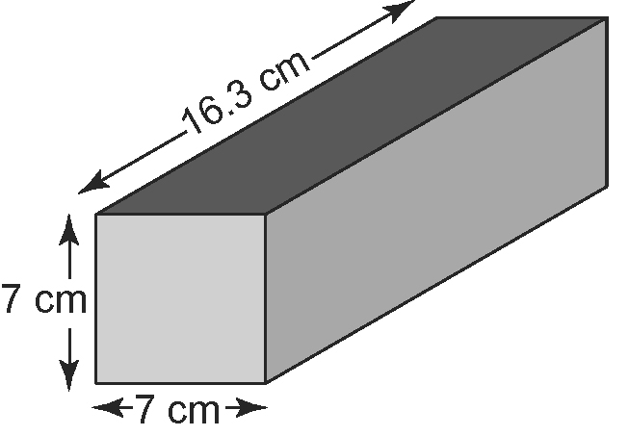
B

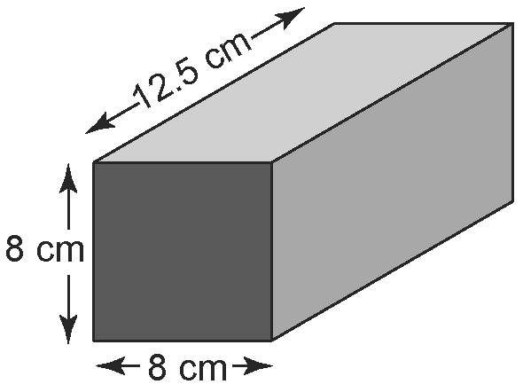
C

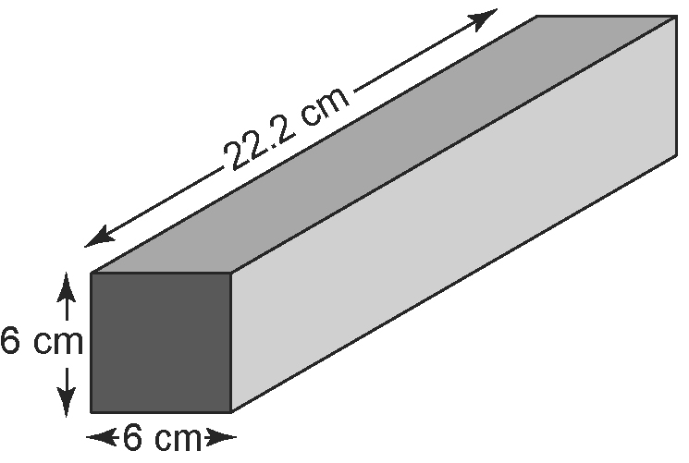
D

Without measuring, order the storage containers from minimum to maximum surface area. Explain your reasoning.
14. Each container has the same surface area.
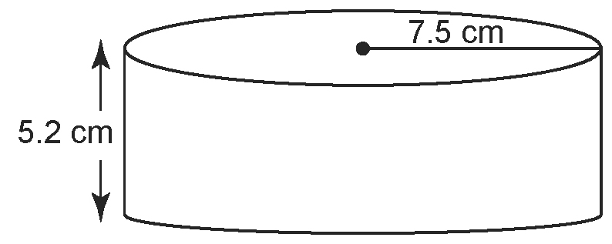
A

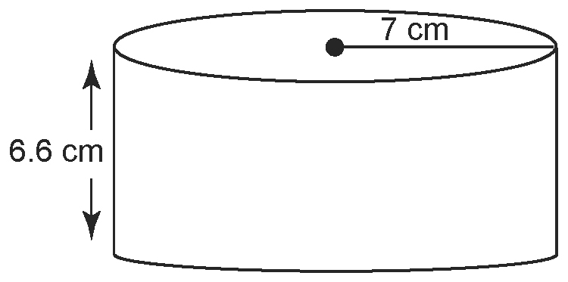
B

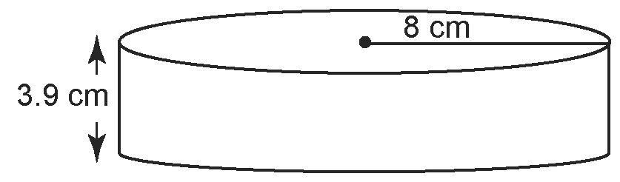
C

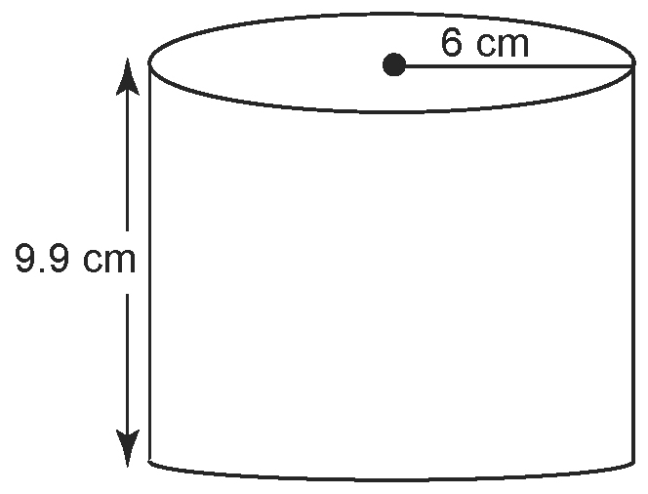
D

Without measuring, order these packages
from maximum to minimum volume. Explain your reasoning.

1.6 Analyse Optimum Volume and
Surface Area, pages 54–63
15. A cylindrical juice container is to have a volume of 2 L or 2000 cm³.
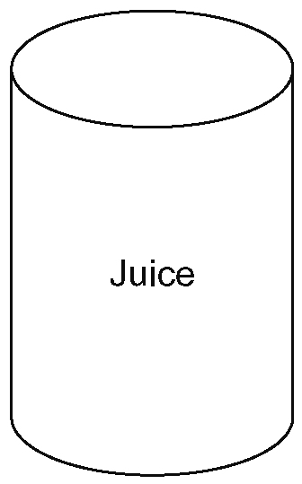
a) Determine the dimensions of the container with minimum surface area. Discuss any assumptions you made.
b) Suggest two reasons why the manufacturer may not choose this design.

16. a) What are the dimensions of a box in the shape of a square-based prism with a surface area of 900 cm² and the
greatest volume?
b) Describe the shape of the box.
c) What is the maximum volume of
this box?

17. Ken is going to build a tree house for his son’s 12th birthday. He has 28 m² of wood with which to build it. He plans to build it in the shape of a square-based prism.
a) What is the maximum volume he can enclose?
b) How much additional volume can be added to the tree house in each case? Round your answer to the nearest tenth
of a cubic metre.
i) Ken leaves the roof open.
ii) Ken leaves the roof and the back wall (facing the tree trunk) open. Include any assumptions that you made.

