Chapter 1 Practice Test

For questions 1 to 5, select the best answer.
1. What is the perimeter of the figure?
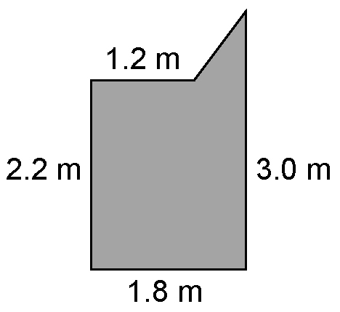
A 3.96 m B 9.2 m
C 8.96 m D 4.2 m

2. What is the volume of the cylinder?
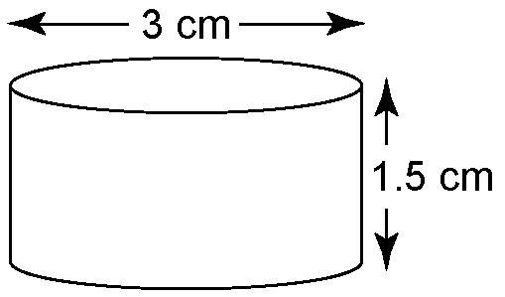
A 21.2 cm³ B 42.4 cm³
C 28.3 cm³ D 10.6 cm³

3. What is the surface area of the cylinder in question 2?
A 15.7 cm² B 28.3 cm²
C 23.6 cm² D 42.4 cm²

4. What is the volume of the triangle-based prism?
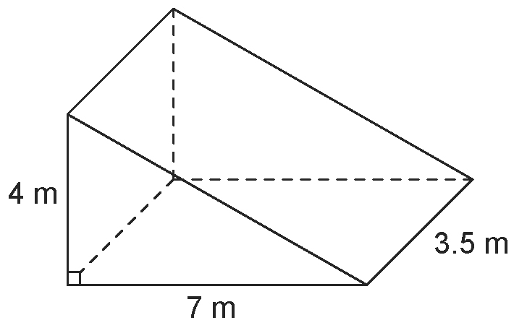
A 49 m³ B 56 m³
C 28 m³ D 98 m³

5. Which statement is true?
A For a rectangle with a given area, the maximum perimeter occurs when the length equals the width.
B For a cylinder with a given surface area, the maximum volume occurs when the height is twice the radius.
C For a square-based prism with a given volume, the maximum surface area occurs when the height is equal to the side length of the base.
D For a cylinder with a given surface area, the maximum volume occurs when the height is equal to the radius.

6. Determine the surface area of this wedge of cheese, to the nearest square centimetre.
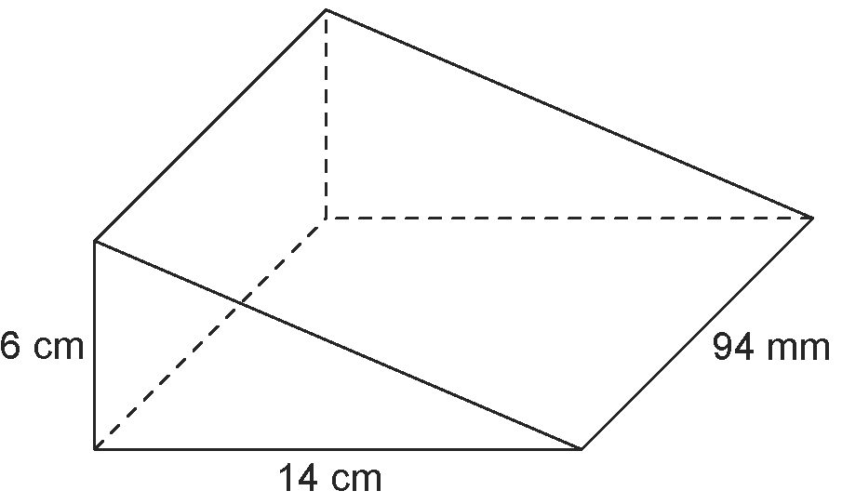

7. A box, used to package cellular telephones, is in the shape of a square-based prism and is to have volume 1400 cm³.
a) Determine the dimensions of the box with minimum surface area.
b) Sketch the box and label its dimensions.
c) Determine the minimum surface area.

8. A cylindrical container has a diameter of
16 cm and a height of 30 cm. Determine the surface area of the can, to one decimal place.

9. Refer to question 8.
a) Determine the volume of the can to one decimal place.
b) For this volume, determine the dimensions of the can with minimum surface area.

10. The hole in this medallion is shaped like a rectangle-based prism with a length of
4.5 cm and a height of 2 cm.
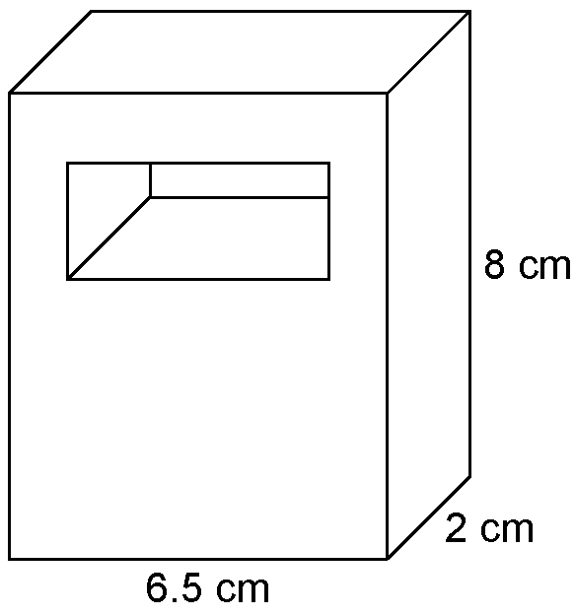
Determine the volume of the medallion. Discuss any assumptions you made.

11. Ling has 11 m of fencing which he can use to surround a small garden.
a) What is the maximum area of the garden, assuming Ling uses fencing for all
four sides?
b) How much additional area can be obtained if Ling uses his house as one side of the garden? Explain.

12. This patio is to be painted with water sealant.
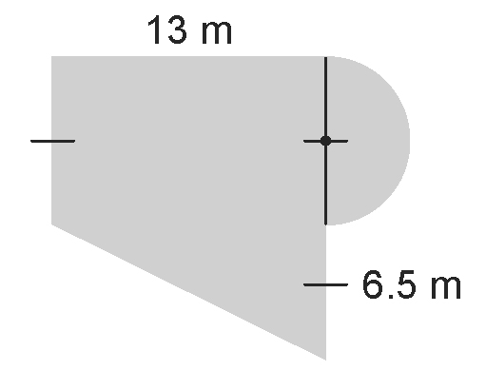
Determine the area to be painted.

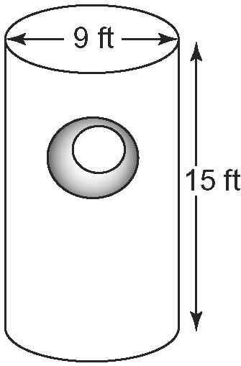
13. This geometric statue is made
out of a solid piece of wood.
The diameter of the hole
is half the diameter
of the statue.

a) What is the volume of the statue to the nearest square foot?
b) What is the volume of the statue to the nearest square metre?
c) The statue is to be painted with two coats of paint not including the bottom face. What is the surface area of the statue that needs to be painted to the nearest square foot?
d) If a 1-L can of paint covers approximately 10 m², how many cans of paint are needed?
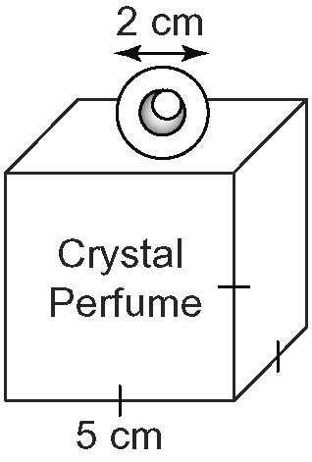
14. The Crystal Perfumery
Company bottles their
products in bottles that
are square-based prisms
with a spherical top.
The top is made of solid
wood. The diameter of the
hole is half the diameter of
the top.
a) What is the volume of wood used to make the top to the nearest tenth of a cubic centimetre? Hint: V_{sphere} = 4πr².
b) Determine the surface area of the bottle and top to the nearest square centimetre.
c) Both the bottle and top are sprayed with a lacquer containing sparkles. One can of spray covers approximately 4 m². How many bottles can be covered by one can of spray, if each bottle receives five coats of spray? List any assumptions that you made.

