Chapter 1 Test

For questions 1 to 5, select the best answer.

1. What is the area of the figure?
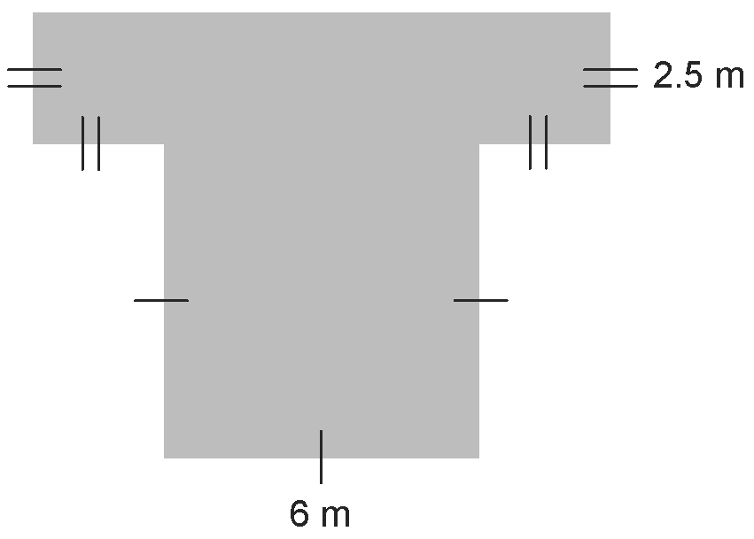

A 57.25 m B 39 m
C 63.5 m D 66 m

2. What is the volume of the square-based prism?
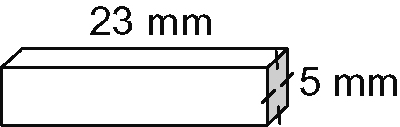

A 5.75 cm³ B 510 mm³
C 6.25 cm³ D 580 mm³

3. What is the surface area of the prism in question 2?
A 535 cm² B 580 mm²
C 485 mm² D 510 mm²

4. What is the volume of the cylinder?
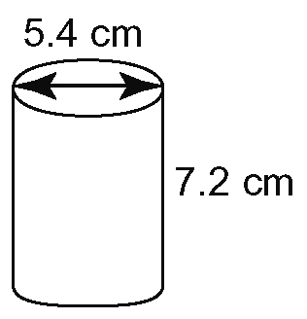
A 164.9 cm³ B 219.9 cm³
C 167.9 cm³ D 203.6 cm³

5. A box in the shape of a square-based prism is to have a volume of 900 cm³. What are the approximate dimensions of the prism that give the minimum surface area?
A 10 cm, 10 cm, 9 cm
B 9 cm, 9 cm, 11.1 cm
C 9.65 cm, 9.65 cm, 9.65 cm
D 9.5 cm, 9.5 cm, 10 cm

6. Determine the volume of concrete used to make this ramp, to the nearest cubic metre.
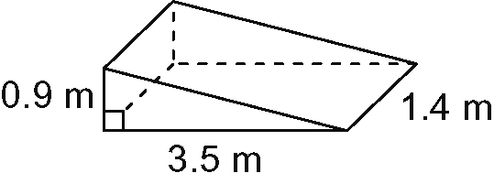

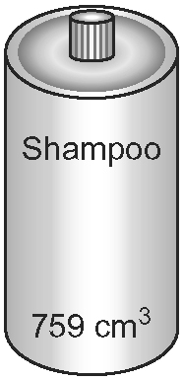
7. A cylindrical shampoo
container is to have volume
750 cm³.

a) Determine the dimensions of the container with minimum surface area.
b) Sketch the container and label its dimensions.
c) Determine the minimum surface area.

8. A storage container in the shape of a
square-based prism has a base length of
2.6 yd and a height of 5.5 yd.
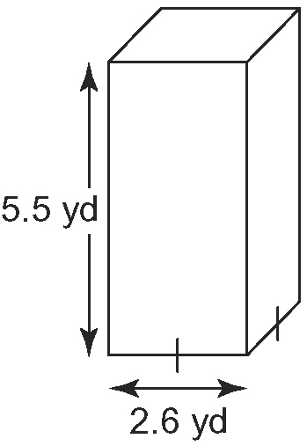
Determine the surface area of the container, to one decimal place.
9. Refer to question 8.
a) Determine the volume of the container to one decimal place.
b) For this volume, determine the dimensions of the container with minimum surface area.

10. Determine the volume of metal used to make this pipe. The pipe has a thickness of 5 mm. Discuss any assumptions you made.
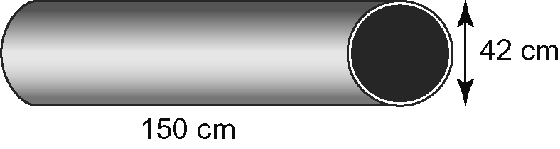

11. Tamara has 30 m of fencing which she can use to surround a rectangular garden.
a) What is the maximum area of the garden, assuming Tamara uses fencing for all
four sides?
b) How much additional area can be obtained if Tamara uses the side of her house and her neighbour's fence as two sides of the garden? Explain.

12. This patio is to be painted with water sealant. Determine the area to be painted, to the nearest metre.
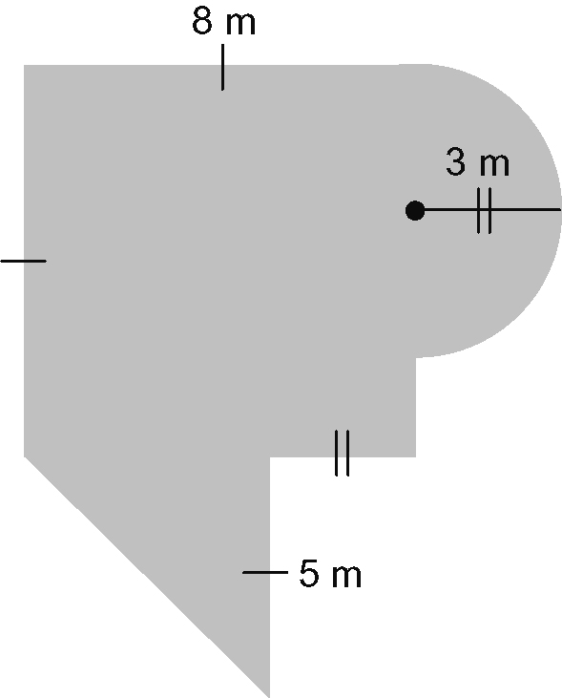

13. Two book ends are n the shape of
trapezoidal prisms.
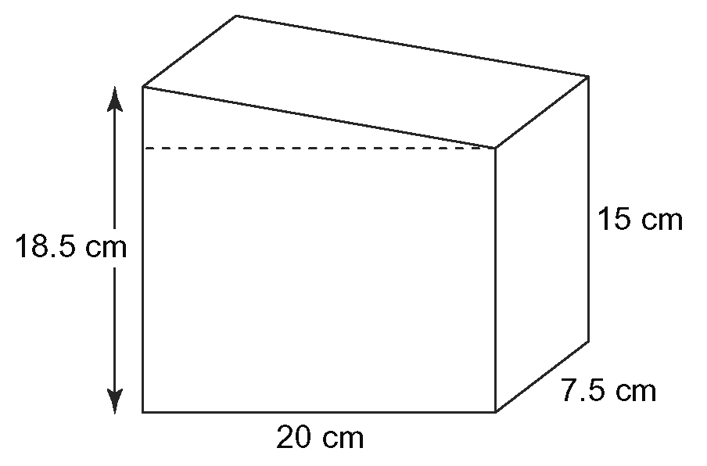
Each is made of marble.
a) What is the volume of marble in one set of two bookends?
b) An artist has a 0.25-m³ block of marble. How many sets of bookends can be made?
List any assumptions you made.
c) Two coats of protective lacquer must be sprayed on the marble to make them more resistant to damage. One can of lacquer covers 8 m². How many sets of bookends can be sprayed if
i) the bottoms of the book ends are not sprayed
ii) the bottoms of the book ends are sprayed

14. Find an object at home that uses geometrically shaped packaging. Select one you have not used before.
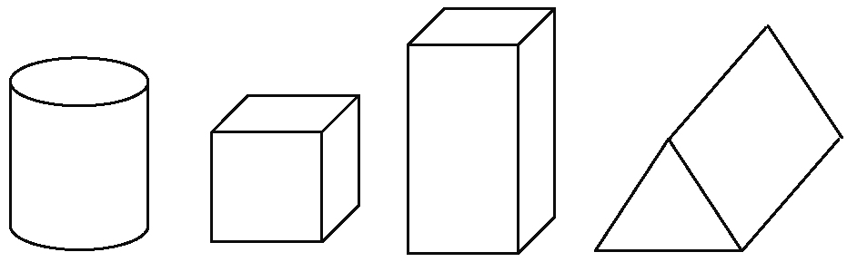
a) Take measurements and determine the volume of the object.
b) Calculate the surface area of the object.
c) Is the object packed optimally? Explain.
d) Determine the dimensions of a package having the same shape and volume but with a minimum surface area.
e) Suggest reasons why objects in stores are not all packaged optimally.

