Chapter 1 Answers

BLM 1-1 Prerequisite Skills
1. a) x = 36 b) x = 6 c) x = 2.8
d) x = 5.1 e) x = 2.5 f ) x = 1.5
2. a) z = 2x – y b)
c)
3. a) C b) D c) B d) A
4. a) 63.5 cm b) 20.7784 yd c) 0.65 m²
d) 157.48 in. e) 329.184 m f) 24.756 39 ft²
5. a) 4.8768 m b) 192 in. c) 5.333 yd
6. a) 600 m by 200 m
b) i) 0.12 km² ii) 120 000 m²
c) The area in square metres is 1 000 000 times greater than the area in square kilometres. 1 km = 1000 m, so 1 km² = 1000 m × 1000 m or 1 000 000 m².
7. a) 5.5 L b) 0.043 L c) 0.6 L d) 2.36 L
8. a) 450 000 cm³ b) 0.45 m³
9. a) 3.2 L b) 5.632 pt
10. 18.8 cm
11. 8.5 cm
12. 10.3 mm
13. A, C
14. a) 50 m b) 22.434 cm c) 24.8 yd d) 46.5 in.
15. a) 144 m² b) 20 cm² c) 38.44 yd² d) 172 in.²
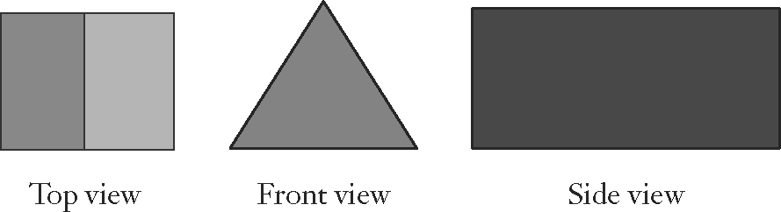
16. a)

b) 5 faces; 2 triangles, 3 rectangles
c) the two triangles and the three rectangles

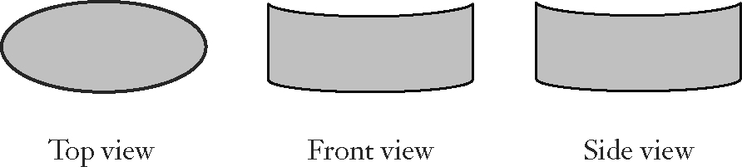
17. a)

b) 3 faces; 2 circles, 1 curved rectangle
c) the two circles
18. a) 6
b) bases: squares; faces: rectangles
c) cube
19. a) pentagonal prism
b) 7 faces: 2 pentagons, 5 rectangles
c) the two pentagons and the five rectangles

BLM 1-4 Section 1.1 Area
1. a) i) 2 rectangles
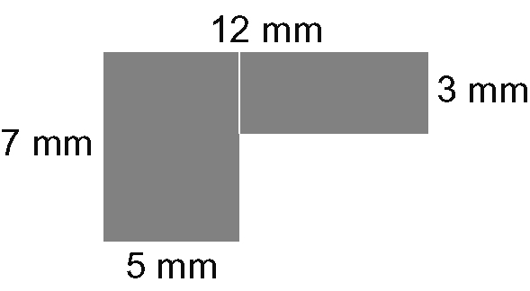

ii) 1 rectangle, 1 right triangle
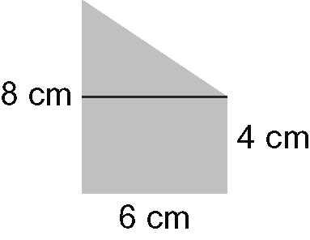

b) i) 56 mm² ii) 36 cm²
2. i) 56 mm² ii) 36 cm²
3. For question 1, calculated the areas of the two shapes and added the areas. For question 2, found the area of the 8 cm by 6 cm rectangle and subtracted the area of the right triangle.
4. 55 in.²
5. 62.06 yd²
6. a), b) 50.625 ft²
c) Answers may vary. Components. This method required fewer steps.
7. a) Rectangle has parallel sides, so unmarked side is also 3.7 m. The semi-circle's diameter is 3.7 m (7.4 – 3.7).
b) 32.8 m²
8. a) approximately 17 705 m²
b) 18 pails
9. a) 8314 cm² b) $307.61
10. a) 37.74 m² b) 3 cans; $77.97
BLM 1-8 Section 1.2 Volume
1. a) hexagon b) 420 cm³
2. a) Cubic metres. It is less work to convert the one imperial measure to metric than the two metric measures to imperial. There are two large measures (yards and metres) so it makes more sense to convert centimetres to metres.
b) 1.12 m²
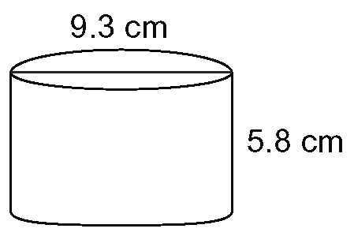
3. a)

b) 394 cm³
c) 0.39 L
4. 575 in.³
5. 29.3 cm
6. 4.5 cm
7. 0.48 m³
8. a) 10 619 cm³ b) 8340 cm³ c) 22.79 cm³

BLM 1-11 Section 1.3 Surface Area
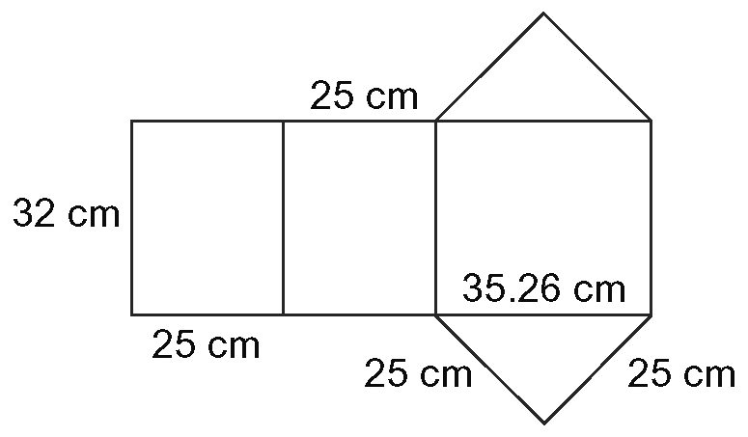
1. a)

b) 3356.52 cm²
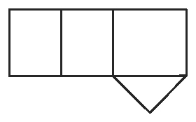
2. a)

b) 3044.02 cm²
3. 3600 cm²
4. 56.55 in.²
5. 534 cm²
6. 2400 cm²
7. 4.78 m²
8. a) 243 in.² b) 202.5 in.² c) Box from part b).
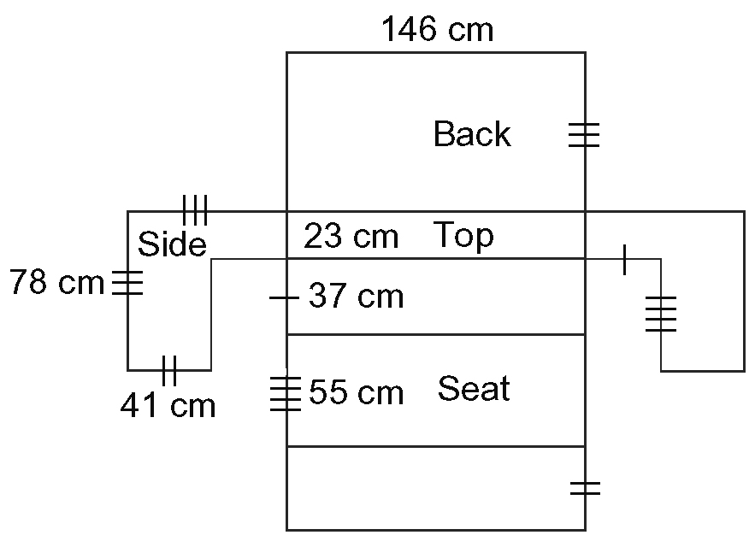
9. a)

b) The main part of the sofa is a large rectangle.
Find the length: 78 + 23 + 37 + 55 + 41 = 234.
Find the area: 234 × 146 = 34 164. For the sides of
the sofa, use net area: 2 × (78 × 78 – 37 × 55) = 8098.
Add the two amounts to find the total surface
area: 42 262 cm².
c) $42.21
10. a) 2.7146 m² b) $27.11
11. a) 424 in.² b) 8 mailboxes
12. Two more mailboxes could be painted.
13. a) 100 cm² b) 110 cm
BLM 1-14 Section 1.4 Optimize Perimeter
and Area
1. B, D, A, C
2. Yes. Diagrams may vary. For example, draw a rectangle with the same perimeter that is longer and narrower than rectangle C.
3. H, F, G, E
4. Yes. Diagrams may vary. For example, draw a rectangle with the same area that is longer and narrower than rectangle F.
5. The maximum dining area is a rectangle with two sides 10 m in length and the third side (opposite the barn)
20 m in length. Diagrams may vary.
6. a) 7 m by 8 m
b) The dimensions change to 7.5 m by 7.5 m; there is 0.25 m² of additional area.
7. 25 m by 50 m
8. 40 ft by 40 ft; 1600 ft²
9. Side opposite river or wall is 80 ft, other two sides are 40 ft; maximum area is 3200 ft²
10. 80 ft by 80 ft; 6400 ft²
11. a) 80 ft by 80 ft; 80 ft by 40 ft; 40 ft by 40 ft
b) The design from question 9; it has the greatest area.
12. 80 cm by 80 cm
13. a) 6.7 m by 13.4 m b) 26.8 m
14. a) A b) 36 ft c) Answer may vary.
BLM 1-15 Section 1.6 Analyse Optimum Volume and Surface Area
1. D, B, A, C; A cube has the minimum surface area, so the box that most resembles a cube will have the least surface area, and boxes that are not cube shaped will have a greater surface area.
2. G, H, F, E; Volume is maximized in a cylinder when the height and the diameter are the same, so cylinders that are taller than they are wide have a lesser volume and cylinders that are as tall as they are wide have a greater volume.
3. A cube with a side length of 9.283 m.
4. The shed would become shorter and the square base will be larger: base 11.7 m by 11.7 m, height 5.84 m.
5. a) 480 000 cm³ or 0.48 m³
b), c) A cube with a side length of 78.3 cm.
6. a) approximately 1728 cm³
b) Yes. If the diameter and the height of the can were the same (13 cm), Coca will use less packaging.
c) 6%
7. radius: 4.07 cm, height 8.15 cm
8. a) side: 12.60 cm; length: 7.274 cm
b) Answers may vary. For example, set up the volume and surface area formulas in a spreadsheet and use systematic trial to find the minimum surface area for the given volume.
9. a) base: 7.913 cm by 7.913 cm; 939.2 cm³
b) side: 11.96; 928.69 cm³
c) radius: 4.82; 1094.2 cm³
10. a) Square-based prism: cube with side length 10 cm; 1000 cm³. Equilateral triangle-based prism:
side: 15.197 cm, height: 8.77 cm; 877.38 cm³. Cylinder: radius: 5.64 cm, height: 11.28 cm;
1128.38 cm³.
b) The square-based prism and the equilateral
triangle-based prism are shorter. The cylinder is wider and shorter; the diameter and the height are now the same.
11. Cylinder. Rectangular gifts will not fit easily in cylindrical boxes. Cylinders are more difficult to assemble and store than square-based prism boxes.

BLM 1-18 Chapter 1 Review
1. 64 ft²
2. 2450 cm²
3. a) 4 cans b) 1 can
4. 4.6 cm
5. 0.7 m³
6. 7.5 ft
7. 4.8 m²
8. 48 ft²
9. 1403 cm²
10. a) Make a square with sides 6 m in length.
b) Make a rectangle with sides 12 m and 6 m in length against 12 m of the existing fence.
11. 31 yd
12. The minimum perimeter would be 21.9 yd. The garden would be 10.9 yd by 5.5 yd, built against a 10.9 yd section of the school.
13. A, C, B, D; A cube has a minimum surface area for a given volume. So the box that is most like a cube will have the minimum surface area. Order the boxes from the one that looks most like a cube to the one that looks least like a cube.
14. D, B, A, C; A cylinder will have a maximum volume for a given surface area when the diameter is equal to the height. Order the containers from the one that looks as wide as it is tall to the one that is much wider than it is tall.
15. a) radius: 6.83 cm; height: 13.66 cm. Assume the
radius and height can be any value that gives the fixed volume.
b) The container will be awkward to hold and pour since it is so wide. It will take up more shelf space than a taller, narrower container so fewer containers can be displayed in stores.
16. a) approximately 12.25 cm by 12.25 cm by 12.25 cm
b) a cube
c) 1837 cm³
17. a) 10.1 m³
b) i) 4.2 m³
ii) 8.9 m³

BLM 1-19 Chapter 1 Practice Test
1. B
2. D
3. B
4. A
5. B
6. 415 cm²
7. a) All sides approximately 11.2 cm.
b) Box should be a cube with side lengths 11.2 cm.
c) 751 cm²
8. 1910.1 cm²
9. a) 6031.9 cm³ b) radius: 9.86 cm; height: 19.75 cm
10. 86 cm³. Assume the medallion is solid except for the visible cut-out part.
11. a) approximately 7.6 m²
b) He can double the area. The garden would be 2.75 m wide and 5.5 m long, along a 5.5-m section of
his house.
12. 143.3 m²
13. a) 3244 ft²
b) 301 m²
c) 488 ft²
d) 46 cans
14. a) 2.6 cm³; assume the hole approximates a cylinder
b) 194 cm²
c) 41 bottles; assume the bottle spouts are not included
BLM 1-20 Chapter 1 Test
1. C
2. A
3. D
4. A
5. C
6. 2.2 m²
7. a) radius: 4.92 cm; height: 9.85 cm
b) Cylinder should have same height and diameter.
c) 456.97 cm²
8. 70.7 yd²
9. a) 37.2 yd³ b) all sides approximately 3.34 yd
10. 9778.2 cm³. Assume the pipe is hollow and does not have any holes.
11. a) 56.25 m²
b) She would have four times the area, 225 m. The garden would be 15 m wide and 15 m long.
12. 91 m²
13. a) 5025 cm³
b) 49 sets; assume there is no wastage
c) i) 44 sets ii) 33 sets
14. a) to e) Answers may vary.

