Prerequisite Skills

Geometric Properties
1. Determine the measure of each
indicated angle.
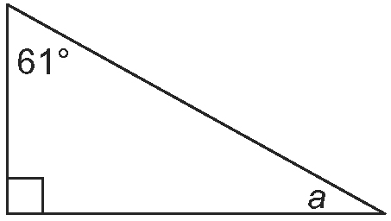
a)

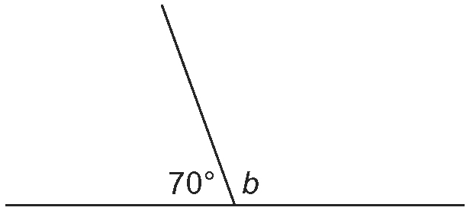
b)

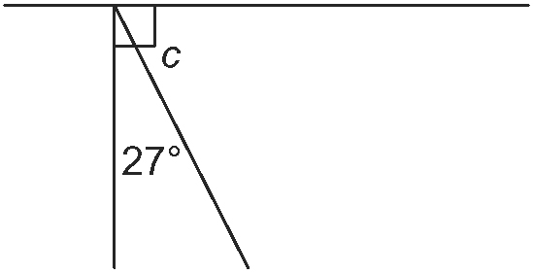
c)

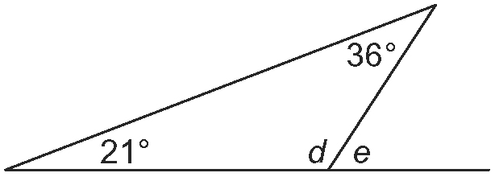
d)

2. a) What are complementary angles?
Draw an example.
b) What are supplementary angles?
Draw an example.

The Pythagorean Theorem
3. Determine the length of each indicated
side, to one decimal place.
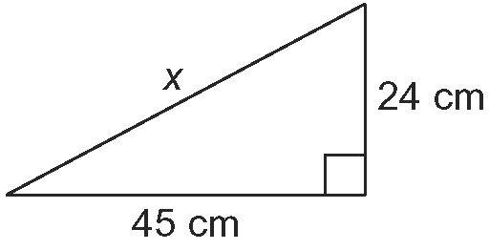
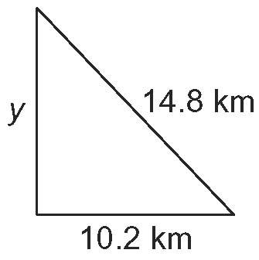
a) b)

4. Jevon is standing on a point that is
8.1 m from the base of a 10.8-m tall tree. Determine the shortest distance from the point where Jevon is standing to the top
of the tree.

Primary Trigonometric Ratios
5. For each triangle, label the hypotenuse and the sides opposite and adjacent to ∠θ.
a) b)
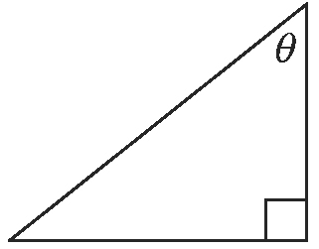
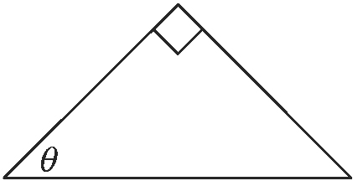

6. Evaluate to four decimal places. Use
a calculator.
a) sin 75° b) cos 63° c) tan 22°

7. Solve for ∠θ to the nearest degree.
Use a calculator.
a) sin θ = 0.8660
b) cos θ = 0.7071
c) tan θ = 1.4417

Solve Equations
8. Solve for x to one decimal place.
a) b)
c) d)

9. Solve each equation to one decimal place.
a) 7² + 9² = a²
b) 2b² = 8.4²
c) n² = 10.1² + 13.5² − 2(10.1)(13.5)(0.5)

