Section 2.1 Trigonometric Ratios With
Acute Angles

1. For each triangle, write the three primary trigonometric ratios relative to∠θ. Express each ratio as a fraction in lowest terms.
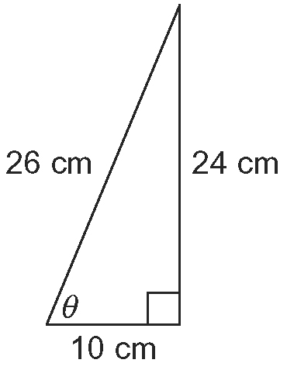
a)

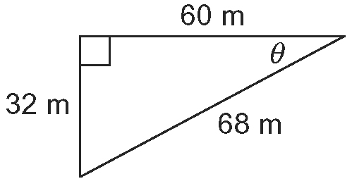
b)

2. Determine the length of x to one
decimal place.
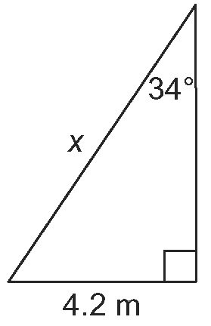
a)

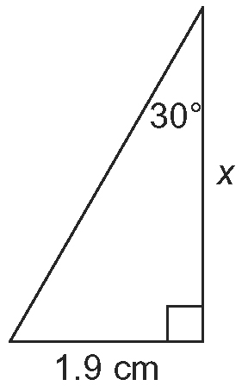
b)

3. Solve for ∠θ to the nearest degree.
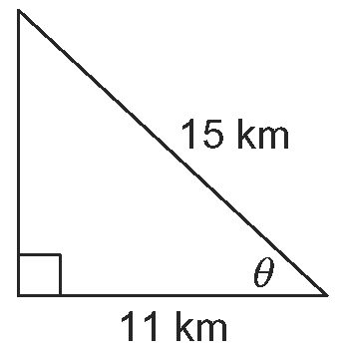
a)

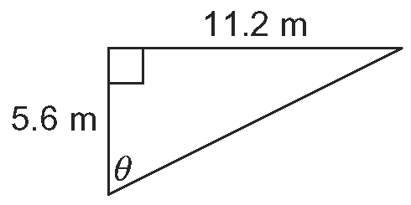
b)

4. a) Draw and label a diagram of each triangle.
i) In LMN, ∠L = 90º, l = 4.5 m, and
n = 3.4 m.
ii) In RST, ∠R = 40º, ∠S = 50º, and
t = 12.6 cm.

b) For each triangle in part a), solve for the unknown angles and side lengths. Express all lengths to one decimal place and all angles to the nearest degree.

5. a) A radio mast is supported by a guy wire that is 245 m in length and that has an angle of inclination of 54º. How far up
the mast does the guy wire reach, to the nearest tenth of a metre?
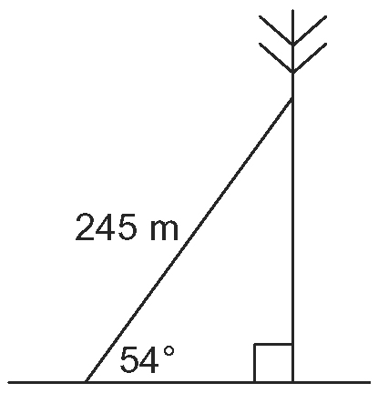

b) What is the angle of inclination of a guy wire anchored 144 m from the base of a radio mast that reaches 286 m up it? Round your answer to the nearest tenth
of a degree.
6. A ferry sets sail at 6.3 km/h at a 90º angle from the shore to cross a river. The resulting direction of the ship is at an angle of 70º from the shore due to a current that is parallel to the shore. The resulting speed
and direction of the ferry is shown by the dashed arrow.
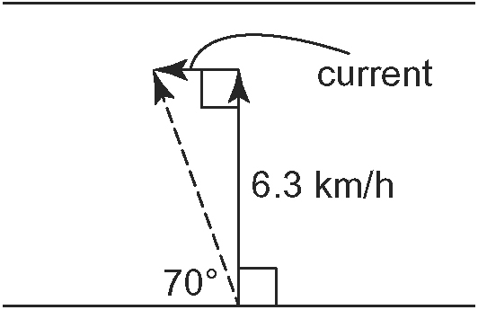
a) Find the resulting speed of the ferry.
b) Find the speed of the current.

7. An air traffic controller is in a control tower 92 m above the ground. He estimates his angle of elevation to a passing airplane to be 17º. The airplane is approximately 4800 m from the control tower.

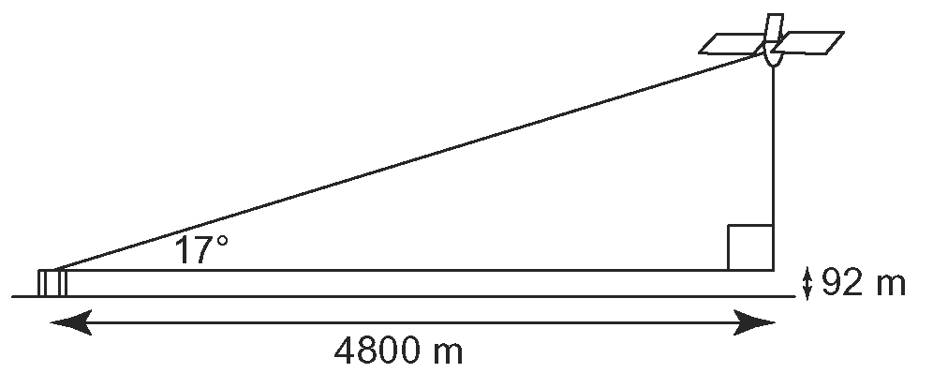

a) Approximately how high is the airplane above the ground?
b) Determine the approximate angle of elevation from the bottom of the control tower to the airplane.

8. Keisha stands at a point between two trees and measures the angle of inclination to the top of each to be 34º. One tree is 23.6 m in height and the trees are 60 m apart. Determine the height of the other tree.
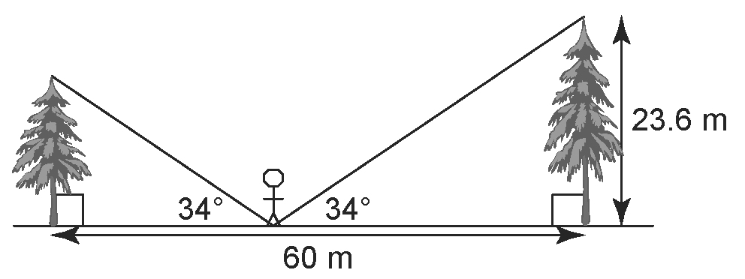

9. Randee is on the ground waving to her friend Alana, who is on the second floor of a five storey building.
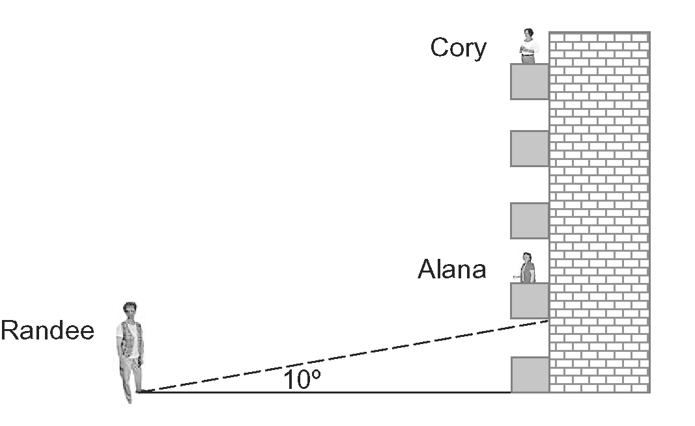
Randee is 20 m from the base of Alana’s apartment building. She estimates that the angle of elevation from the ground to the bottom of Alana’s balcony is 10º.
a) Approximately how high is Alana’s apartment above the ground?
b) How tall is the apartment building?
c) Cory lives on the top floor directly above Alana’s apartment. Suppose Cory comes to the balcony to wave to Randee. What is the angle of elevation to the bottom of Cory’s balcony to the nearest degree?

