Section 2.2 Trigonometric Ratios With
Obtuse Angles

1. The terminal arm of an angle, θ, in
standard position passes through A(1, 4).
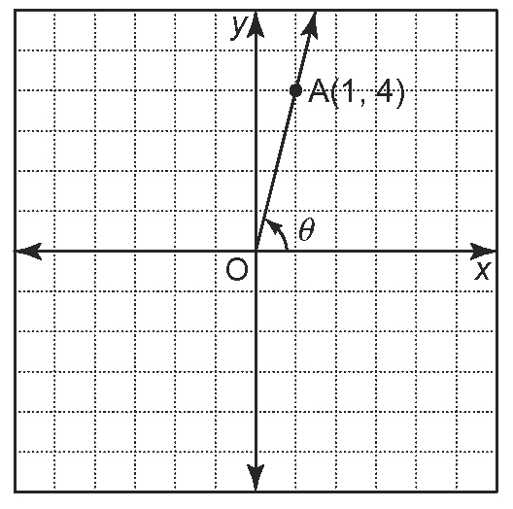
a) Determine the length of OA.
b) Determine the primary trigonometric ratios to three decimal places.

2. The terminal arm of an angle, θ, in standard position passes through X(5, 3).
a) Sketch a diagram for this angle in standard position.
b) Determine the length of OX.
c) Determine the primary trigonometric ratios to three decimal places.

3. Refer to question 2.
a) Use a protractor. Measure ∠θ to the nearest degree.
b) Use a calculator. Calculate the primary trigonometric ratios to three decimal places. Compare the results to your answer to question 2, part c).
4. The terminal arm of an angle in standard position passes through C(–4, 6).
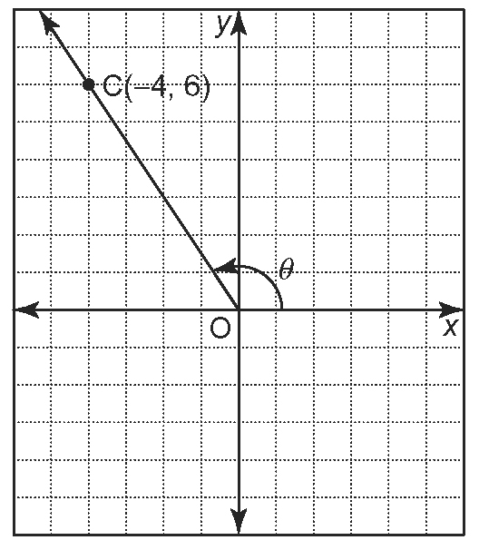
a) Determine the length of OC.
b) Determine the primary trigonometric ratios to three decimal places.

5. Refer to question 4.
a) Use a protractor. Measure ∠θ to the nearest degree.
b) Use a calculator. Calculate the primary trigonometric ratios to three decimal places. Compare the results to your answer to question 4, part b).

6. a) Plot the point Z(–4, 3) on a Cartesian grid.
b) Draw a terminal arm through the point and label the angle in standard position.
c) Determine the primary trigonometric ratios for the angle.

7. Refer to question 6. Find a point in the first quadrant such that the sine value of the acute angle created by the terminal arm passing through this point is the same as the sine value of the obtuse angle in question 6, part b). Explain how you found your answer.

8. a) Sketch the terminal arm for each angle in standard position.
Angle | Sine | Cosine | Tangent
28°
145°
58°
104°
162°
b) Complete the table. For each angle, indicate whether each trigonometric ratio is positive or negative.

9. The tangent of an acute angle, θ, in standard position is .
a) Sketch a diagram of ∠θ.
b) Identify the coordinates of a point that lies on the terminal arm of ∠θ.
c) Determine sin θ and cos θ.
d) Determine the measure of ∠θ,
using technology.

10. The cosine of an obtuse angle, θ, in standard position is .
a) Sketch a diagram of ∠θ.
b) Identify the coordinates of a point that
lies on the terminal arm of ∠θ.
c) Determine sin θ and tan θ.
d) Determine the measure of ∠θ,
using technology.

11. The sine of an acute angle, θ , in standard position is . Sketch a diagram of ∠θ.
a) Identify the coordinates of a point that lies on the terminal arm of ∠θ.
b) Determine cos θ and tan θ.
c) Determine the measure of ∠θ,
using technology.

12. The tangent of an obtuse angle, θ , in standard position is . Sketch a diagram of ∠θ.
a) Identify the coordinates of a point that lies on the terminal arm of ∠θ.
b) Determine sin θ and cos θ.
c) Determine the measure of ∠θ, using technology. Round your answer to the nearest degree.

13. If the given point is on the terminal arm of an angle A in standard position and
0° ≤ A ≤ 180°, find the measure of ∠A, to the nearest degree.
a) (4, 3)
b) (12, 5)
c) (−6, 8)
d) (−24, 7)

