Section 2.3 Sine Law

1. Use the sine law to determine the measure
of ∠θ to the nearest degree.
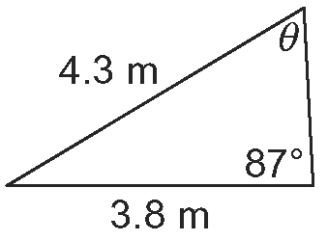
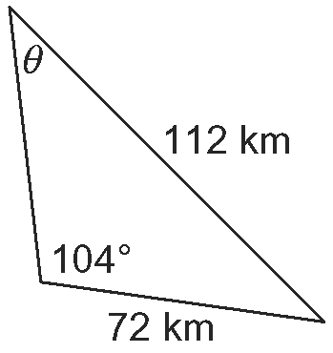
a) b)

2. In DEF, ∠D = 132º, d = 17.9 cm,
and f = 12.5 cm.
a) Draw and label a diagram.
b) Determine the measure of ∠F to the nearest degree.

3. Determine the length of each indicated
side to one decimal place.
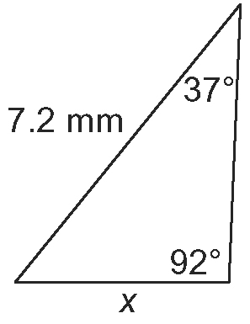
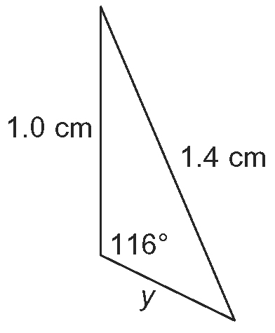
a) b)

4. In GHI, ∠H = 100º, ∠I = 39º, and
h = 37 m.
a) Draw and label a diagram.
b) Determine the length of side g to the nearest metre.

5. Solve each triangle for all angles to the nearest degree and all side lengths to one decimal place.
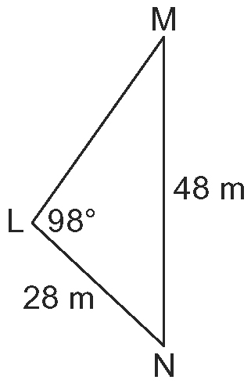
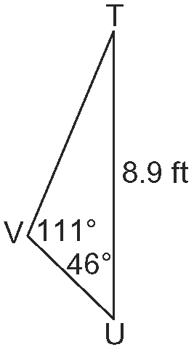
a) b)

6. In XYZ, ∠Z = 105º, y = 9.9 km, and
z = 14.2 km.
a) Draw and label a diagram.
b) Solve XYZ for all angles to the
nearest degree and all side lengths to
one decimal place.

7. A weather balloon is being tracked by two radar stations that are 68 km apart.
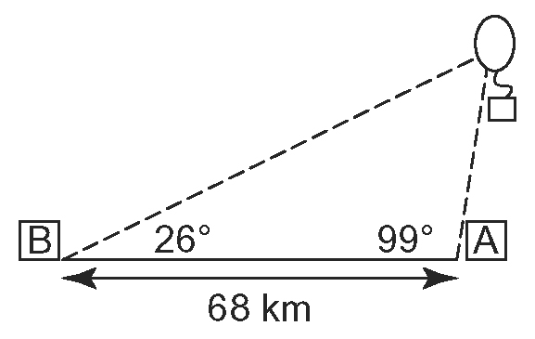
The angle between the radio signals sent from station A to the balloon and station B
is 99º. The angle between the radio signals
sent from station B to the balloon and
station A is 26º.
a) Determine the distance from each
radar station to the weather balloon.
b) How high is the weather balloon
above the ground?

8. A tree is leaning at 10º from vertical. Shafin walks 15 m from the base of the tree in the direction of the lean and measures the angle of elevation to the top of the tree to be 38.4º.
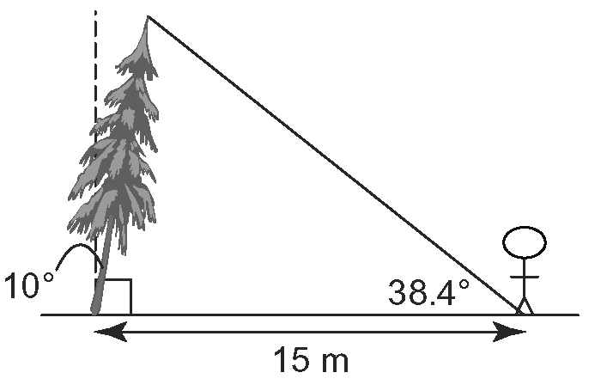
Determine the height of the tree to the nearest tenth of a metre.

