Section 2.5 Applications of Trigonometry

Use these diagrams to answer
questions 1 and 2.

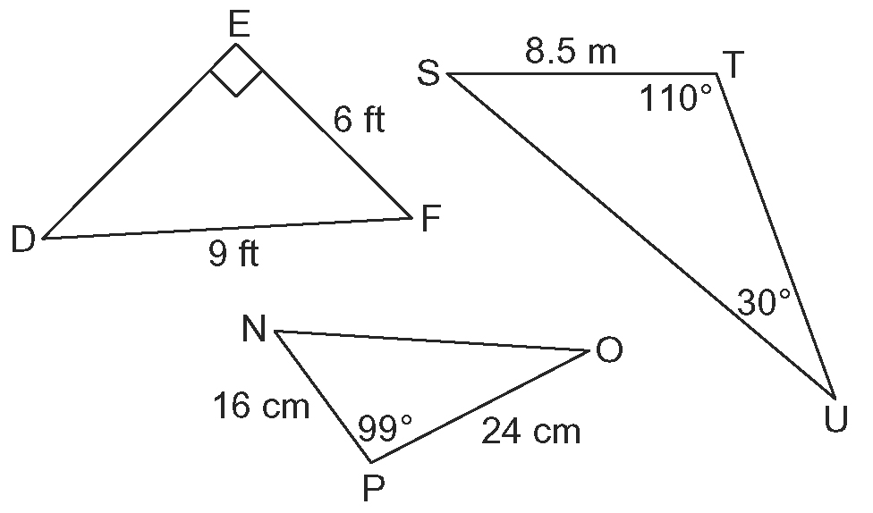

1. Match each problem with the most appropriate tool or strategy. Explain
your choices.
a) Find the length of side f.
b) Find the measure of ∠F.
c) Find the measure of ∠D.
d) Find the measure of ∠S.
e) Find the length of side p.
f) Find the length of side t.

A the sine law
B the sine ratio
C the sum of the angles in a triangle
D the cosine law
E the Pythagorean theorem
F the cosine ratio

2. Solve each problem in question 1
using the tool or strategy you chose.

3. a) Draw a diagram of quadrilateral PQRS with PQ = 7.2 cm, QR = 8.0 cm,
PS = 6.3 cm, ∠Q = 90º, and ∠S = 90º. Connect P and R with a dashed line to create two right triangles.
b) Determine the length of side RS.
c) Determine the measures of ∠P and ∠R.
4. In XYZ, x = 15 m, ∠Y = 104º, and
y = 15 m.
a) Draw and label a diagram.
b) Determine the length of side y using
the cosine law.
c) Determine the length of side y using a different method.
d) Compare your answers to parts b) and c). Which method requires fewer steps?

5. Pablo is 20 km from a rocket launch pad, watching a rocket lift away from the Earth. At one point, Pablo measures the angle of inclination to the rocket to be 34º. One minute later, the angle of inclination has increased to 54º.
a) How high above the Earth’s surface is the rocket at each point that Pablo measured?
b) What is the average speed of the rocket
in kilometres per hour?

6. Amina is constructing a roof for her shed. The width of her shed is 3.8 m and she plans to make the sloping sides of the roof 2.4 m and 2.5 m in length.
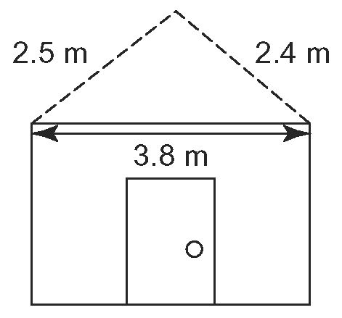
Determine the measures of the three
interior angles of the roof and label them
on the diagram.

7. An electric company has two options for
the route of a proposed transmission line.
Route A is above ground and has a cost of $200 000/km. Route B is underground and has a cost of $1 000 000/km.
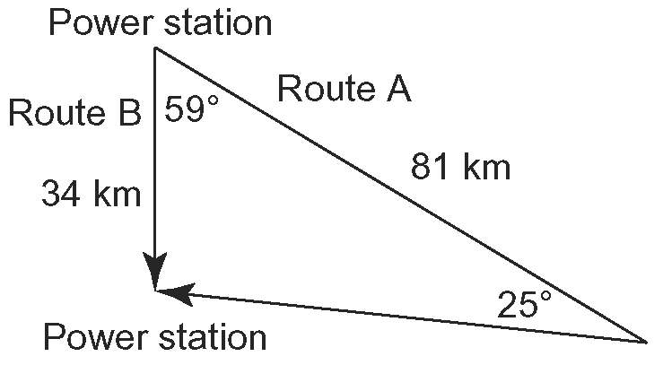
a) Determine the total length of Route A.
b) Which option costs less?

8. Sonja measures the angle of elevation to the top of an office building to be 57º. She then walks 25 m closer to the building and measures the angle of elevation to be 70º.
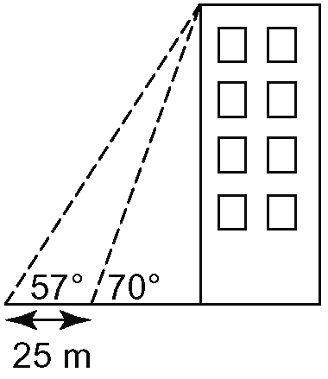
Determine the height of the building to the nearest metre.

9. A triathlon is an event that has competitors swim, run, and bicycle over a set course. The organizers of a triathlon wish to know the total length of the course and took the measurements shown.
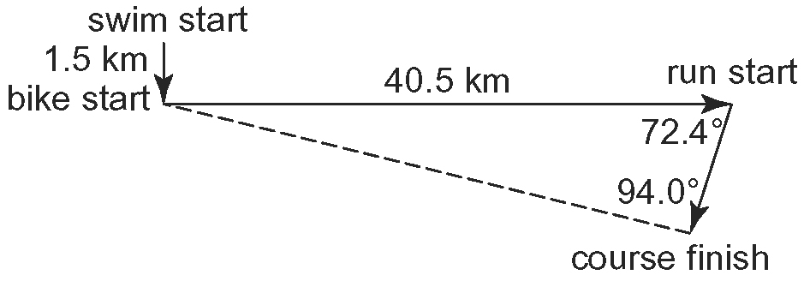
Determine the total length of the course, represented in the diagram by the arrows.
10. A naval architect is designing a sail plan for a small sailboat. She has drawn a diagram that shows the sail divided into sections by the mast (the vertical dashed line) and the gaff (the angled dash line).
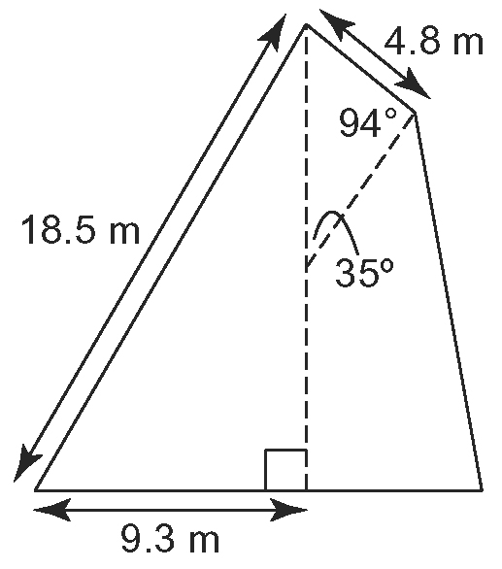
Find the lengths of the mast and gaff that will fit the sail.

11. A Global Positioning System (GPS) receiver is receiving signals from two satellites. One is at a 10º angle above the horizon and the other at a 20º angle above the directly opposite horizon. The distances between the GPS receiver and the satellites are given
in kilometres.
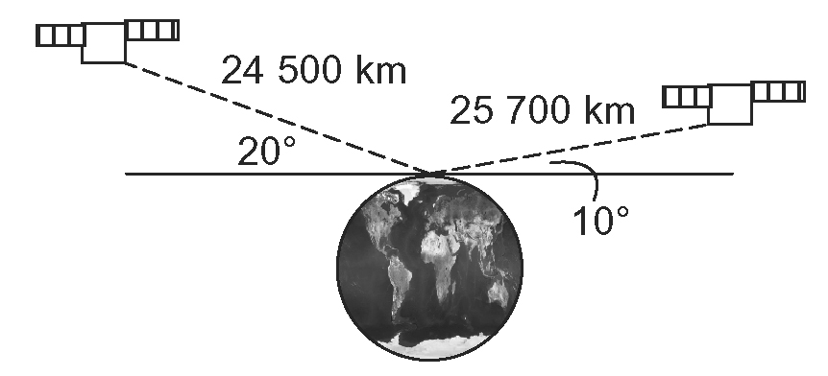
Determine the distance between the satellites.

