Chapter 2 Review

2.1 Trigonometric Ratios With Acute Angles, pages 74–83
1. a) For each triangle, determine the primary trigonometric ratios relative to ∠θ to two decimal places.
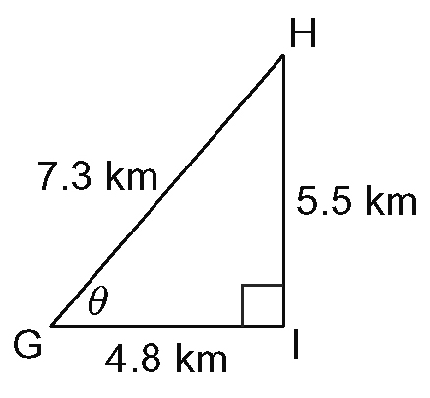
i)

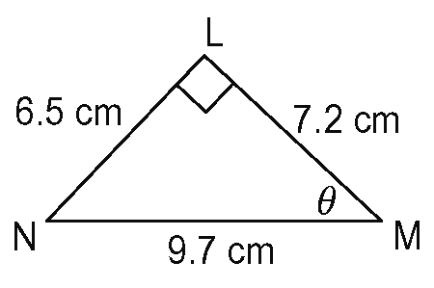
ii)

b) Determine the measure of ∠θ to the nearest degree for each triangle in part a).

2. Oliver needs an inclined plane for a physics experiment. This inclined plane is in the shape of a right triangle, has a height of
24 cm, and has a base of 36 cm.
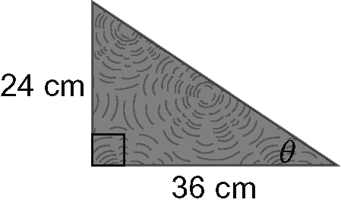
a) Determine the length of the plane.
b) Determine the angle, θ, between the plane and the horizontal to the nearest degree.

3. Solve RST. Express all measures to
one decimal place.
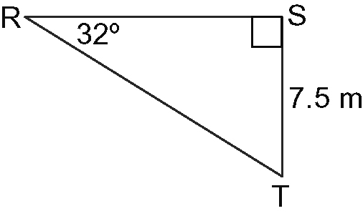
2.2 Trigonometric Ratios With Obtuse Angles, pages 84–95
4. The terminal arm of an angle, θ, passes through K(12, 9). Determine the primary trigonometric ratios for ∠θ as fractions in lowest terms.
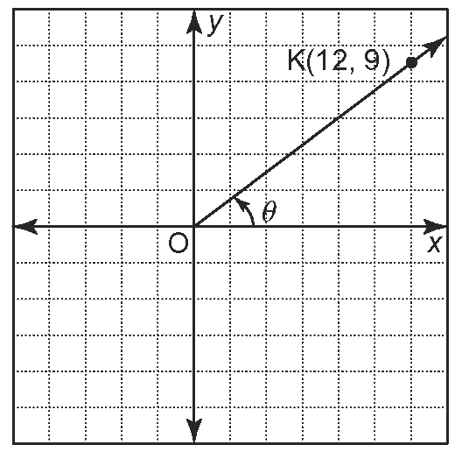

5. The terminal arm of an angle, θ, passes through B(–3, 2).
a) Draw the angle in standard position.
b) Determine the primary trigonometric ratios for ∠θ to three decimal places.

2.3 Sine Law, pages 96–103
6. Maya’s class decided to test the elasticity
of a rubber band. The rubber band was cut and each end was attached to the end of
a 30-cm ruler. The rubber band was pulled away with a pencil and the angles between the ends of the ruler and the pencil were measured.
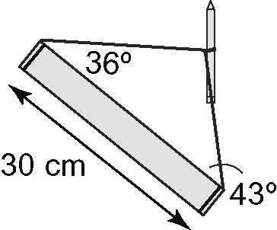
Find the length of the stretched rubber band to the nearest centimetre.

7. Solve CEV. Round side lengths to the nearest foot and angle measures to the nearest degree.
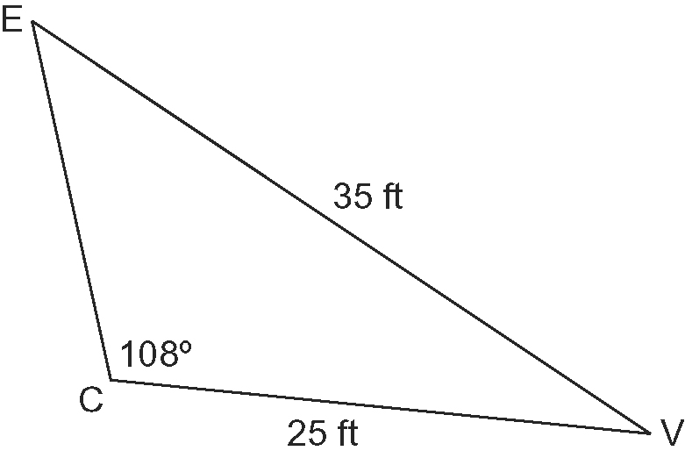

2.4 Cosine Law, pages 104–111
8. Two boats started at the same location.
One boat travelled 18 km while the other travelled 46 km. From their starting point, the angle between the current positions of the boats is 135º. Find the distance, d, between the boats to the nearest kilometre.
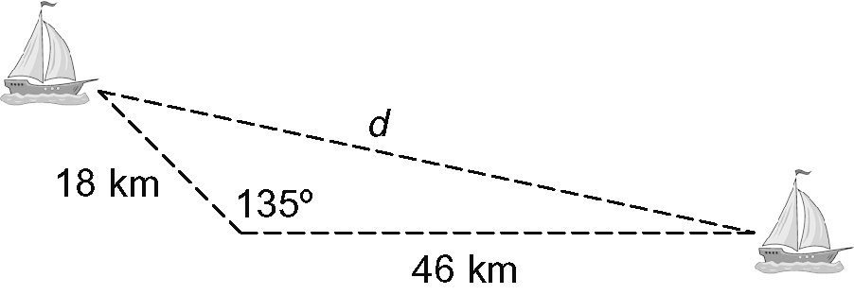

9. Solve DTP. Round angles to the
nearest degree.
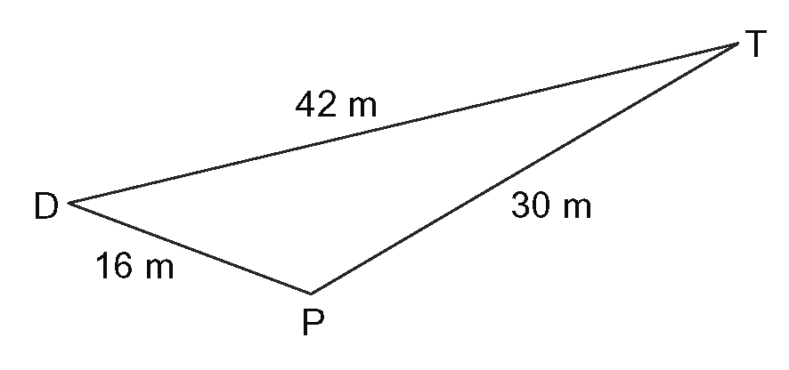
2.5 Applications of Trigonometry,
pages 120–129
10. Ali is attaching two guy wires to support a wind turbine. The first guy wire is 60 m in length and has an angle of inclination of 47º. The second guy wire will be attached to the same place on the turbine as the first but its base will be 20 m closer to the turbine.
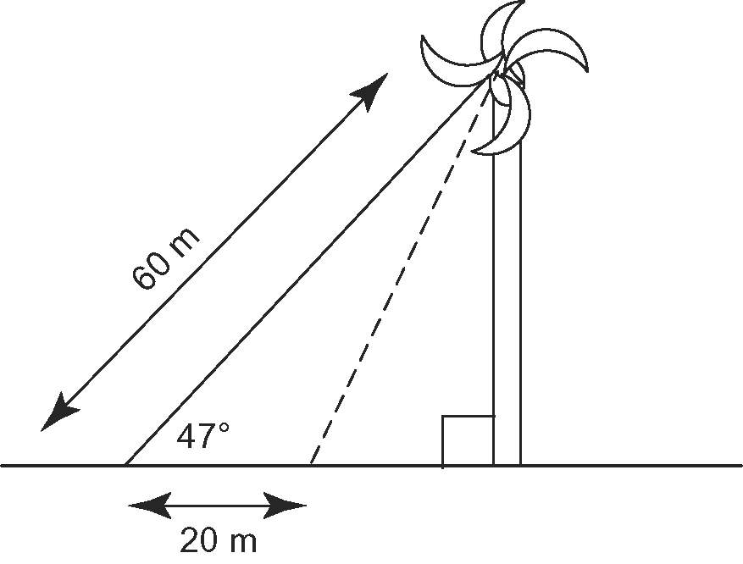
a) Determine the length of the second
guy wire.
b) Determine the angle of inclination of the second guy wire.

11. A surveyor took measurements and drew a diagram to determine the length of a proposed tunnel through a mountain.
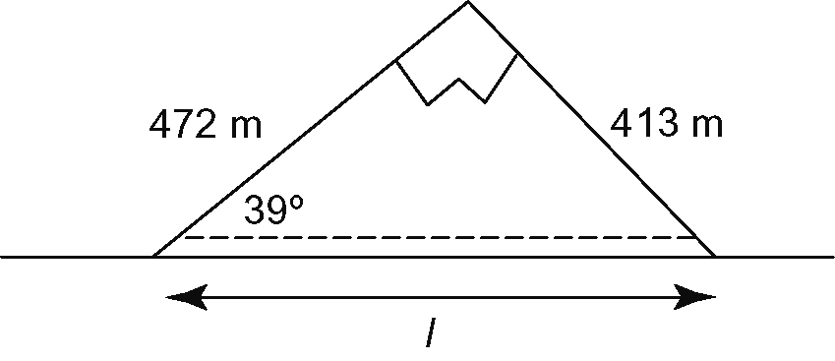
Determine the length, l, of the proposed tunnel.

