Chapter 2 Practice Test

For questions 1 to 3, choose the
best answer.

1. Which is the best estimate for the
length of z?
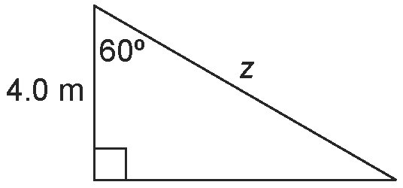
A 9.5 m B 8.0 m
C 6.9 m D 5.0 m

2. Which is the best estimate of sin θ ?
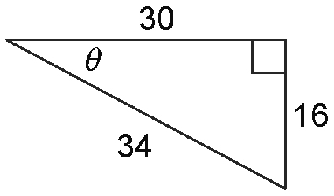
A 0.53 B 2.13
C 0.88 D 0.47

3. Which tool or strategy could you use to
solve the triangle?
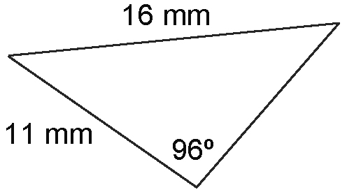
A the cosine ratio
B the sine law
C the cosine law
D There is not enough information to solve this triangle.

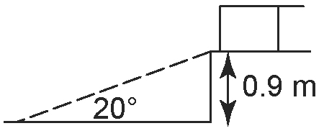
4. A ramp is to be built onto
a loading dock.
The dock is 0.9 m tall,
and the angle of inclination of
the ramp is to be 20º.
Find the length of the
ramp, to the nearest tenth of a metre.
5. The point J(–4, 7) lies on the terminal arm of an angle, θ, in standard position. Sketch ∠θ in standard position. Determine the primary trigonometric ratios to three decimal places.

6. Determine the primary trigonometric ratios for ∠θ to three decimal places.
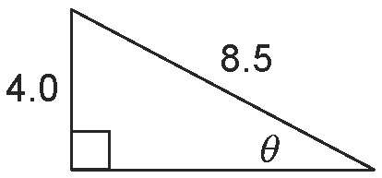

7. Solve JKL. Express all measures to one decimal place.
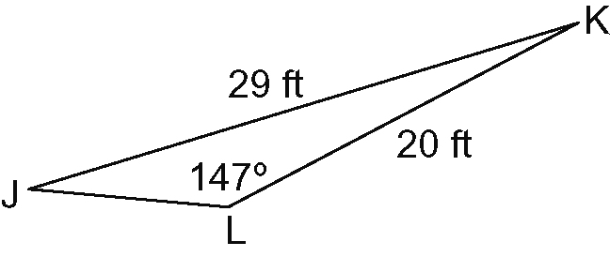

8. A gardener is fencing off a triangular flower patch. He wants one side to be 4.5 m in length, another side to be 3.0 m in length, and plans to use 10.0 m of fencing in total. Determine the measures of the three interior angles of the flower patch.

9. Three buildings are to be connected by television cables, as shown.
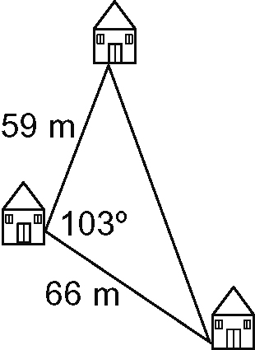
Determine the total length of cable needed to connect the buildings.

