Chapter 2 Test

For questions 1 to 4, choose the best answer.

1. Which is the best estimate of cos θ ?
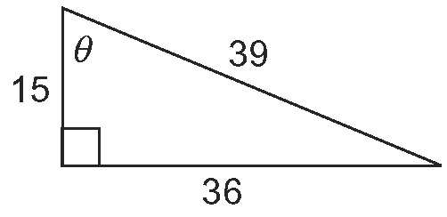
A 1.08 B 2.40
C 0.38 D 2.60

2. Refer to question 1. Which is the measure of ∠θ to the nearest degree?
A 21º B 23º
C 47º D 67º

3. Which is the best estimate for the
length of d ?
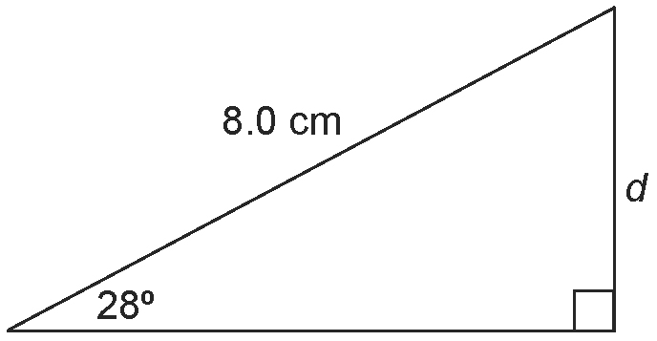
A 3.8 cm B 4.3 cm
C 6.0 cm D 7.1 cm

4. Which tool or strategy could you use to
solve this triangle?
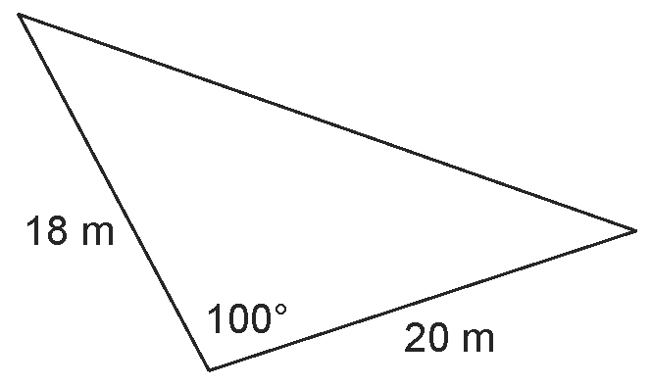
A the sine law
B the cosine law
C the Pythagorean theorem
D There is not enough information to solve this triangle.
5. Determine the primary trigonometric ratios for ∠θ to three decimal places.
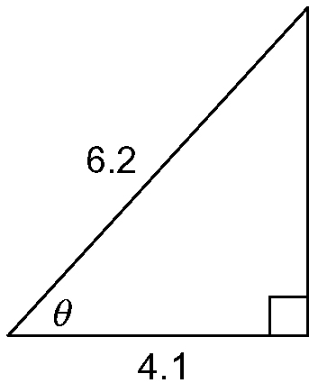

6. A 16-ft beam is supporting a wall.
The beam attaches to the wall 12 ft above
the ground.
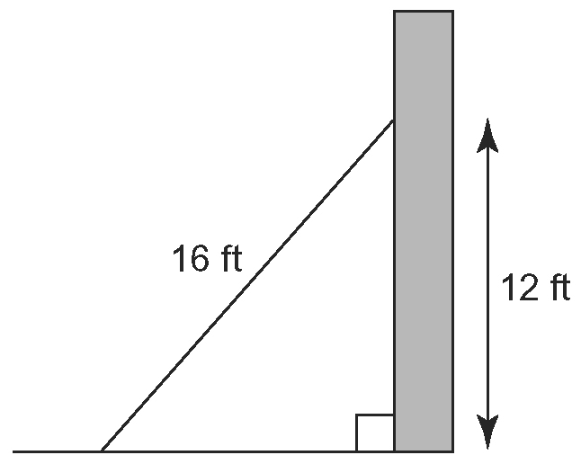
Determine the angle of inclination made by the beam with respect to the ground.

7. The point Q(–6, 5) lies on the terminal arm of an angle, θ, in standard position.
a) Sketch ∠θ in standard position.
b) Determine the primary trigonometric ratios to three decimal places.

8. In CPY, c = 35 km, p = 29 km, and
y = 33 km. Determine the measure of
∠Y to the nearest degree.

9. Two surveyors are 7.7 km apart on a straight highway. They each measure the angle between the highway and a power station and find the angles to be 49º and 60º.
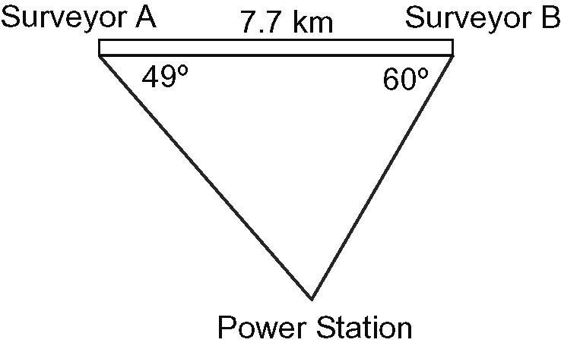
Determine the distance each surveyor is from the power station.

10. Katie built a simple circuit by connecting a battery to two light bulbs with wire. She took the measurements shown.
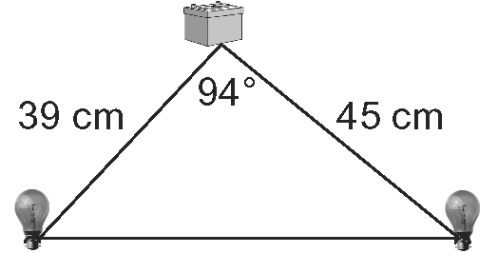
Determine the total length of wire used
in Katie’s circuit, to the nearest tenth of
a centimetre.

11. To determine the height of a tree growing on a slope, a civil engineer took measurements and drew the diagram shown.
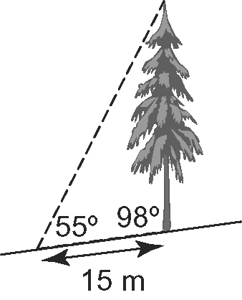
Determine the height of the tree, to the nearest tenth of a metre.

12. Distances from Ron’s house to the grocery store and library are shown.
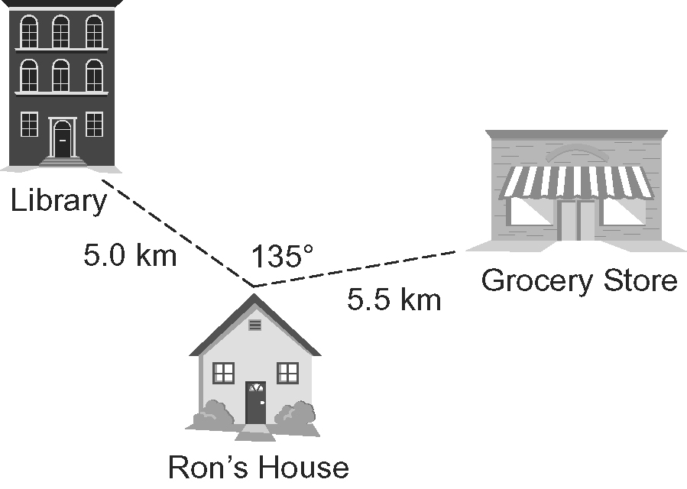

a) How far is the library from the grocery store?
b) Ron in-line skates from his house to the grocery store. Then he goes to the library and returns home. How far does he travel, in total?

13. Josh wants to replace two guy wires that are supporting a pole. He took measurements and drew this diagram.

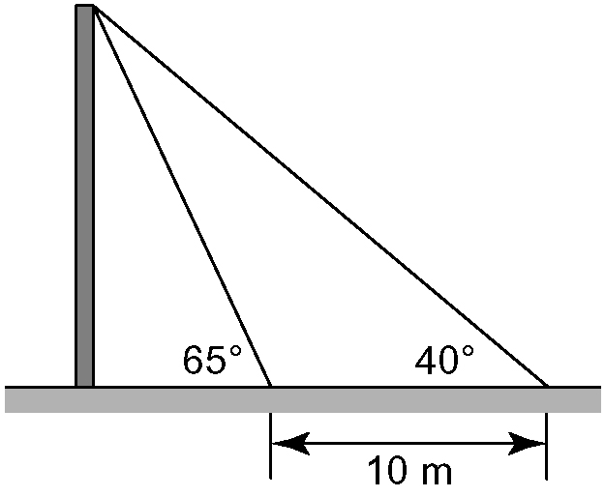

a) Determine the total length of guy wire that needs to be replaced to the nearest metre.
b) Determine the height of the pole to the nearest metre.

