Chapter 2 BLM Answers

BLM 2-2 Prerequisite Skills
1. a) a = 29° b) b = 110°
c) c = 63° d) d = 123°, e = 57°
2. a) Two angles with measures that add to 90º
are complementary.
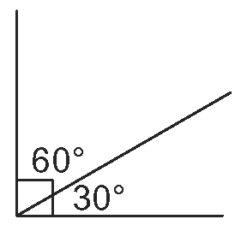
b) Two angles with measures that add to 180º
are supplementary.
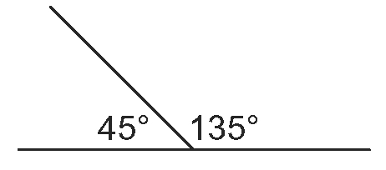
3. a) x = 51 cm b) y = 10.7 km
4. 13.5 m
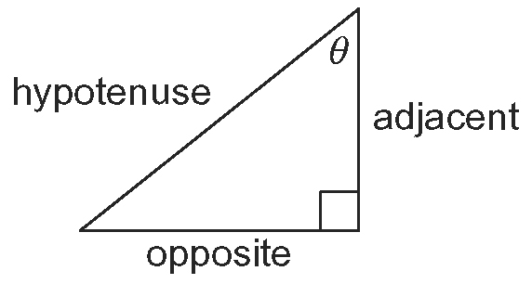
5. a)

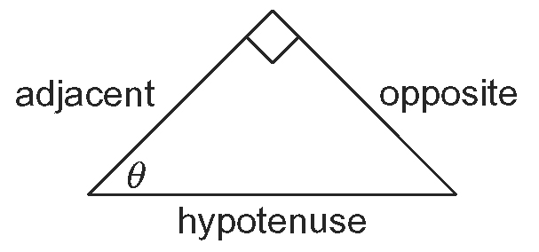
b)

6. a) 0.9659 b) 0.4540 c) 0.4040
7. a) 60.0° b) 45.0° c) 55.3°
8. a) 2.3 b) 8.4 c) 10.4 d) 32.4
9. a) a = 11.4 b) b = 5.9 c) m = 7.7 d) n = 12.2

BLM 2-4 Section 2.1 Trigonometric Ratios With Acute Angles
1. a) sin θ = , cos θ = , tan θ =
b) sin θ = , cos θ = , tan θ =
2. a) x = 7.5 m b) x = 3.3 cm
3. a) ∠θ = 43º b) ∠θ = 63º

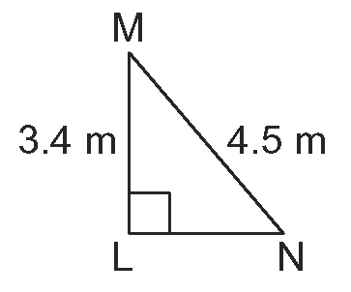
4. a) i)

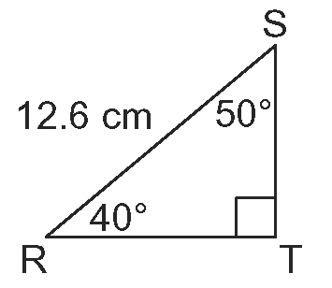
ii)

b) i) ∠M = 41º, ∠N = 49º, m = 2.9 m
ii) ∠T = 90º, r = 8.1 cm, s = 9.7 cm
5. a) 198.2 m b) 63.3º
6. a) 6.7 km/h b) 2.3 km/h
7. a) approximately 1560 m b) approximately 18º
8. 16.9 m
9. a) 5.4 m b) 13.5 m c) 34º

BLM 2-6 Section 2.2 Trigonometric Ratios With Obtuse Angles
1. a) OA 4.123
b) sin θ 0.970, cos θ 0.243, tan θ = 4
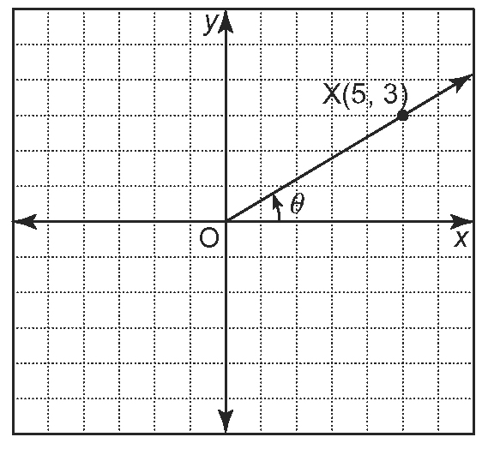
2. a)

b) OX 5.831
c) sin θ 0.514, cos θ 0.857, tan θ = 0.6
3. a) ∠θ = 31º
b) sin θ 0.515, cos θ 0.857, tan θ 0.601. Answers are very similar.
4. a) OC 7.211
b) sin θ 0.832, cos θ –0.555, tan θ = −1.5
5. a) ∠θ = 124º
b) sin θ 0.829, cos θ −0.559, tan θ −1.483. Answers are very similar.

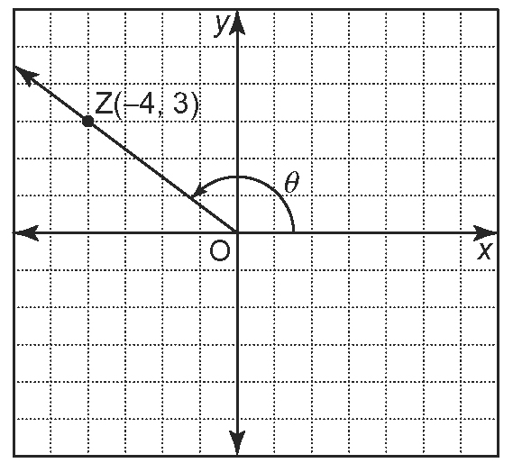
6. a), b)

c) sin θ = 0.6, cos θ = –0.8, tan θ = –0.75
7. Answers may vary. For example, point (4, 3).
For the sine values to be equal, the two angles must be supplementary. Reflect point Z(–4, 3) in the
y-axis to obtain the image point (4, 3), which is on the supplementary acute angle’s terminal arm.
8. a) Sketches may vary.
b) | Angle | Sine | Cosine | Tangent
 | 28° | 0.469 | 0.883 | 0.532
 | 145° | 0.574 | –0.819 | –0.700
 | 58° | 0.848 | 0.530 | 1.600
 | 104° | 0.970 | –0.242 | –4.011
 | 162° | 0.309 | –0.951 | –0.325
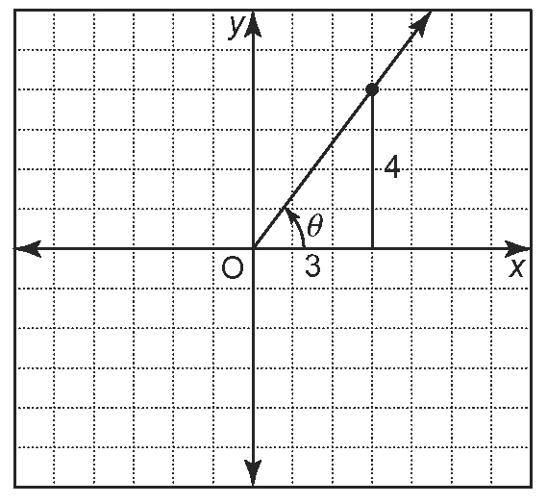
9. a)

b) Answers may vary. For example, (3, 4).
c) sin θ = , cos θ =
d) ∠θ 53.130°
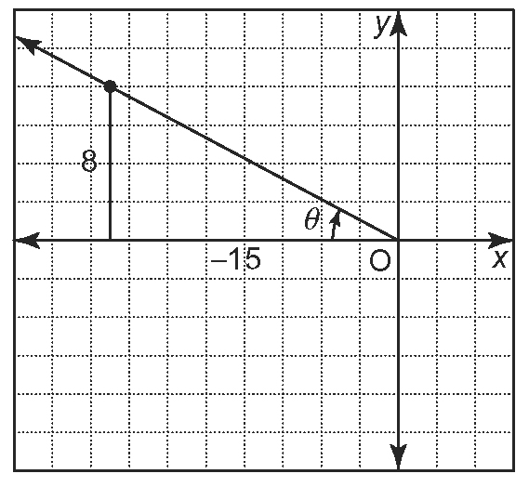
10. a)

b) Answers may vary. For example, (–15, 8).
c) sin θ = , tan θ =
d) ∠θ 151.928º

11. a) (3, 4) b) 1, 0.02 c) 53º
12. a) (−5,12) b) 0.02, 1 c) 113º
13. a) 37º b) 23º c) 127º d) 164º

BLM 2-7 Section 2.3 Sine Law
1. a) ∠θ 62º b) ∠θ 39°
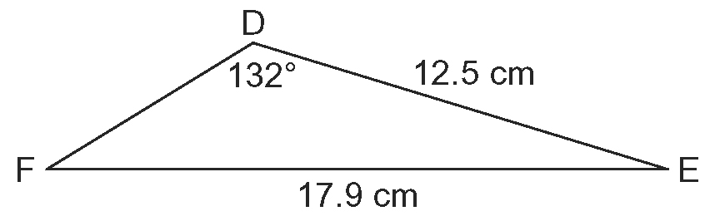
2. a)

b) ∠F 31º
3. a) x 4.3 mm b) y 0.6 cm
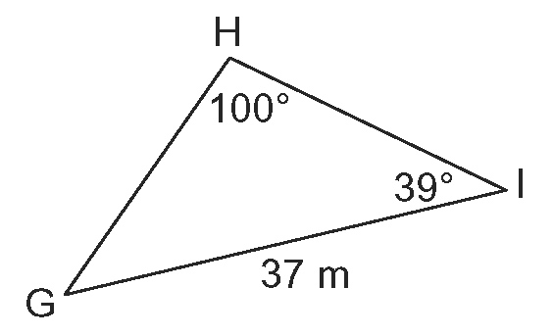
4. a)

b) g 25 m
5. a) ∠M = 35º, ∠N = 47º, n = 35.3 m
b) ∠T = 23º, t = 3.7 ft, u = 6.9 ft
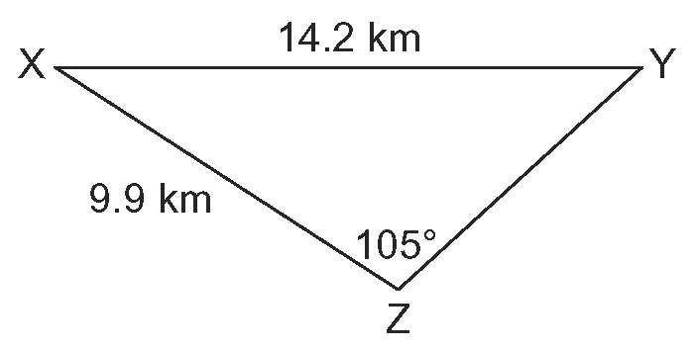
6. a)

b) ∠X = 33º, ∠Y = 42º, x = 7.9 km
7. a) station A: 36.4 km; station B: 82.0 km
b) 35.9 km
8. 10.6 m

BLM 2-8 Section 2.4 Cosine Law
1. a) c = 30 m b) d = 11.2 cm
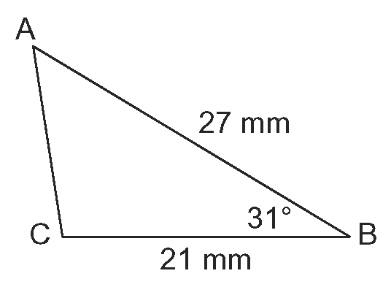
2. a)

b) b = 14 mm
3. a) ∠θ = 50º b) ∠θ = 92º

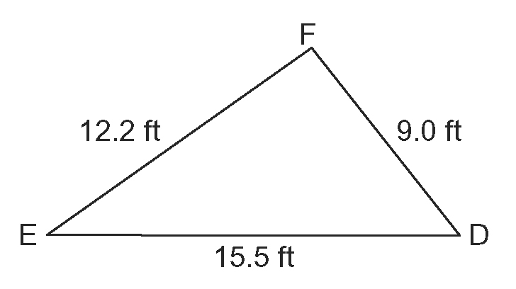
4. a)

b) ∠F = 93º
5. a) ∠L = 37º, ∠M = 46º, w = 9.1 cm
b) ∠R = 30º, ∠Q = 41º, ∠T = 109º
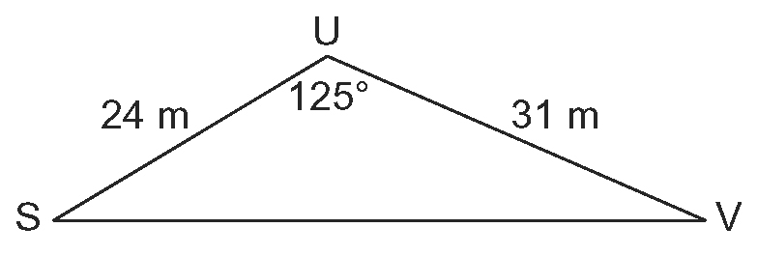
6. a)

b) ∠S = 31º, ∠V = 24º, u = 49 m
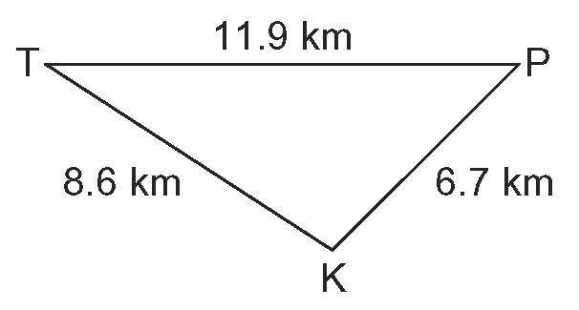
7. a)

b) ∠T = 33º, ∠P = 45º, ∠K = 101º
8. 32º, 21º, 127º

BLM 2-10 Section 2.5 Applications of Trigonometry
1. a) E b) F c) B d) C e) D f) A
2. a) f = 6.7 ft b) ∠F = 48º
c) ∠D = 42º d) ∠S = 40º
e) p = 30.9 cm f ) t = 16.0 m
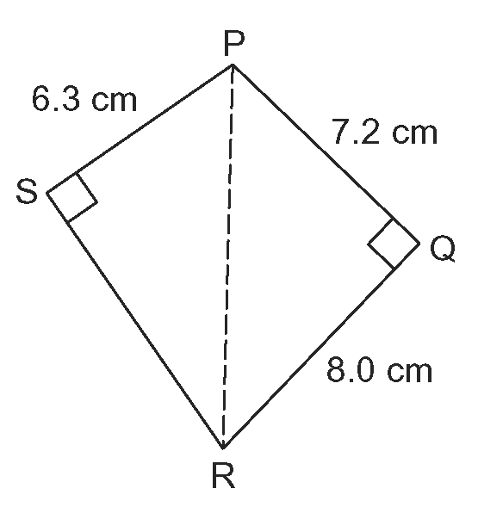
3. a)

b) RS = 8.7 cm
c) ∠P = 102º, ∠R = 78º

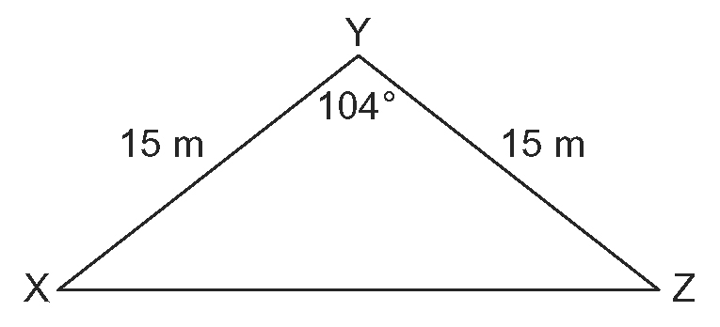
4. a)

b) y = 23.6 m
c) Methods may vary. For example, XYZ is isosceles so ∠X and ∠Y both equal 38º. Sine law can be used to obtain y = 23.6 m.
d) Answers may vary. For example, cosine law.
5. a) 13.5 km, 27.5 km b) 840 km/h
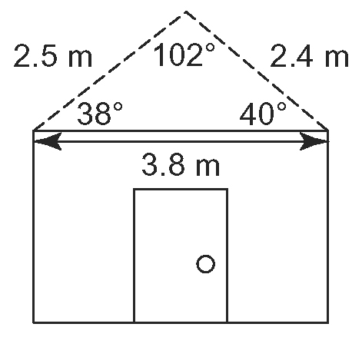
6.

7. a) 150 km b) Route A
8. 87.6 m
9. 51.5 km
10. mast: 16.0 m; gaff: 6.5 m
11. 48 490 km

BLM 2-13 Chapter 2 Review
1. a) i) sin θ = 0.75, cos θ = 0.66, tan θ = 1.15
ii) sin θ = 0.67, cos θ = 0.74, tan θ = 0.90
b) i) ∠θ = 49º, ii) ∠θ = 42º
2. a) 43 cm b) ∠θ = 34º
3. ∠T = 58º, s = 14.2 m, t = 12.0 m
4. sin θ = , cos θ = , tan θ =
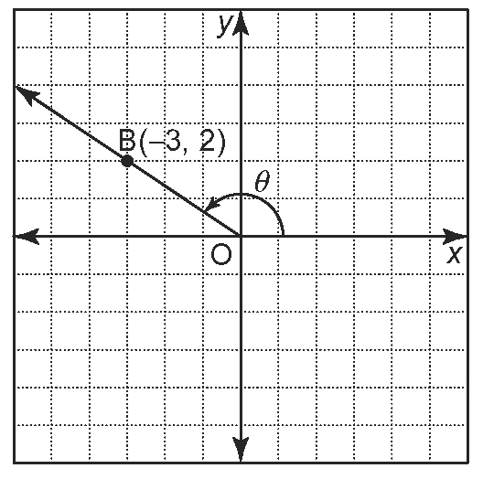
5. a)

b) sin θ = 0.555, cos θ = –0.832, tan θ = –0.667
6. 39 cm
7. ∠E = 43º, ∠V = 29º, v = 18 ft
8. d = 60 km
9. ∠D = 34º, ∠T = 17º, ∠P = 129º
10. a) 48.6 m b) 64.5º
11. 654 m

BLM 2-14 Chapter 2 Practice Test
1. B
2. D
3. B
4. 2.6 m
5. sin θ = 0.868, cos θ = –0.496, tan θ = –1.75
6. sin θ = 0.471, cos θ = 0.882, tan θ = 0.533
7. ∠J = 22.1º, ∠K = 10.9º, k = 10.1 ft
8. 109º, 39º, 32º
9. 223 m
BLM 2-15 Chapter 2 Test
1. C
2. D
3. A
4. B
5. sin θ = 0.750, cos θ = 0.661, tan θ = 1.134
6. 48.6º
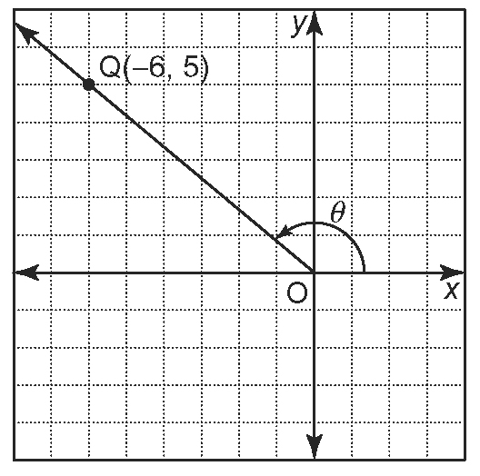
7. a)

b) sin θ = 0.640, cos θ = –0.768, tan θ = –0.833
8. ∠Y = 61º
9. Surveyor A: 7.1 km; Surveyor B: 6.1 km
10. 145.6 cm
11. 27.1 km
12. a) 9.7 km b) 20.2 km
13. a) 37 km; assume the triangle formed by the path of the ball, the goal posts, and the ground is not
right-angled
b) 14 m

