Prerequisite Skills

Statistics Terminology
1. Complete each statement with the correct term from the list.
population outlier
variance discrete data
sample primary source
secondary source bias
a) A person who collects data for their
own use is the ___________.
b) A database or research collected by someone else is a ____________.
c) The entire set of people or items
being studied is called the ____________.
d) A selection of members of a population
is called the ____________.
e) An extreme value in a set of data is
called an ____________.
f) An unwanted influence on a sample
that prevents a study from being representative of the population is
called ____________.

2. Identify each measure of central tendency.
a) The middle value when a set of data is ordered from least to greatest.
b) The sum of a set of data divided by the number of data.
c) The value or attribute that occurs most often in the set of data.

Linear Graphs
3. Graph each equation.
a) y = 3x − 2
b) y = − 4x + 2
c) y = x –
d) y = −0.63x + 3.21
Interpret Graphs
4. The graph shows the trend in temperature in Iqaluit, Nunavut during one week in July, 2008 at 2 p.m.
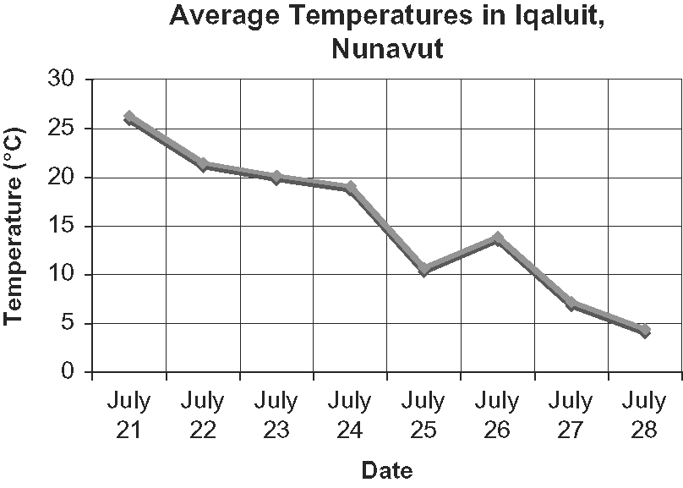
a) Identify the type of graph shown.
b) Why was a histogram not used?
Explain.
c) Which days had the highest and
lowest temperatures?

Use Technology
5. Sameer recorded the ages of student volunteers at the local library.
12, 16, 15, 14, 18, 17,
12, 18, 13, 16, 14,
13, 15, 16, 13, 14,
15, 12, 13, 15, 17,
16, 18, 17, 13, 12
a) Use a graphing calculator or dynamic statistical software to make a histogram
of the data.
b) Determine the mean, median, and mode.

