Section 3.5 Analysis and Conclusions

1. Does each situation describe a cause and effect relationship? Explain.
a) As the price of movie tickets decreases, the number of tickets purchased increases.
b) As the rabbit population increases from July until October, the temperature decreases.
c) The more posters Becky puts up advertising her craft show, the more people come to the show.
d) As a camper gets colder, she moves farther away from the campfire.

2. What is the difference between an outlier and an influential point?

3. Jeremy found this data in a magazine.

University Discipline | Average Annual Tuition Fees ($) | Average Hourly Earnings ($)
Science | 4 200 | 31
Medicine | 10 500 | 65
Law | 7 200 | 36
Engineering | 5 000 | 45
Education | 3 500 | 30
Dentistry | 13 500 | 60
Commerce | 4 000 | 25
Arts | 4 100 | 25
Architecture | 3 850 | 27

a) Make a scatter plot of the data.
b) Identify any outliers or influential points.
c) Is there a cause and effect relationship?
If so, describe it.
d) Use linear regression to model the relationship.
e) Is it valid to use a linear model? Explain.
4. Regression analysis was performed on each pair of variables, where the first variable was the independent variable. For each pair, give another independent variable that might affect the dependant variable.
a) The number of snowfalls during January; sale of ski passes in January.
b) The price of digital cameras; sale of digital cameras.
c) Distance of a house to public transit access; resale price of a house.

5. Examine the scatter plot.
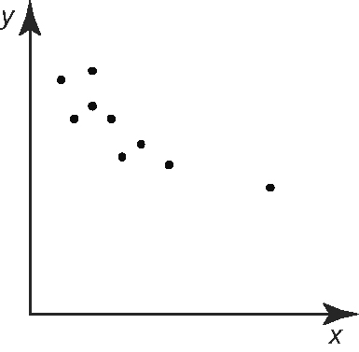
a) Is there a cause and effect relationship?
If so, describe it.
b) Is the point on the right an outlier or an influential point? Explain.
c) Describe the line of best fit with and without this point.
d) The x-axis is amount of snowfall and
the y-axis is cars on the road. Make a conclusion about this data.

6. A young swimmer has adopted a new practice method for working on her front crawl. After trying the new method for a couple of days, she invites a few members
of her family to watch her swim. Each of
the family members agrees that the new method has produced better results than the usual practice methods.
a) Does this agreement imply that the swimmer should adopt the new method? Explain.
b) Describe a better way of testing the effectiveness of the new practice method.

