Chapter 3 Review

3.1 Two-Variable Data Sets, pages 142–151
1. Do the following graphical organizers display one-variable or two-variable data?
a) dot plot
b) scatter plot
c) bar graph
d) box-and-whisker plot
e) line graph
f) circle graph

2. A education researcher recorded students’ grades in English and mathematics, and displayed the data in a scatter plot.
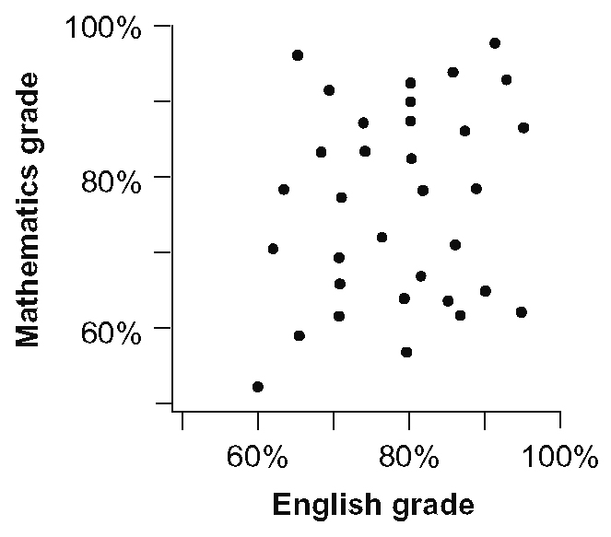
a) Explain why a scatter plot was used to display the data.
b) What do you know about each person?
c) Pose a question that would require
two-variable data analysis.

3.2 Effective Surveys, pages 152–159
3. The owners of a newspaper intend to conduct a short survey to determine subscribers' level of satisfaction with the newspaper. Write two three-question
surveys for the newspaper, one following
the principles of surveying and the other breaking the rules.

4. Give an example of each survey question type below that would relate to a
high school student council.
a) Dichotomous
b) Multiple Choice
c) Rating Scale
d) Completion
e) Open-ended

5. A survey included this question:
“What is your favourite CFL team?
A Calgary Stampeders
B Hamilton Tiger-Cats
C Toronto Argonauts
D Other: _______________________”
What could be changed or added to make the question more inclusive?

3.3 Collect and Organize Data, pages 160–167
6. Wallace measured the masses, in kilograms, of fish caught on a camping trip. Identify the outlier and calculate the mean mass with and without the outlier.
0.8 | 0.4 | 1.4 | 0.7
1.1 | 4.0 | 0.7 | 1.0

7. Identify whether the data in each situation
is primary data or secondary data. Explain your choice.
a) A circle graph published in a newspaper is converted into a bar graph for an accounting report.
b) A student who was researching the impact of oil prices on the Canadian economy downloaded data from government
Web sites.
c) An airport investigates the number of cars in their overnight parking lot each day for two weeks.
d) A student compares the number of red jellybeans in four different packages of assorted jellybeans.
8. A market research firm surveyed 10 Internet advertisers to determine the effectiveness of Internet advertising. Make a scatter plot of the data.

Change in Advertising Budget (%) | Change in  Sales (%)
2.1 | 1.8
–1.2 | –3.6
10.6 | 12.9
6.7 | 8.1
21.3 | 42.5
–10.6 | –8.8
12.5 | 12.7
9.9 | 11.3
15.0 | 12.2
6.4 | 10.2

3.4 The Line of Best Fit, pages 168–179
9. Illustrate the general appearance of a scatter plot associated with each value of the correlation coefficient.
a) r = − 0.9
b) r = 0.75

10. Determine an equation for the line of
best fit of the data in question 9. Classify
the correlation and indicate whether the line
of best fit is appropriate.

11. Would the correlation coefficient be positive, negative, or zero for each situation?
a) number of minutes with the tap running versus volume of water in a bath tub
b) height versus grade of a science test
c) number of songs stored versus amount
of storage space remaining on the
MP3 player

3.5 Analysis and Conclusions, pages 182–189
12. Examine the scatter plot in question 2. Does there appear to be a cause and effect relationship? Explain.

13. Tankless or on-demand water heaters can be used to replace traditional hot water tanks. They use much less energy and take up less space. A manufacturer’s Web site shows this table comparing the number of litres per minute of hot water with the power of the available heaters, in kilowatts.
Electricity (kW) | Hot Water (L/min)
12 | 5.2
15 | 6.1
20 | 8.3
24 | 10.3
29 | 12.5
36 | 15.5
Perform regression analysis to determine the strength of the relationship and the equation of the line of best fit. Discuss whether a cause and effect relationship exists.

14. The price of entrance and the number of attendees at a theme park over several years is shown.
Year | Entrance Fee ($) | Number of Attendees (100 000s)
2000 | 9.95 | 15.1
2001 | 10.75 | 16.5
2002 | 11.50 | 17.0
2003 | 12.00 | 16.5
2004 | 12.00 | 18.5
2005 | 12.75 | 18.0
2006 | 14.00 | 16.0
2007 | 14.50 | 16.0
Perform regression analysis to determine
the equation of the line of best fit.
Discuss whether a cause and effect relationship exists.

