Chapter 3 Practice Test

For questions 1 to 4, select the best answer.

1. Which situation involves bias when surveying customers at a restaurant?
A Giving questionnaires to every
tenth customer.
B Giving questionnaires to big tippers.
C Giving questionnaires to customers
whose last name starts with an S.
D Giving questionnaires to customers if their bill ends in a 0.

2. What is the name of a point that follows
the trend in the data and affects the slope
of the regression line?
A outlier
B bias point
C influential point
D erratic

3. The correlation coefficient, r, for a set
of data is − 0.5. Which percent represents
the accuracy of predictions made from a model of this data?
A 0%
B 25%
C 50%
D 100%

4. What do you know about the slope
of the line of best fit if r² = 0.5?
A It is positive.
B It is horizontal.
C It is negative.
D It is not horizontal.

5. Is each statement true or false?
a) Scatter plots display single variable data.
b) For a cause and effect relationship to exist, a change in the independent variable must result in a change in the dependent variable.
c) A dichotomous question is designed to have at least three responses: "yes,” “no,” and “maybe.”
d) Primary data is information that is made available by others.

6. Describe each type of survey question.
a) Dichotomous
b) Multiple Choice
c) Rating Scale
d) Completion
e) Open-ended

7. Describe the error in regression for each example.
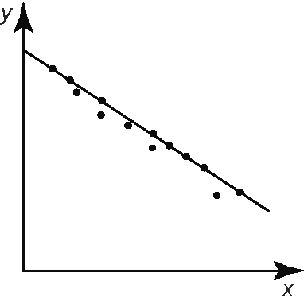
a)

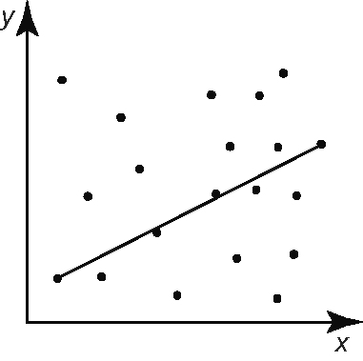
b)

8. A doctor is looking for relationships between her patients' mass and their blood pressure.
a) Set up a recording sheet that could be used in this study.
b) Is the doctor using an observational study, an experiment, or secondary data? Explain.
9. A train driver checked the time since departure when the train passed
various checkpoints.
Distance (km) | Time (min)
4 | 3.0
10 | 7.5
20 | 15.0
25 | 18.75
30 | 22.5
40 | 30.0
50 | 37.5
60 | 45.0
80 | 60.0
a) Draw a scatter plot of the data on
graph paper.
b) Describe the relationship between
the variables.
c) Use algebra to determine the equation
of the line of best fit.

10. The cost of purchasing one dozen eggs in Canada over several years is shown.
Year | Cost ($)
1900 | 0.26
1914 | 0.45
1929 | 0.65
1933 | 0.45
1945 | 0.56
1955 | 0.70
1965 | 0.64
1975 | 0.92
1985 | 1.34
1995 | 1.63
2005 | 2.22
Perform regression analysis to determine
the equation of the line of best fit. Discuss whether a cause and effect relationship exists.

11. While searching for an apartment in Toronto, Geoff found a property management company that advertised its monthly rent and the floor space of its apartments.
Apartment Area (ft²) | Monthly Rent  ($)
610 | 700
870 | 900
579 | 620
767 | 850
463 | 550
930 | 910
1025 | 900
700 | 680
585 | 644
650 | 650
752 | 720
875 | 850
a) Make a scatter plot of the data.
b) Is there a cause and effect relationship?
If so, describe it.
c) Use linear regression to model this relationship algebraically.
d) How well does the regression equation fit the data? Explain.
e) Give the slope and y-intercept, and interpret their meanings.
f) Explain how Geoff could use the equation to choose an apartment.

