Chapter 3 Test

1. Is each statement true or false?
a) A dot plot is a statistical graph used
to display data with two or more variables.
b) Bias can be caused by the wording
of survey questions.
c) Secondary data is information that is made available by others.
d) The closer the correlation coefficient,
r, is to 0, the better the regression
equation fits the set of data.

2. Describe one advantage of each type of survey delivery.
a) Internet
b) telephone
c) personal interview

3. Kenard downloaded the results of a
survey that asked these questions.
“How old are you?”
“What is your occupation?”
“How long have you worked at your
current job?”
What would the column headings
be for the summary table?

4. Make a scatter plot associated with
each value of the correlation coefficient.
a) r = −1
b) r = 0.5
c) r = −0.9

5. Does each situation describe a cause and effect relationship? Explain.
a) As the amount of time a football
team has possession of the ball
increases, their score increases.
b) As students' heights increase, their
grades increase.
6. Identify whether the data in each situation
is primary data or secondary data. Explain your choice.
a) A teacher uses a scatter plot to compare her students’ grades in science and mathematics.
b) A student makes a circle graph using data on movie attendance he gathered from two different Web sites.

7. Describe the error in regression for this scatter plot.
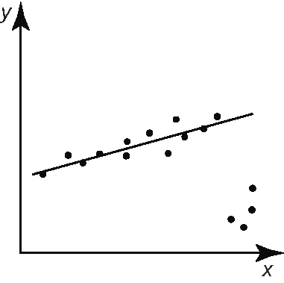

8. A market research firm surveyed several advertisers to determine the effectiveness
of magazine advertising.
Change in Advertising Budget (%) | Change in  Sales  (%)
–9.6 | –7.9
11.5 | 12.2
–2.0 | –1.6
–10.0 | –12.4
22.1 | 21.8
1.2 | 2.5
6.7 | 8.1
0 | 1.4
15.0 | 16.2
5.4 | 8.5
a) Make a scatter plot of the data.
b) Perform regression analysis to determine the equation of the line of best fit and the strength of the relationship.
c) Is there a cause and effect relationship? Explain.

