Chapter 3 BLM Answers

BLM 3-1 Prerequisite Skills
1. a) primary source b) secondary source
c) population d) sample
e) outlier f) bias
2. a) median b) mean c) mode
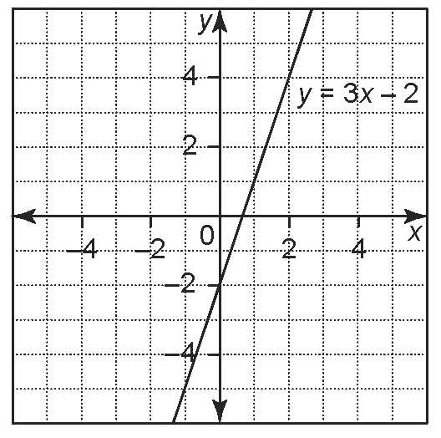
3. a)

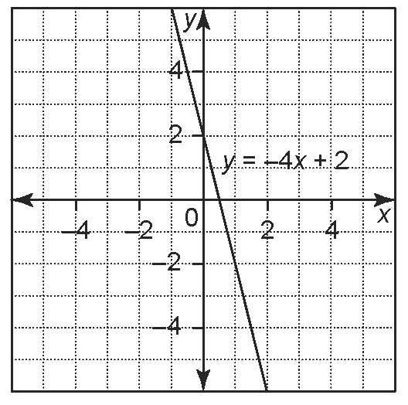
b)

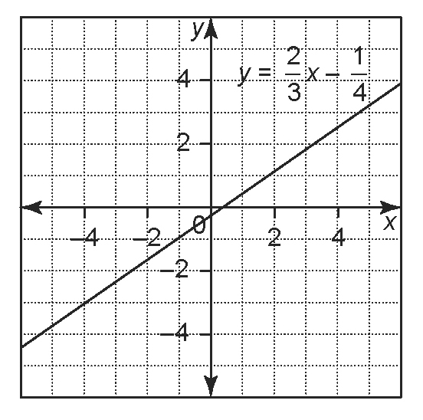
c)

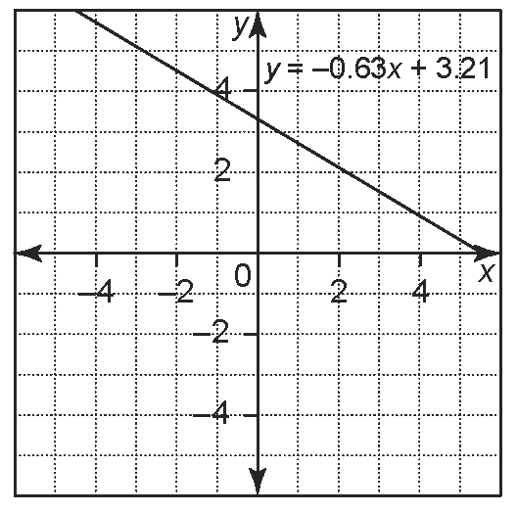
d)

4. a) line graph b) The data is continuous.
c) highest: July 21; lowest: July 28
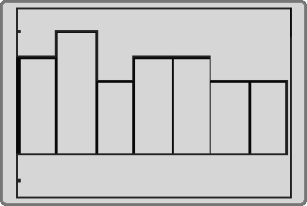
5. a)

Xmin = 12, Xmax = 19, Xscl = 1, Ymin = 1.50345, Ymax = 5.85, Yscl = 1
b) mean: 14.8, median: 15, mode: 13

BLM 3-3 Section 3.1 Two-Variable
Data Sets
1. a) two-variable; two different time values
b) one-variable; just one value (laptops sold)
c) two-variable; distance and volume of gas
d) one-variable; just one value (volume of
shampoo sold)
For one-variable data sets, you know one attribute about each subject. For two-variable data sets, you know two attributes about each subject.
2. a)
Language | Number of Ontario Speakers (100 000s)
English | 102
French | 5
Chinese languages | 4
Italian | 2
Portuguese | 1
b) The number of people in Ontario who speak
the language.
c) one-variable; language is a category
d) The number of people in Ontario who speak
each language.
e)
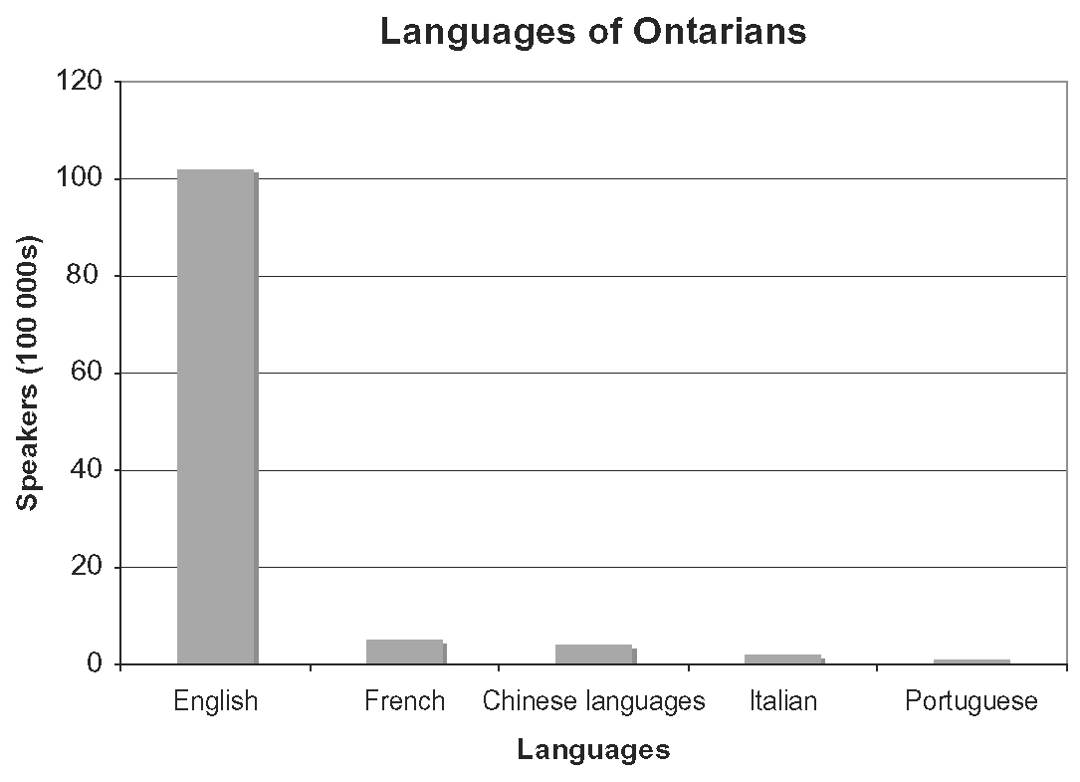
3. a) The percent of the total time spent watching Canadian and foreign programs.
b) Answers may vary. For example, double bar graph to compare all types and see the breakdown of Canadian and foreign programming.
c) Answers may vary. For example: "What types of programming are watched the most?"
d) Answers may vary. For example: "For which types of programming do Canadians spend
more time watching Canadian programs than foreign programs?"

BLM 3-4 Section 3.2 Effective Surveys
1. Answers may vary. For example:
a) "Do you own more than one television?"
b) "Which of the following do you use the most?
A. computer B. television
C. stereo or MP3 player D. other: _____"
c) "How likely are you to purchase a new television in the next year?
Very unlikely 1 2 3 4 5 Very likely"
d) "How old are you? _______"
e) "What added features would you like to see on an entertainment system?"
2. Make the question a completion or open-ended question rather than listing only a few choices.
3. Answers may vary. For example:
Following the principles of surveying:
A How many people are in your
household? ____
B How much is your monthly grocery bill?
under $100 $100 to $200 $200 to $300
$300 to $400 over $400
C How many times per month do you go
grocery shopping? ____
D Rate the wait time at checkouts from
acceptable (1) to unacceptable (5).
1 2 3 4 5
Breaking the rules:
A What is your name? _______
B What is your age? ________
C How much money do you make? ________
D You wouldn’t mind if prices of premium foods increased a tiny bit, would you? Yes / No
4. The first part of the question makes you question the mayor’s motivations.
“Do you think Mayor Royce will follow
through with his plan to increase salaries for
city employees?”
5. Respondents may not understand all
the terminology.
6. Question A: use categories of ages so respondents do not have to give their exact age. Question C: ask for the number of cups instead of using categories. Question D: ask respondents to list their three favourite beverages instead of using a rating system. Question E: change question to “What do you think of the service at our shop?” to reduce bias.

BLM 3-6 Section 3.3 Collect and
Organize Data
1. a) It is first-hand or primary information.
b) Secondary data is collected from data that has been made available and then reused.
2. a) Yes. This data is collected through the
Canadian census.
b) There might be errors in the data, the researcher might not state how the data was collected, and there may be limitations to its use.
c) You do not have to spend time designing a survey and collecting data.
3. a) Record the data. b) Ask people at random.
4. Language Spoken at Home, Occupation, Years Lived in Canada
5. The rural population in 1851 represented about 87% of the total population but in 2001 it represented only 20% of the total population.
6. a) to d) Answers may vary.
e) They could plan to have more staff in the library at the busiest times.
f) The data is gathered by observing people, not by asking them questions.
7. Answers may vary. For example: I tested people’s ability to hit a target with a nickel dropped from heights of 0.5 m, 1.0 m, 1.5 m, and 2.0 m. For the target, I put a 1-cm dot in the middle of a sheet of paper, then measured the distance from the centre of the dot to the dropped coin. Each person tried three times from each height and I calculated the mean distance from the target. As the height increased, the accuracy decreased. Also, the distance people would miss the target by increased by a greater amount as the drop height increased by a constant amount. So, as the height increases, the difficulty of hitting the target increases very quickly. I used Fathom™ to organize the data and create a scatter plot of Mean Distance from Target versus Height to confirm my conclusion.

BLM 3-7 Section 3.4 The Line of Best Fit
1. Graphs may vary. For example:
a) Scatter plot with dots on a line, positive slope.
b) Scatter plot with dots clustered around the line, positive slope.
c) Scatter plot with dots somewhat clustered around the line, negative slope.
d) Scatter plot with dots closely clustered around the line, negative slope.
2. a) zero b) negative
c) zero d) negative
3. a)
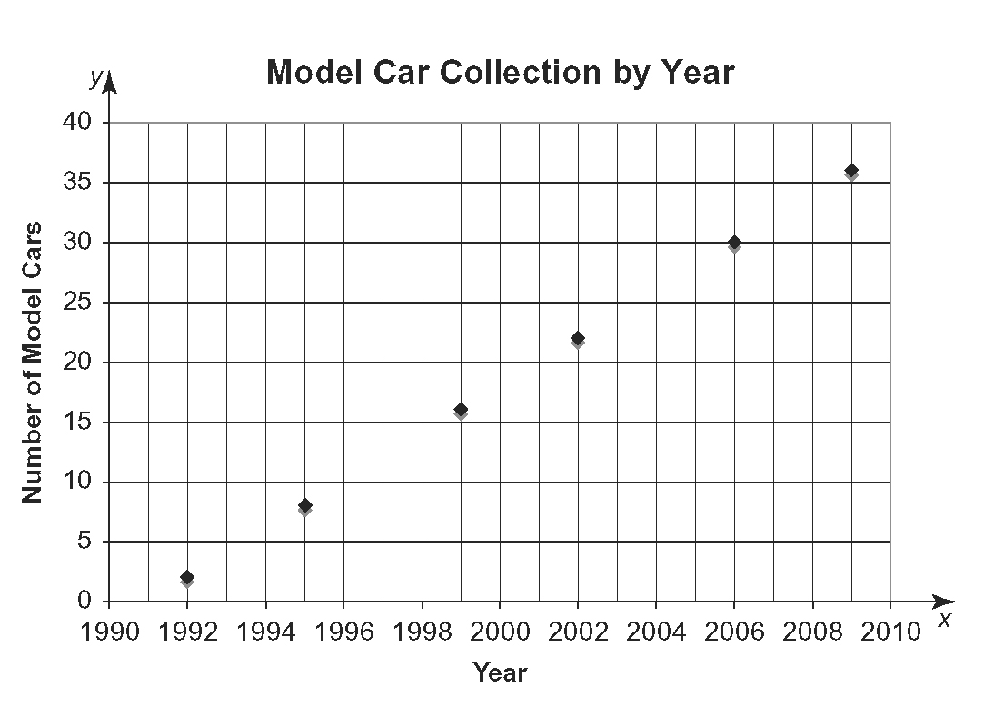
b) As the years after 1991 increase, the number
of model cars increases by two.
c) y = 2x – 3982
4. a)
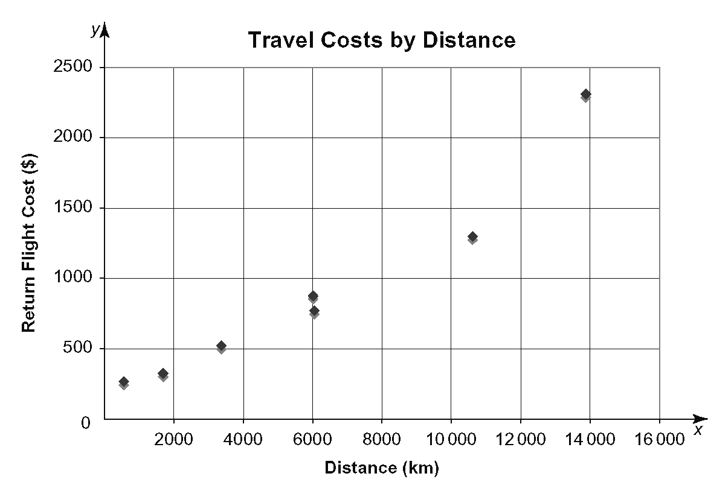
b) y = 0.14x + 40.8
c) Closely. But the data appears to curve up slightly instead of being linear.
d) The slope is 0.14. For every kilometre
travelled from Toronto, the price increases $0.14. The y-intercept is 40. The price is $40 plus a rate per kilometre travelled.
e) Answers may vary. For example, choose a budget for the flight, and then calculate approximately how far she can travel. Or, choose a destination, then use the equation to approximate the flight cost.
f) Answers may vary. For example, airport fees, government regulations, and the popularity of
a destination.

BLM 3-9 Section 3.5 Analysis and Conclusions
1. a) Yes. People will buy more movie tickets at a lower price.
b) No. Population increase and temperature decrease have separate causes.
c) Yes. If more people know about the craft show, more people are likely to attend.
d) No. The relationship is reversed. A camper who is colder would move closer to a campfire.
2. An influential point follows the same pattern as the other points and an outlier does not.
3. a)
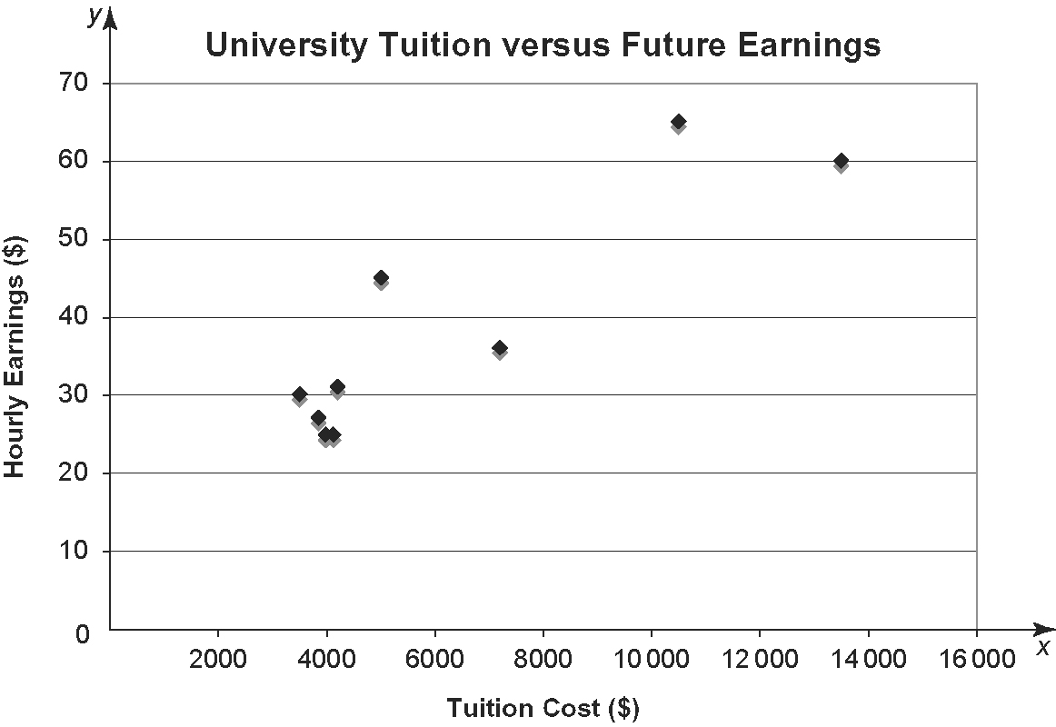
b) The point for dentistry (13 500, 60) is influential, since it is far from the first 7 points but follows the same pattern. There is not enough data to confirm that any points
are outliers.
c) Yes, as tuition costs increase, hourly earnings tend to increase.
d) y = 0.0038x + 14.48
e) No. It does not allow for earnings of less than $14.48/h.
4. a) The accumulation of snow during January.
b) Models of digital cameras available.
c) Amount spent on renovations.
5. a) Yes. As the x-values increase, the y-values tend to decrease.
b) An influential point. It follows the same pattern as the other points.
c) The line of best fit slopes downward left to right. The slope would be steeper without the influential point.
d) As the amount of snowfall increases, there tend to be fewer cars on the road.

6. a) Possibly. More testing is needed to determine if the swimmer's improvement is really a result of the new method.
b) Answers may vary. For example, have criteria such as speed and style as judged by a coach to test for improvement.

BLM 3-12 Chapter 3 Review
1. a), c), d), f) one-variable data
b), e) two-variable data
2. a) The data is two-variable data without categories.
b) The person's grade in English and mathematics.
c) Answers may vary. For example: "What range of grades do students who score less than 60% in mathematics score in English?"
3. Answers may vary. For example:
Following the principles of surveying:
A How many people are in your household? ____
B How much time per day do you spend reading newspapers? ____
C What do you think is a reasonable cost of a weekday newspaper? _____
Breaking the rules:
A What is your phone number? (You may be contacted for subscription sales.) ____
B How much money do you make? ____
C Do you agree that Internet news lacks the integrity of established newspapers? Yes / No
4. Answers may vary. For example:
a) "Do you think the current student council is doing a good job?"
b) "Which student council position would you
like to hold?
A. president B. vice president
C. treasurer D. social rep."
c) "How likely would you be to attend a semi-formal in November?
Very unlikely 1 2 3 4 5 Very likely
d) "Which candidate would make the best
student council president? ___________"
e) "What activities would you like the student council to organize this year?"
5. Either include all the teams or make it a completion question.
6. outlier: 4.0; mean with outlier: 1.26; mean without outlier: 0.87
7. a), b) secondary data c), d) primary data
8.
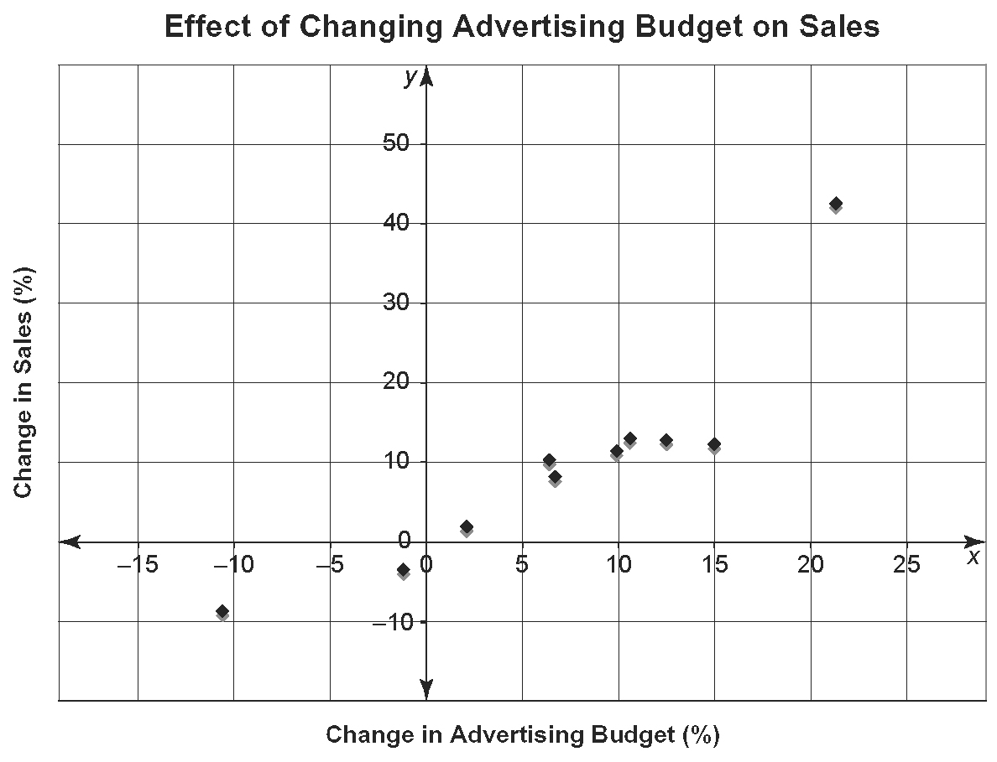
9. Graphs may vary. For example:
a) Scatter plot with dots closely clustered around the line, negative slope.
b) Scatter plot with dots clustered around the line, positive slope.
10. a) very strong negative correlation
b) strong positive correlation
11. a) positive b) zero c) negative
12. No. The correlation coefficient is zero.
13. y = 0.44x − 0.29. The correlation coefficient is almost 1. There is a very strong relationship between the electricity used and the amount of water that can be heated in a minute.
14. y = 0.07x + 15.8. The correlation coefficient is 0.1. The is no strong linear relationship between the entrance fee and the number of attendees. Performing a quadratic regression analysis, the coefficient is 0.7, which is stronger and indicates there is a cause and effect relationship, where attendance increases to a maximum fee and then decreases when the maximum is reached.

BLM 3-13 Chapter 3 Practice Test
1. B
2. C
3. B
4. D
5. a), c), d) false b) true
6. a) A question with only two options.
b) A question with more than two options.
c) A question with several choices in a
rating scale.
d) A question with space for a short, one-word answer not from a list.
e) A question with space for a long answer.
7. a) The points below the line are not included.
b) There is no correlation so the line should
be horizontal.

8. a)
Mass (kg) | Blood Pressure
b) Observational study. She is gathering information by observing, not by asking questions or looking at another doctor's research.
9. a)
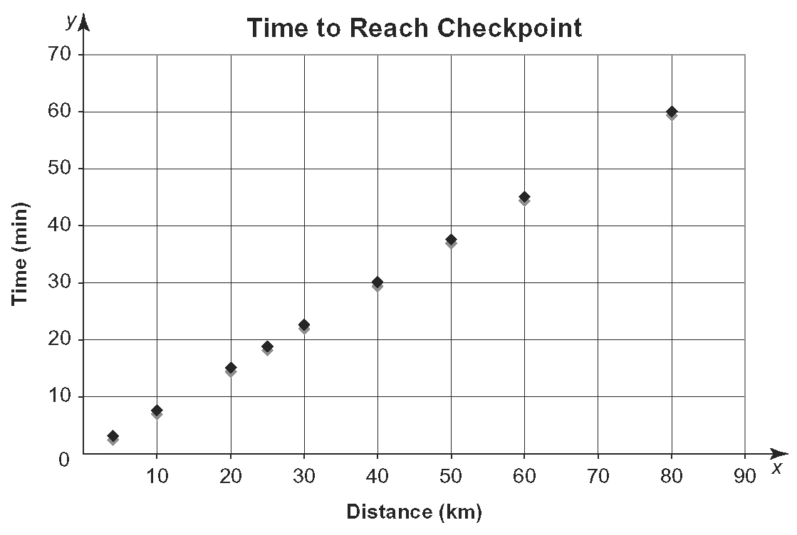
b) As the distance increases, the time increases.
c) y = x
10. y = 0.02x − 29.7. The correlation coefficient is approximately 0.9. There is a strong relationship between the year or time and the cost of one
dozen eggs.
11. a) 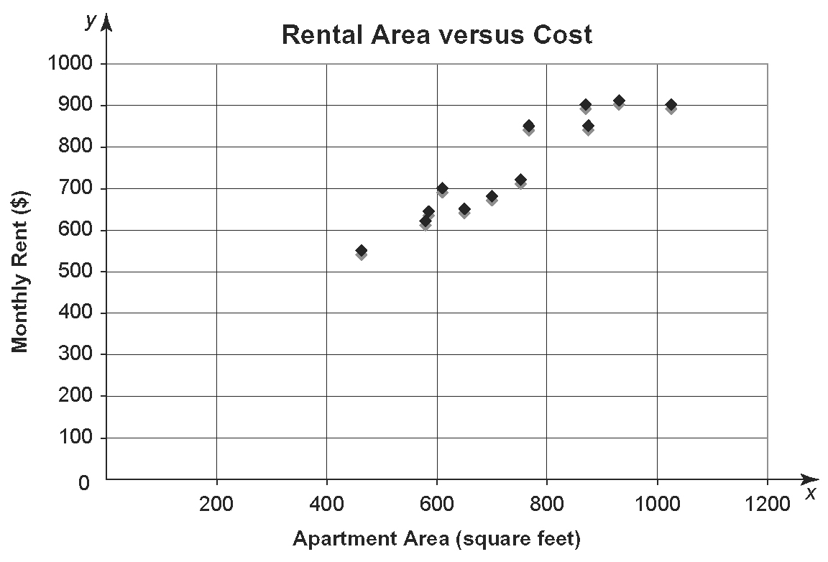
b) Yes. As apartment area increases, rent tends
to increase.
c) y = 0.72x + 222
d) Very closely, r = 0.94.
e) The slope is 0.72. The price per square foot
is $0.72. The y-intercept is 222. The base cost for an apartment is $222 plus the cost per
square foot.
f) He could determine his budget and then find appropriately sized apartments. Or he could determine how much area he would like and then determine the rent required.
BLM 3-14 Chapter 3 Test
1. a), d) false b), c) true
2. Answers may vary. For example:
a) Graphics and videos can be included as part of the survey.
b) Many people can be contacted in a short period of time.
c) Can contact people who cannot be reached in other ways.
3. Age, Occupation, Years at Current Job
4. Graphs may vary. For example:
a) Scatter plot with dots on the line, negative slope.
b) Scatter plot with dots somewhat clustered around the line, positive slope.
c) Scatter plot with dots closely clustered around the line, negative slope.
5. a) Yes. The team has a greater chance of scoring points the longer they have possession
of the ball.
b) No. Being taller does not lead to getting better grades. Increased study time would lead to increased grades.
6. a) primary data; teacher gathered the data herself
b) secondary data; student gathered data from someone else
7. The outliers on the right are not included in the line of best fit.
8. a) 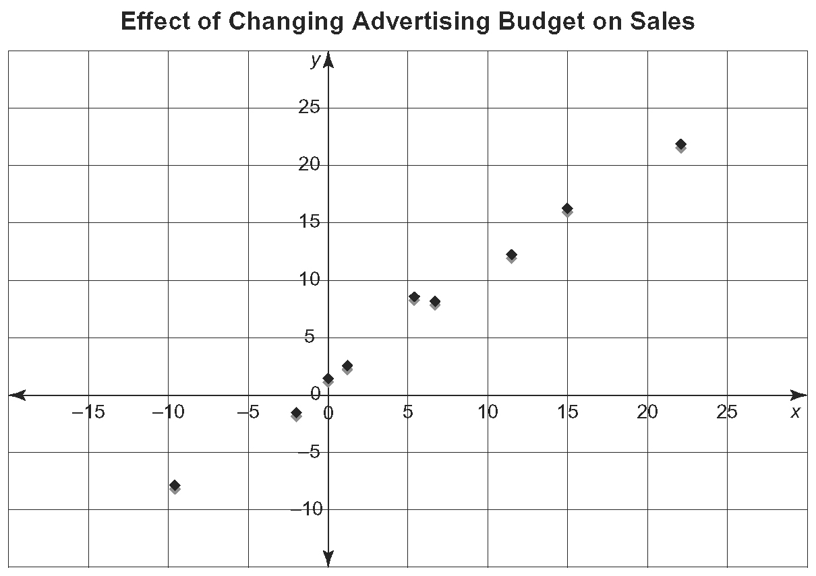
b) The line of best fit is y = 1.02x + 0.77.
Since r = 0.99, the fit is very good.
c) Yes. When the money spent on advertising changes, the amount of sales changes by a similar percent.

