Prerequisite Skills

Rates
1. Calculate each unit rate to two
decimal places.
a) Five crates of oranges cost $11.25.
What is the cost per crate?
b) 20 kg of flour costs $85.50. What is the cost per kilogram?
c) Renee walked 300 m in 200 s. What was her average speed?
d) 81 475 households contain 316 950 individuals. What is the average number of individuals per household?

2. Oak hardwood flooring costs $45.00/m². What is the cost to purchase enough
flooring to cover an area of 80 m²?

3. Foam peanuts sell for $3.49/ft³. How many cubic feet of foam peanuts can you buy
for $40?

Percent
4. Calculate each mark as a percent rounded
to one decimal place.
a) A mark of 17 out of 20.
b) A mark of 25 out of 40.
c) A mark of 52 out of 70.
d) A mark of 30 out of 66.

5. Andre drove to his brother's town and used 70% of a full tank of gasoline. The tank can hold 80 L of gasoline.
a) How many litres of gasoline were consumed?
b) How many litres of gasoline were remaining?
6. The price of a tonne of road salt increased by 150%. If the original price was $50, what is the new price?

Measures of Central Tendency
7. The stopping distances, in metres, for a car performing 11 brake tests are listed.
49, 41, 49, 45, 47, 40,
43, 51, 42, 48, 52
Determine the mean, median, and mode stopping distance to two decimal places.

8. A meteorologist recorded the average monthly precipitation, in millimetres, in Toronto over one year.
45.9, 45.5, 55.9, 63.5,
66.0, 68.9, 76.2, 83.8,
73.7, 63.5, 71.1, 65.7
Determine the mean, median, and mode average monthly precipitation to two
decimal places.

9. The mean mass of a bag of grapefruit in an order of 30 bags of grapefruit was 4.58 kg per bag. What was the total mass of grapefruit in the order?

10. A camp counsellor recorded the heights, in centimetres, of the campers in the dining hall one morning.
147.6, 148.4, 153.6, 158.1,
153.5, 159.2, 139.8, 137.5,
160.9, 162.0, 166.3, 170.2,
142.6, 159.6, 164.1, 163.8,
157.4, 160.9, 155.3, 147.9
Determine the mean, median, and mode height to two decimal places.

Statistical Graphs
11. This graph shows the national direct and indirect household energy use, in petajoules, for Canada from 1993 to 2003. The data was compiled by Statistics Canada from Statistics Canada surveys and statistical methods were used to estimate data that were not available.
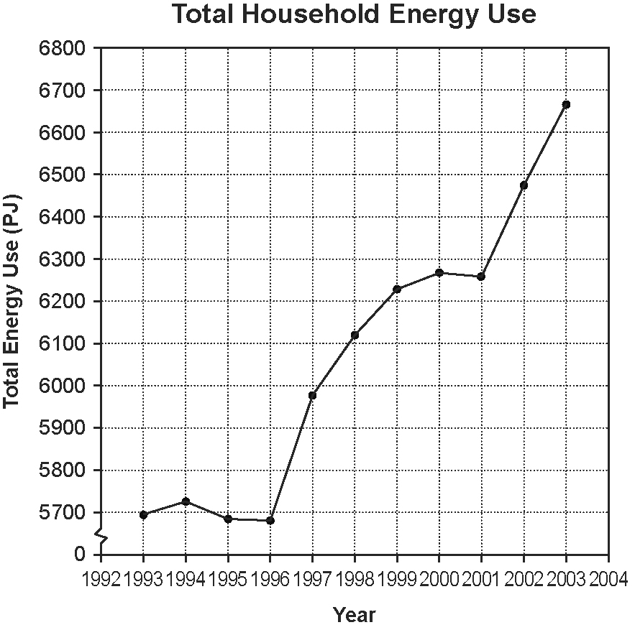
Source: Statistics Canada, CANSIM Table
153-0046 Database: E-STAT

a) Is the graph an example of primary or secondary research by Statistics Canada?
b) Why was a line graph used instead of a bar graph?
c) Approximate the increase in total household energy use from 2001 to 2003.
12. For each scatter plot, state whether there is a strong linear correlation or a weak linear correlation between the two variables.
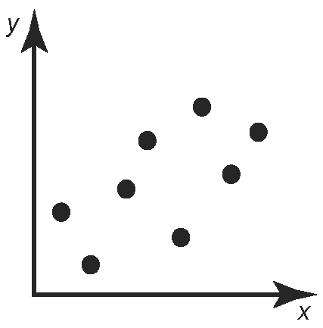
a)

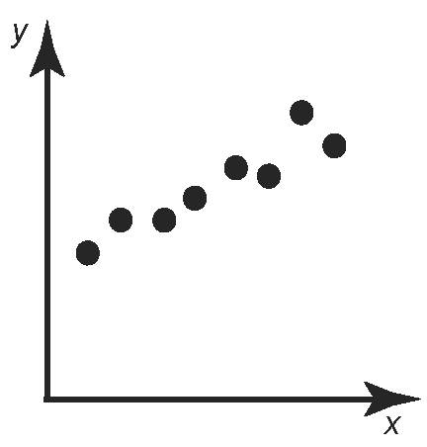
b)

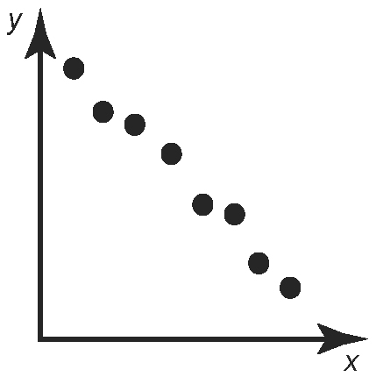
c)

