Section 4.2 Statistical Indices

1. The CPI weight for dairy products is 1.69%, and for bakery products is 1.13%, because people spend more money on dairy products than on bakery products. How would the effect of a 5% increase in the price of dairy products compare to a 5% increase in the price of bakery products?

2. The Air Quality Health Index (AQHI) measures the level of many air pollutants.
It has a scale from 1 (low health risk) to 10 (high health risk). The graph shows the AQHI for Ottawa for one week.
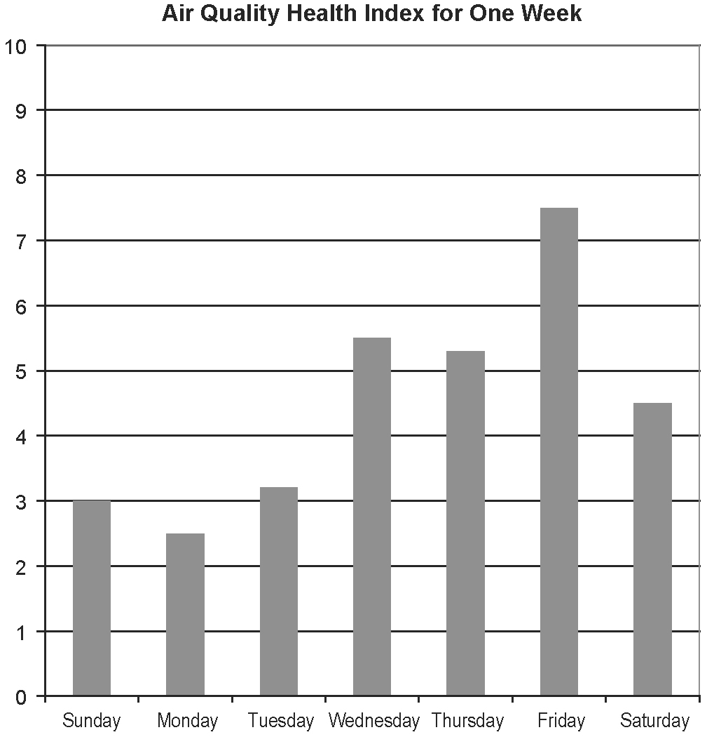

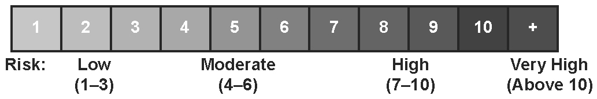
a) Estimate the value of the index for each day of the week. Classify the health risk for each day.
b) By what factor did the index increase between Wednesday and Friday?
c) Calculate the percent decrease from Friday to Saturday.
3. Each year, the Employment Insurance (EI) premium rates in Canada are adjusted based on the forecasted revenues and payments of the program for that year. The employee EI premium rates for 2004 to 2006 are shown
in the table.
Year | Employee EI Premium Rate (%)
2004 | 1.98
2005 | 1.95
2006 | 1.87
a) Calculate the percent decrease in the employee EI premium rate from 2004
to 2006.
b) The yearly maximum employee EI premium in 2004 was $772.20. Calculate the yearly maximum employee EI premium in 2006.

4. On January 2, 2004, Raquel invested $2000 in a fund that mirrors the Toronto Stock Exchange Index. She recorded the value of the TSX on that day as 8293.70.
a) Calculate the value of Raquel’s investment on January 2, 2008, when the TSX was 13 833.06.
b) The CPI showed inflation was approximately 9.5% from January 2, 2004 to January 2, 2008. Determine the real value of Raquel’s investment on
January 2, 2008.
c) Is Raquel ahead of inflation or has she lost money in a real sense?

5. The graph shows the value of the Gasoline Price Index (GPI) for each month in 2007 and 2008.
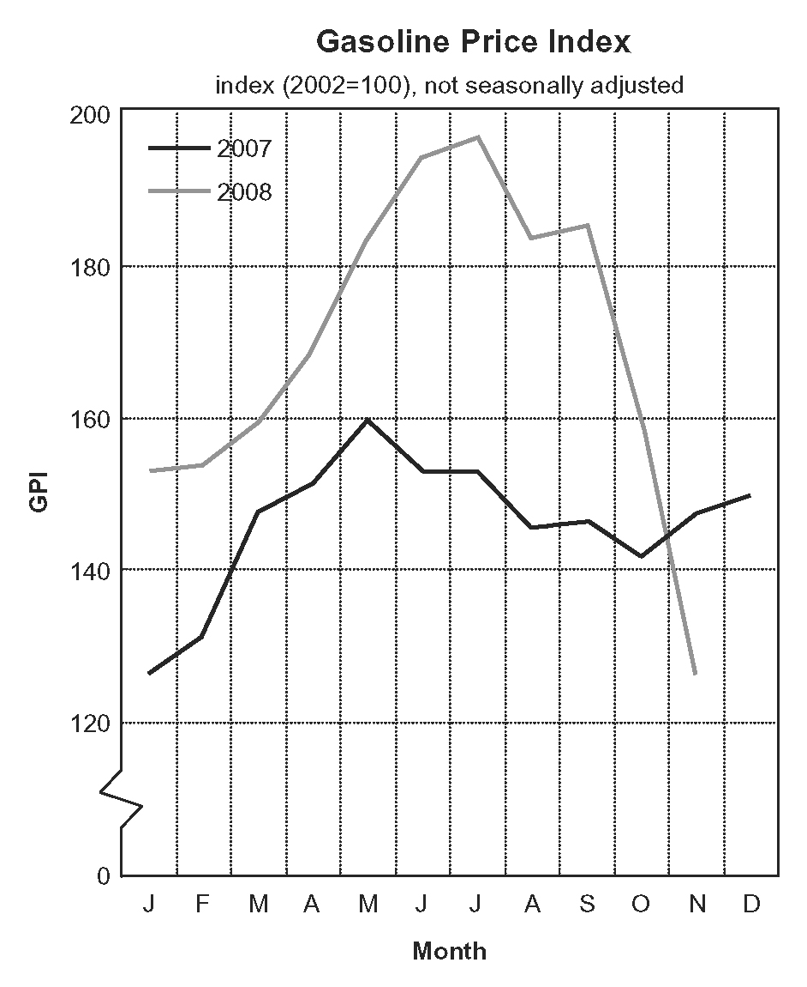
Adapted from: Statistics Canada. http://www.statcan.gc.ca/daily-quotidien/081219/cg081219b-eng.htm,
Jan 23, 2009
a) Explain what is meant by 2002 = 100.
b) Describe the changes in the GPI in 2008 relative to the changes in the GPI in 2007.
c) Explain how comparing the value of a price index over different years may help an economist to find and predict seasonal trends.
6. The UV Index is a measure of the intensity of the sun’s ultraviolet (UV) radiation. The greater the UV Index, the greater the potential harm to your skin, eyes, and immune system.
UV Index | Category
11+ | extreme
8 to 10 | very high
6 to 7 | high
3 to 5 | moderate
0 to 2 | low
a) The UV Index for London, Ontario, measured 3.5 on Wednesday, but increased to 6.1 on Thursday. What was the percent increase in the index?
b) One day, the UV Index measured 7.2 in Toronto and 3.4 in Ottawa. By what factor was Ottawa’s measure less than the measure in Toronto?

7. On December 4, 2005, Francis invested $1500 in a fund that mirrors the Toronto Stock Exchange Index. He recorded the value of the TSX on that day as 11 005.24.
a) Calculate the value of Francis’ investment on September 4, 2008, when the TSX was 12 814.14.
b) The CPI showed inflation was approximately 9.3% from December 4, 2005 to September 4, 2008. Determine the real value of Francis’ investment on December 4, 2008.
c) Is Francis ahead of inflation or has he lost money in a real sense?
d) Francis decided to keep his money invested. Calculate the value of Francis’ investment on December 4, 2008, when the TSX was 8057.52.
e) The CPI showed inflation was approximately 9.4% from December 4, 2005 to December 4, 2008. Determine the real value of Francis’ investment on December 4, 2008.
f) Is Francis ahead of inflation or has he lost money in a real sense?

