Section 4.3 Interpret Statistics in the Media

1. Write three questions that could be used to challenge or validate each claim.
a) Seven out of ten home decorating magazine subscribers rank Homedeco Guru as their favourite magazine.
b) Buttonlatch bags can increase freezer storage life of food by three months.
c) A recent test confirmed that Insectiprotect pesticide is 30% better for the environment.
d) Tests show that the Ballena is one of the safest cars in its class, so it is a great choice for a safety-conscious individual.

2. In a magazine advertisement, Aged Neuron brand MP3 players presents this graph of MP3 player sales in 2009.
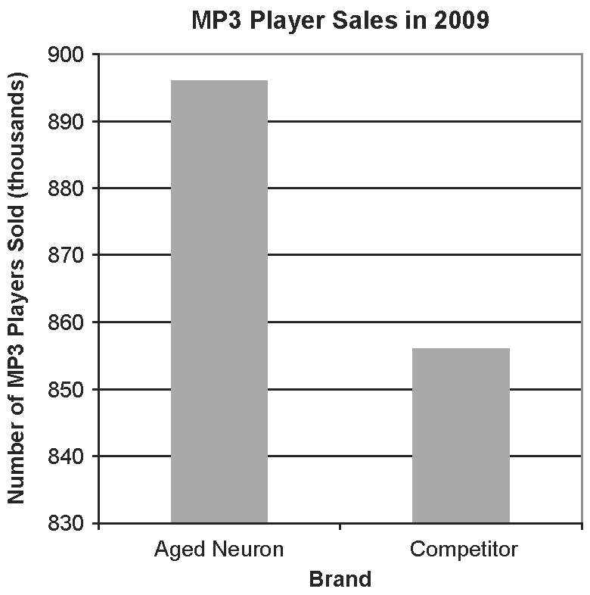

a) What is the advertiser’s message?
b) Describe how the graph distorts the data.
c) Describe how the graph could be changed to better illustrate the data.
3. A magazine article included the statement: “66.4% of Canadians are happy with their job. The results are accurate to within 3.2 percentage points, 19 times out of 20.” Explain the meaning of this statement.

4. A 100-year flood refers a size of flood that has a 1% chance of occurring in any given year. The probability of a 100-year flood occurring at least once in any given set of
x years is the difference 100% − (99%)^{x}. For example, the probability of a 100-year flood occurring at least once between 2010 and 2012 (x = 2) is 100% − (99%)² = 1.99%.
a) Use technology to determine the probability of a 100-year flood occurring at least once
i) between 2010 and 2060
ii) between 2000 and 2100
b) A magazine article claims that a 100-year flood will certainly occur within the next 100 years. Is this conclusion correct? Explain.

5. Which advertisement offers more savings? Explain.
Advertisement A
Take $20 off the regular price of $100.
Buy before Friday to take 40% off the
sale price.
Advertisement B
Take 40% off the regular price of $100.
Use your coupon to take an additional
$20 off the sale price.

6. A newspaper article included this graph, which shows Canada’s per capita personal disposable income (PDI) from 1991 to 2006. PDI is the sum of all incomes of residents of Canada, minus personal direct taxes, such as income taxes, payments to social insurance plans, and other fees.
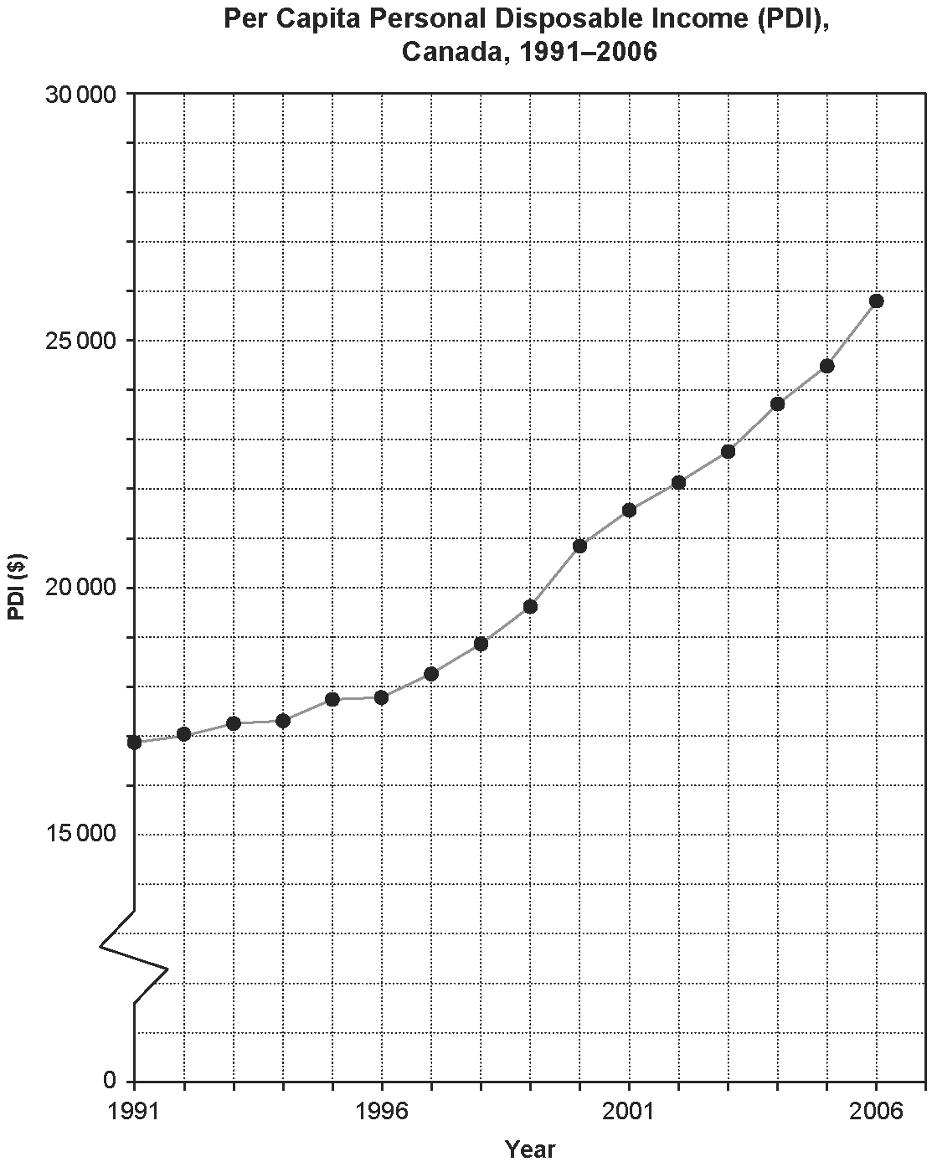
Source: Statistics Canada, CANSIM Table 384-0013 Database: E-STAT
a) Describe what is meant by per capita PDI.
b) Determine the per capita PDI in each year.
i) 1991
ii) 1996
iii) 2001
iv) 2006
c) Calculate the percent growth in per capita PDI for each five-year period, starting from 1991.
d) Describe the trend in per capita PDI.
e) Assume a five-year inflation rate of 10.4%. In which five-year periods did the per capita PDI increase at a greater rate than inflation?
7. The table shows the change in the number of applications to various programs (as a first choice) in Ontario universities from February 4, 2000 to February 6, 2009.
Program | Applicants (2000) | Applicants (2009)
Arts | 19 023 | 27 538
Science | 10 656 | 15 556
Business Administration | 8 736 | 12 295
Engineering | 5 633 | 7 057
Environmental Studies | 428 | 811
Fine & Applied Arts | 2 293 | 4 283
Physical & Health Education | 3 015 | 3 558
Music | 538 | 726
Nursing | 669 | 2 844
Education | 790 | 1 954
Mathematics | 1 787 | 1 442
Journalism | 977 | 1 376
Source: Ontario Universities Application Centre
a) Which programs had the greatest increase in the number of applications and by what percent?
b) Which programs had the least increase in the number of applications and by what percent?
c) Which programs had a decrease in the number of applications and by what percent?
d) Describe three trends you see in the data.
e) What type of graph would you use to display the data? Justify your choice.

