Chapter 4 Review

4.1 Statistical Measures, pages 200–211
1. Calculate the per capita value for each situation to two decimal places.
a) Number of new cars sold in Ontario in 2007: 312 000.
Ontario’s population: 12 900 000.
b) Gross federal government debt in 2007: $618 790 000 000.
Canada’s population: 33 100 000.

2. The marks, out of 50, on a math quiz are shown in the table.
Student | Mark | Student | Mark
Charlie | 41 | Zachary | 44
Desmond | 37 | Omar | 40
Robin | 32 | Jaqueline | 35
Aaron | 28 | Sheena | 38
Shannon | 46 | Darcy | 27
Stacey | 31
a) Determine the percentile rank of each student.
i) Robin
ii) Omar
b) Which student is in each percentile?
i) 50th percentile
ii) 90th percentile

3. The final mark for a term project is determined using these weights:
presentation 40%
research paper 60%
Determine the final project mark for each student.
Student | Presentation  (Out of 50) | Research Paper  (Out of 80)
Vanessa | 39 | 70
Nathan | 40 | 66
Claude | 33 | 75
Mallory | 35 | 63

4. Calculate the percent change for each situation.
a) Volume decreased from 7.9 L to 5.2 L.
b) Voter turnout increased from 6512 to
14 370.

4.2 Statistical Indices, pages 214–225
5. The graph shows the Gini Index for Ontario, which is a measure between 0 and 100 of the degree of inequality in the distribution of income. A Gini Index of close to 0 indicates that most members of the population receive close to the same income. A Gini Index of close to 100 indicates that a few people in the population receive most of the income.
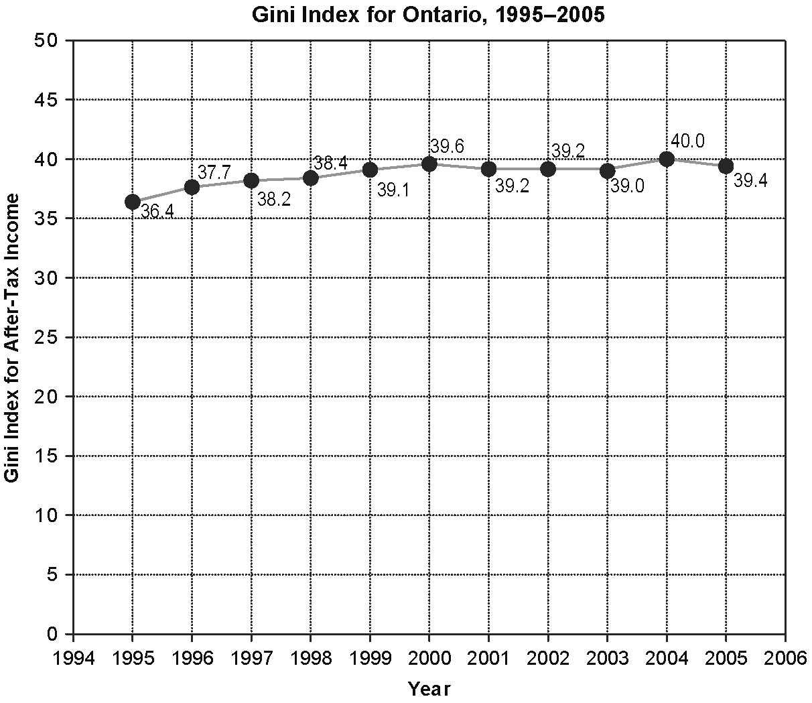
Adapted from: Statistics Canada, CANSIM Table 202-0705 Database: E-STAT

a) Describe the level of income inequality in 1995 compared to 2005.
b) By what factor has the index changed from 1995 to 2005?
c) What was the percent increase in the Gini Index from the low in 1995 to the peak
in 2004?

6. Recall that the Human Development Index (HDI) is a value that describes the combined life expectancy, literacy rates, and per capita income of a country. The index value ranges from 0 and 1. Canada’s HDI was 0.961 in 2005 and 0.967 in 2006. Zambia’s HDI was 0.434 in 2005 and 0.453 in 2006.
a) What was the percent increase in Canada’s HDI from 2005 to 2006?
b) What was the percent increase in Zambia’s HDI from 2005 to 2006?
c) By what factor was Canada’s HDI greater than Zambia’s HDI in 2006?

4.3 Interpret Statistics in the Media,
pages 226–235
7. A television commercial states: “Eight out of ten people agree that Polarini Orange Juice is as good as or better than Nanima Orange Juice.” Write three questions that could be used to challenge this claim.

8. A magazine presented the results of a political poll on the support for different political parties in the graph shown.
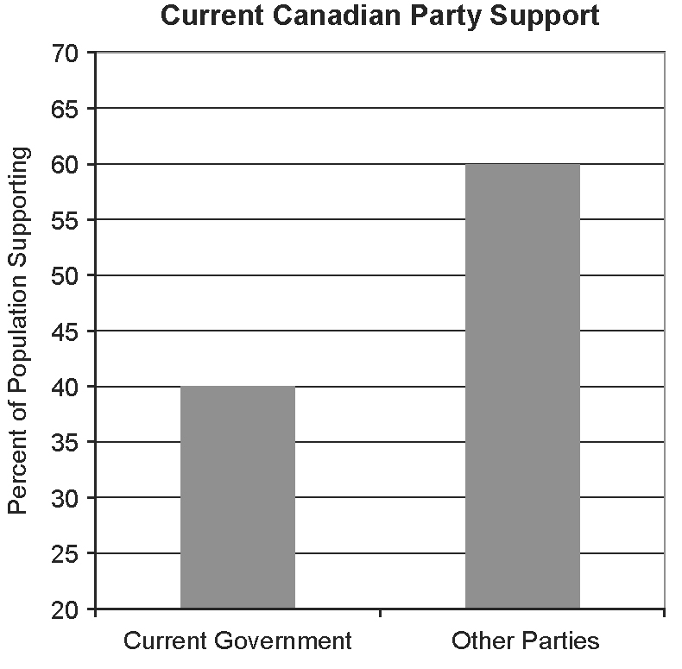
a) What does the graph imply?
b) How could you change the graph to more accurately display the data?
c) What additional information is needed to determine which political party has the most support?
4.4 Statistical Bias, pages 236–243
9. Identify the bias in each situation. Suggest how to eliminate the bias.
a) A survey question asks, “Do you agree that the provincial government should invest more in infrastructure to keep our highways in great condition?”
b) Randomly selected students were asked to take part in a 15-min interview on post-secondary education. Only about 8% of the selected students agreed to participate.
c) A researcher interviewed 50 people in a shopping mall about credit card use.
d) A police officer noticed that his radar gun was registering unusually high readings for passing cars. He tested it and found it needed to be calibrated.

10. A provincial survey was sent to randomly selected homes across Ontario. However, only 5% of the respondents were rural residents, who make up 15% of Ontario's population.
a) What type of bias does this represent?
b) What could be done to improve the response rate from rural residents?

4.5 Critical Analysis, pages 244–255
11. A study stated that 85% of Canadian college graduates 22 to 24 years of age are employed while 80% of Canadian university graduates 22 to 24 years of age are employed.
a) What relationship is being described with the use of statistics?
b) Does this relationship represent descriptive or inferential statistics? Explain.
c) Suggest a reason for the discrepancy in employment rates for Canadian post-secondary graduates 22 to 24 years
of age.

