Chapter 4 Practice Test

For questions 1 to 4, select the best answer.

1. The number of nurses in Canada in 2007 was 330 000 and the population was 33 100 000. What is the per capita value for this situation?
A 0.01
B 100.30
C 32 770 000
D 33 430 000

2. The Consumer Price Index (CPI) was 113.3 in December 2008. What does this mean if 2002 = 100?
A Overall, consumer prices decreased from 2002 to December 2008.
B Consumer prices in December 2008 were 113.3 times as great as prices in 2002.
C The overall percent change in consumer prices from 2002 to December 2008
was 13.3%.
D The average consumer spent $113.30 on goods and services per day in December 2008.

3. Which is an example of response bias?
A A survey is mailed to 10 000 residents of each province in Canada.
B A survey question asks, “Have you ever committed a crime?”
C A survey was mailed to 5000 rural residents of Ontario but only about 5% responded.
D Two students measured the time required to run across a field using two wristwatches. The recorded time was inaccurate because the wristwatches were not synchronized.

4. Which is an example of inferential statistics?
A A random sample of 150 students was interviewed at a high school. Of those questioned, 28% had a part-time job.
B Based on a random sample of 1400 Canadians, 30% of Canadians have difficulty falling asleep or staying asleep.
C Every employee at an office was interviewed. Of those questioned, 12% walked or rode a bicycle to work.
D Every student at a high school was surveyed. A majority of the students indicated they enjoyed exercising.

5. The table shows the total number of registered vehicles in Canada and the population by year.
Year | Number of Registered Vehicles | Population  (as of July 1)
2002 | 18 483 462 | 31 372 587
2003 | 18 729 908 | 31 676 077
2004 | 18 921 020 | 31 995 199
2005 | 19 200 828 | 32 312 077
2006 | 19 731 618 | 32 976 026
Source: Statistics Canada, CANSIM Table 405-0005 Database: E-STAT
a) Calculate the per capita number of registered vehicles for each year to three decimal places.
b) Calculate the percent change in number of registered vehicles for each year.

6. An advertisement states: “In a recent study, it was found that washing with our antibacterial soap kills 200% more bacteria than washing with plain soap.” Write three questions that could be used to challenge
this claim.

7. A provincial survey in Ontario will be conducted to determine residents’ opinions about increasing the provincial sales tax (PST) rate by 1%.
a) Write two questions for the survey, one with response bias and one with no bias.
b) Describe two sampling methods for the survey, one with sampling bias and one with no bias.
c) Suggest a situation where non-response bias would occur in the survey.

8. This graph was included in a newspaper article about home heating options.
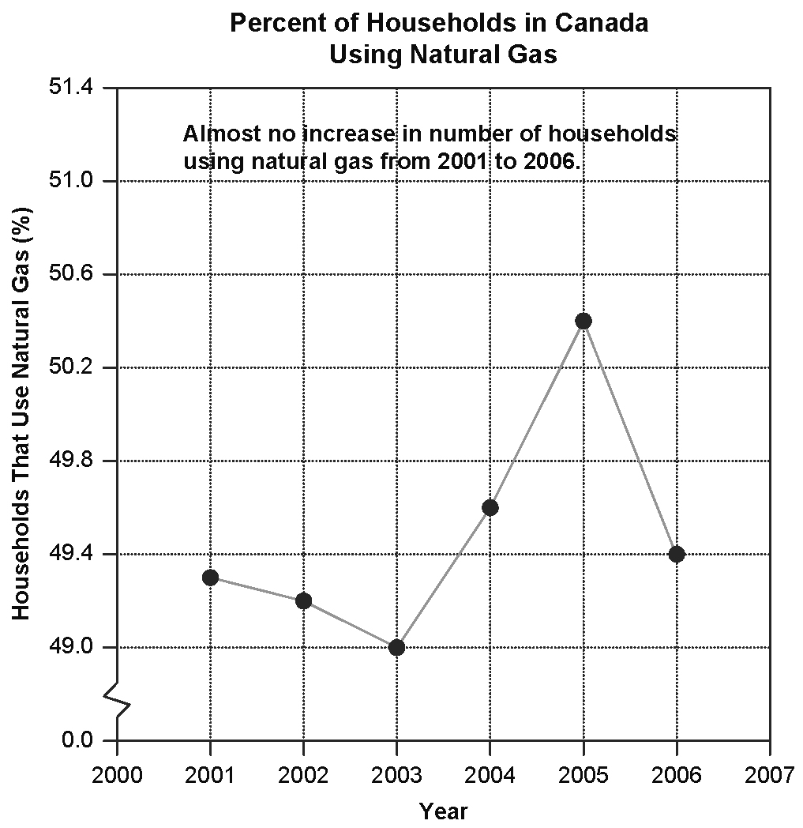
Adapted From: Statistics Canada, CANSIM Table
203-0019 Database: E-STAT
a) Describe any errors made by the headline writer.
b) What would be a better headline for the article?

9. Radon is a colourless, odourless, radioactive gas that presents a health hazard when it accumulates in buildings. The Canadian Nuclear Association states on its Web site, “Health Canada and provincial health departments have published guidelines on what is considered to be an acceptable level of radon exposure. Based on these guidelines and measurements of radon levels in homes across the country, Health Canada estimates that less than one tenth of 1% of all homes in Canada—fewer than 8,000 homes—have high enough levels of radon to warrant corrective action.”
a) Identify how statistics are used in this statement.
b) Is this an example of descriptive or inferential statistics?
c) Perform a critical analysis of this statement.

10. Aimee surveyed 200 people for her college course on urban design and planning. She found that 70% of respondents think that wind energy is the best source of alternative energy and that 50% of respondents think public policy should allow wind turbines to be built in urban areas. She concluded that 50% of the respondents think that wind energy is the best source of alternative energy and that public policy should allow wind turbines to be built in urban areas.
a) Identify how statistics are used in this scenario. Is Aimee’s conclusion correct?
b) Is this an example of descriptive or inferential statistics? Explain.
c) Perform a critical analysis of this scenario.

