Chapter 4 Test

For questions 1 to 4, select the best answer.

1. A farmer’s annual revenue increased from $353 000 to $591 000. What is the percent increase in revenue?
A 40.3%
B 59.7%
C 67.4%
D 167.4%

2. “In a recent study, 65% of city residents support increased spending on recreation. The study is accurate to within 3.1 percentage points, 19 times out of 20.” What does this mean?
A If this study were repeated 20 times, between 61.9% and 68.1% of respondents would support increased spending on recreation in only the first 19 surveys.
B If this study were repeated numerous times, then between 61.9% and 68.1% of respondents would support increased spending on recreation in 95% of those studies.
C The pollsters asked 20 people and between 18 and 20 people said they would support increased spending on recreation 65% of the time.
D The survey was done 20 times and in
19 surveys, between 3.1% and 65% of respondents supported increased spending on recreation.
3. Which situation contains sampling bias?
A A teacher writes the names of her 25 students on slips of paper, places them into a box, and randomly chooses ten names.
B 150 000 Canadian residents were chosen for a survey by randomly selecting residents from each province, in proportion to the population of each province.
C Every resident in Canada was asked to complete a questionnaire or a personal interview for the 2006 Census of Canada.
D To determine Canadians’ views on global issues, a news reporter interviewed five pedestrians.

4. An index consists of related components. To calculate the value of a statistical index, which is used?
A the real value of its components
B the weighted mean of its components
C the percentile rank of its components
D the per capita value of its components

5. The marks, out of 100, on an English assignment are shown in the table.
Student | Mark | Student | Mark
Graham | 65 | Tetyana | 88
Marian | 70 | Sydney | 80
Ahmed | 77 | Cody | 62
Romes | 82 | Bruce | 79
Li Wen | 58 | Alicia | 70
Determine the percentile rank of each student.
a) Graham
b) Alicia
c) Sydney

6. The New Housing Price Index (NHPI) follows Canadian contractors’ selling prices of new residential houses. The index takes into account both the land and house selling price. The graph shows the value of the index from 1997 to 2007, (1997 = 100).
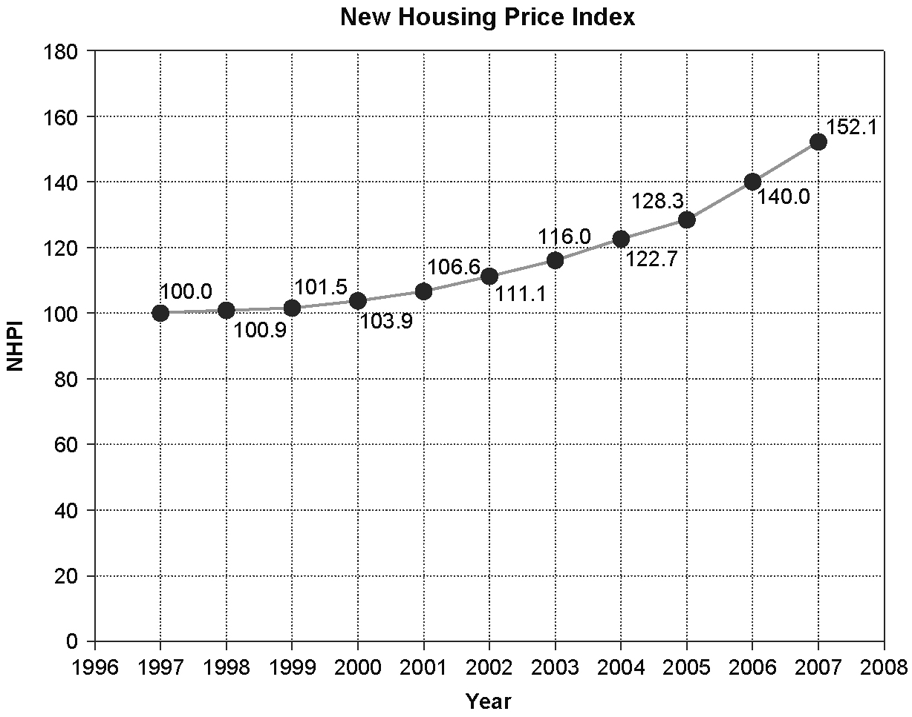
Source: Statistics Canada, CANSIM Table 327-0005 Database: E-STAT
a) What is meant by 1997 = 100?
b) By what percent did the selling price of new residential homes increase from 1997 to 2007?
c) By what percent did the selling price of new residential homes increase from 2006 to 2007?
d) Would the graph distort the data if the vertical scale started at 90 instead of 0? Explain.
7. Identify and describe the bias in each situation.
a) A citywide survey about parks and walking trails was sent to randomly selected households. The response rate was significantly higher for residents who had lived in the city for more than two years than residents who had lived in the city for less than two years.
b) Warren did a project on ocean travel and recorded the units of the distance travelled by boats using an abbreviated form “nm” instead of using “nautical miles.” A student who read the report later mistook "nm" for “nanometres.”
c) A pollster in front of a bank randomly selects people walking past to interview about saving money.
d) A survey question asks, “Don’t you agree that students would greatly benefit if tuition fees were lowered?”

8. A 2007 article on identify theft included the statement: “Electronic payments boosted the Canadian economy by 25 per cent over the past two decades, representing $107 billion of the economy’s $437-billion growth from 1983 to 2003, according to a study sponsored by Visa Canada in 2004.” Identify three items of concern that would be part of a critical analysis.

