Prerequisite Skills

Interpret Graphs
1. Consider these graphs.
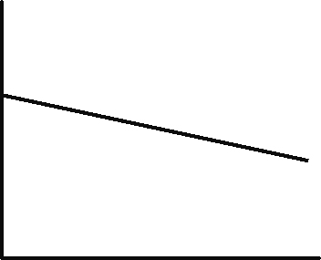
A


B

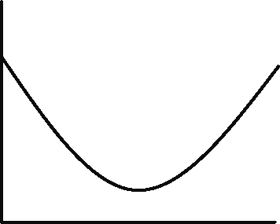
C


D


E

a) Which graph is always increasing?
b) Which graph is always decreasing?
c ) Which graph remains constant?
d ) Which is not any of the above?

2. Miriam is running a 22-km half marathon at a constant speed. Her distance from the finish line decreases with respect to time as shown.
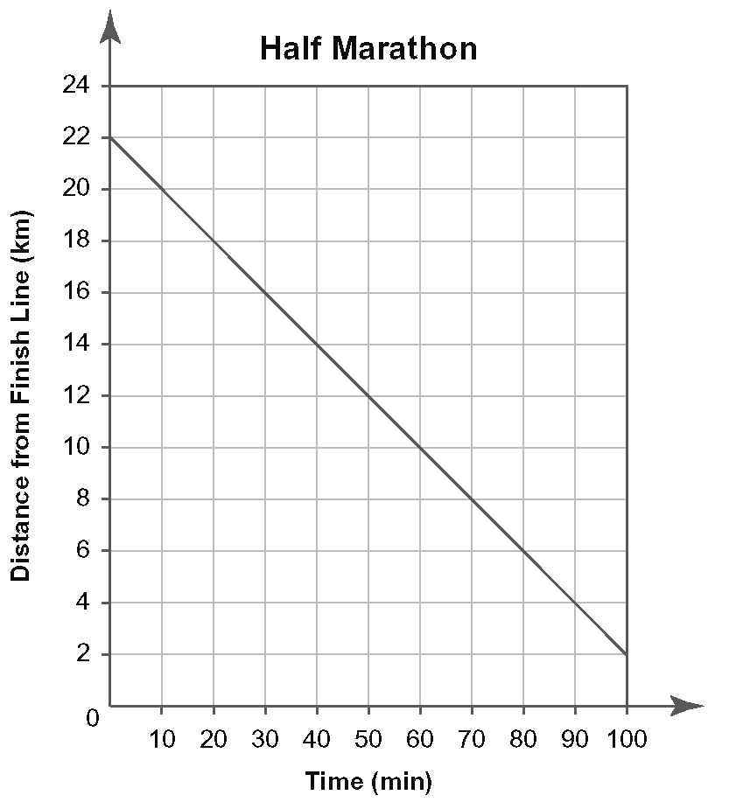
a) Estimate her distance from the finish after one hour.
b) How long does it take Miriam to get halfway to the finish line?
c) Estimate the time when Miriam is 1 km from the finish line.

Calculate Finite Differences
3. The driver of a car travelling at 90 km/h applies the brakes. The table shows the time and distance data for the car, measuring from the moment when the brakes were applied. Calculate the first and second differences.
Time (s) | Distance (m)
1 | 22
2 | 42
3 | 60
4 | 76
5 | 90
6 | 102
7 | 112

4. Complete the table.
Time  (day) | Area  (cm²) | First  Differences | Second  Differences
0 | 0 | First  Differences | Second  Differences
0 | 0 | 30 | Second  Differences
1 | 30 | 30 | 20
1 | 30 | 50 | 20
2 | 80 | 50 | 20
3 | 150
3 | 150 | 90
4 | 240 | 90 | 20
4 | 240 | 110 | 20
5 |  | 110 | 20
5 |  | 130 | 20
6 | 480 | 130

Draw Scatter Plots
5. The manager of a golf course recorded the daily number of tee bookings and the daily probability of precipitation. Create a scatter plot with probability of precipitation on the horizontal axis and number of tee bookings
on the vertical axis.
Probability of Precipitation (%) | Number of Tee Bookings
15 | 45
30 | 41
45 | 38
60 | 33
75 | 29
90 | 26

Linear Regression
6. The table shows the yearly enrolment in an undergraduate level program at a university.
Year | Enrolment
0 | 2615
1 | 2989
2 | 3294
3 | 3653
4 | 3990
5 | 4214
6 | 4601
a) Use technology to graph the data.
b) Use linear regression to determine the equation of a line of best fit.
Evaluate Exponential Expressions
7. Use a calculator to evaluate.
a) 2⁶
b) 5³
c ) 0.9⁴
d) 3.1²
e) 3² × 6⁴
f ) 4.5(5.9)³

8. The number of visitors to a new Web site can be modelled by the equation
N = 100(2.1)^{d}, where N is the total number of visitors to the Web site after d days.
a) Determine the total number of visitors after five days.
b) Determine the total number of visitors after two weeks.
c) Use systematic trial to determine when the total number of visitors will be greater than 1 000 000.

Simple and Compound Interest
9. Ahmad received a $4800 loan at 7% per year simple interest from his parents to buy new furniture. He expects to repay the principal and interest after two years. How much will he owe at that time?

10. Kennedy purchased a $15 000 GIC five years ago. The GIC paid 4.5% per year, compounded annually. Determine the present value of the GIC.

11. Janice received a $5000 GIC ten years ago for her birthday. The GIC paid 1.25% interest per year, compounded semi-annually. Determine the present value of the GIC.

